Faculty Review Instructions for Honors Common Assignments
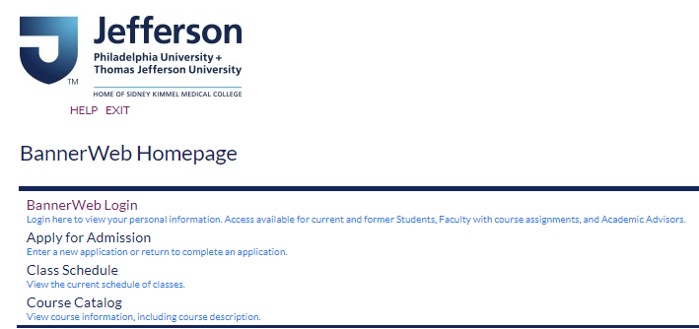
Go to banner.jefferson.edu. Click on the link for BannerWeb Login.
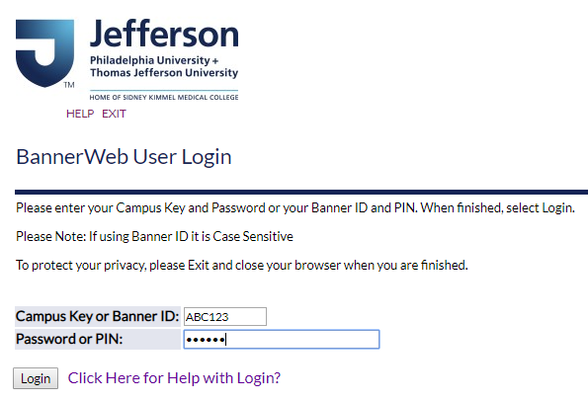
Enter your campus key and password or PIN. Click on Login.

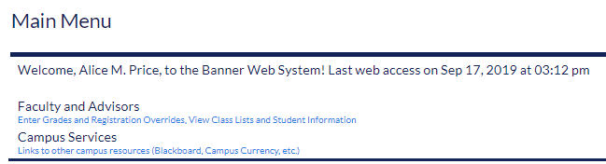
Click on the link for Faculty and Advisors.
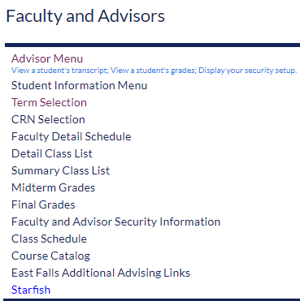
Click on the link for Advisor Menu.
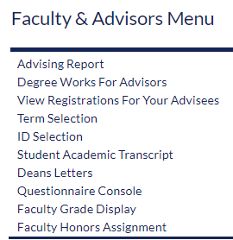
Click on the link for Faculty Honors Assignment.
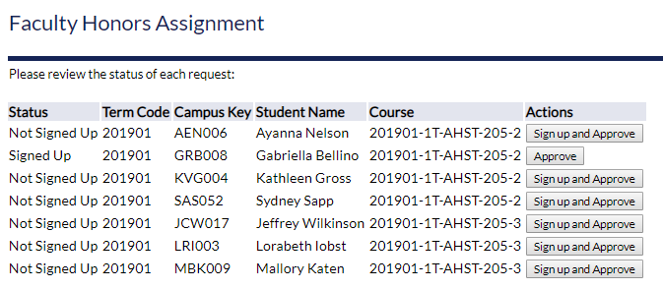
You will see students who are eligible to request an Honors Assignment, as well as students who have submitted a request. The value in the Status column will reflect what the student has done to this point, if anything.
To Sign Up and Approve:
Click on the link to Sign up and Approve for an eligible student.
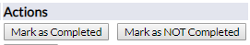
You can click on the link to Mark as Completed or Mark as NOT Completed.
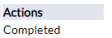
The value in the Action column will change to Completed if you click Mark as Completed.
The value in the Action column will change to NOT Completed if you click Mark as NOT Completed.
To Approve:
Click on the link to Approve a request.
You can click on the link to Mark as Completed or Mark as NOT Completed.
The value in the Action column will change to Completed if you click Mark as Completed.
The value in the Action column will change to NOT Completed if you click Mark as NOT Completed.

