Student Sign-Up Instructions for Honors Common Assignments
Go to banner.jefferson.edu. Click on the link for BannerWeb Login.
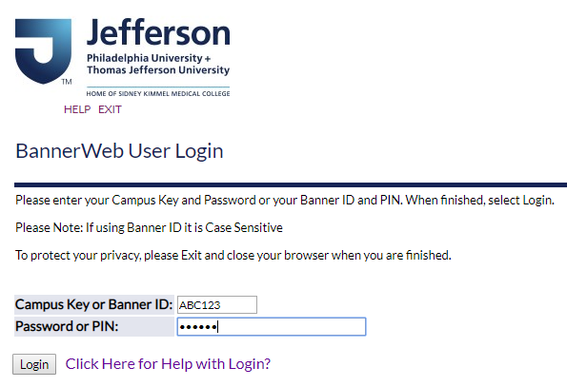
Enter your campus key and password or PIN. Click on Login.
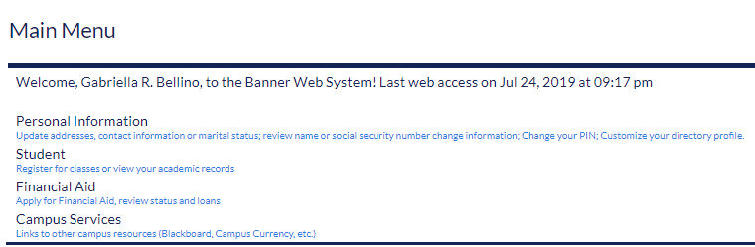
Click on the link for Student.
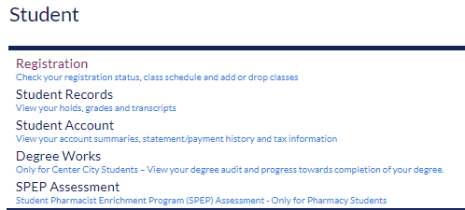
Click on the link for Registration.
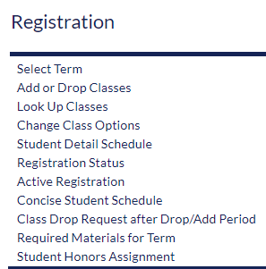
Click on the link for Student Honors Assignment.
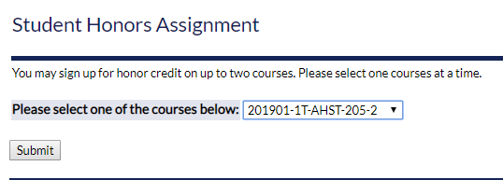
Any classes which are eligible for a Student Honors Assignment designation will appear on the pull-down list. Select the section for which you are applying for an Honors Assignment and click on Submit.
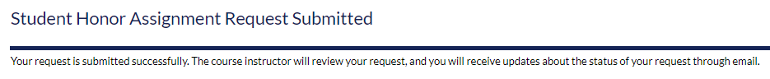
You will see a message indicating that your request was submitted for review. You will receive updates via your Thomas Jefferson University email account.

