Thomas Jefferson University
Office of Student Financial Aid

2016-2017
EXIT INTERVIEW BOOKLET

Sidney Kimmel Medical College
Jefferson College of Biomedical Sciences
Jefferson College of Health Professions
Jefferson College of Nursing
Jefferson College of Pharmacy
Jefferson College of Population Health

TABLE OF CONTENTS

SECTION PAGE
Introduction 3
Questions 4
Important Phone Numbers and Websites 5

Loans Administered by Outside Lenders/ Federal Direct Loans 6
Federal Subsidized & Unsubsidized Stafford Loans 7
Federal PLUS Loan, Federal Grad PLUS Loan 13
Federal Supplemental Loans
Health Education Assistance Loan (HEAL) 19

Loans Administered by Thomas Jefferson University 21
Federal Perkins Loan, National Direct Student Loans & Nursing Loan 22
Health Professions Student Loan Primary Care Loan & Loan for 40
Disadvantaged Students (PCL/LDS)

Thomas Jefferson University Institutional Student Loans 47
Sidney Kimmel Medical College 48
Robert Wood Johnson Student Loan 50
Jefferson Schools (JSHP, JSN, JSP) 52
Jefferson Graduate School of Biomedical Sciences 55
Borrower Responsibilities 58
Student Loan Ombudsman 59

General Repayment Information 60
Monthly Invoicing 61
Defaulting on Student Loans 62
Obtaining Credit Reports 63

Loan Consolidation 64
Information on Loan Consolidation 65
Refinancing 69
HEAL Refinancing 70
Education Tax Benefits 72
Loan Repayment/Forgiveness Programs for Health Professionals 75
Loan Repayment/Forgiveness Programs for Medical Graduates 76
Loan Repayment/Forgiveness Programs for Nursing Graduates 77
Debt Management Information and Federal Perkins Loan Cancellation 78
Debt Management Tools 79
Financial Aid Indebtedness, Acronyms & Terminology 80
Projecting Your Repayment Potential 83
Educational Loan Record 84
Budget Worksheet 85
Department of Education Perkins Loan Cancellation Information 86

Introduction

Purpose of the Exit Interview

Thomas Jefferson University is required to provide an Exit Interview to each student who has received federally funded student loans while in attendance at this institution. It is also our opportunity to advise students of their total indebtedness and outline the specific parameters that govern each component of their debt, including possible grace, deferment, and forbearance privileges, as well as provide students with techniques & strategies for managing their educational loan portfolio after graduation.

Certain loans are administered by outside lenders, and others are handled directly through Thomas Jefferson University. This booklet is divided into these two categories and serves as a reference. When using this booklet, you should first determine which entity is handling your loan.

Loans Administered Loans Administered by
by Outside Lenders Thomas Jefferson University

Federal Subsidized Stafford Loans Federal Perkins Loan (formerly National Direct Student Loan)
Federal Unsubsidized Stafford Loans Health Professions Nursing Loans (HPNL)
Federal PLUS Loans Health Professions Student Loans (HPSL)
Federal SLS Loans Loans for Disadvantaged Students (LDS)
Health Education Assistance Loan Primary Care Loans (PCL)
Private Alternative Loans Institutional Student Loans
Federal Graduate PLUS Loans

Questions

Questions regarding your Thomas Jefferson University Student Loans (including Federal Perkins/NDSL, HPNL, HPSL, LDS, and PCL) should be directed to the Student Loan Office. For deferment and forbearance forms, to make a payment or change of address, please go to www.acs-education.com.

Thomas Jefferson University
Student Accounts Office,
6th & Walnut, Curtis Center
Suite 925 E
Philadelphia, Pennsylvania 19107-5587
(215) 503-7226
Studentloans@Jefferson.edu

Questions on loan consolidation and/or loans that you received from outside lenders (i.e. Federal Subsidized Stafford, Federal Unsubsidized Stafford, Federal PLUS, Federal SLS, HEAL, alternative loans, etc.) while a student at Thomas Jefferson University may be directed to the Financial Aid Office:

University Office of Student Financial Aid
1015 Walnut Street
Suite 115, Curtis Building
Philadelphia, Pennsylvania 19107-5099
(215) 955-2867
Email: financial.aid@jefferson.edu

Susan McFadden
University Director of Student Financial Aid

Thomas Stewart
Associate Director of Financial Aid

Melissa Cadet
University Coordinator of Financial Aid

Atheia Mobley
University Coordinator of Financial Aid

Nicole Bailey
Student Services Coordinator

Important Phone Numbers and Websites

Direct Loan Servicers

Nelnet 1-866-463-5638 www.nelnetloanservicing.com
Great lakes Educational Loan Services, Inc.
1-888-686-6919 www.mygreatlakes.org
Sallie Mae 1-888-272-4665 opennet.salliemae.com
FedLoan Servicing (PHEAA) 1-800-655-3813 www.myfedloan.org
MOHELA 1-888-866-4353 www.mohela.com/schools
ESA/Edfinancial 1-855-845-1001 www.edfinancial.com/DLSchools
CornerStone 1-877-336-7397 www.mycornerstoneloan.org
Aspire Resources Inc. 1-888-902-6077 www.AspireResourcesInc.com
Granite State- GSMR 1-800-303-8353 www.gsmr.org
OSLA Servicing 1-866-264-9762 www.osla.org
VSAC Federal Loans 1-888-307-8722 www.vsacfederalloans.org

Loans Administered
by
Outside Lenders (Prior to 7/1/10)
&
Direct Loans (7/1/10 & after)

Federal Subsidized Stafford Loan
Federal Unsubsidized Stafford Loan
Federal PLUS Loan
Federal Supplemental Loans for Students (SLS)
Health Education Assistance Loan (HEAL)
Federal Graduate PLUS Loan

Federal Direct Subsidized
&
Unsubsidized Stafford Loans

Federal Subsidized Stafford Loans
A Federal Subsidized Stafford Loan is a low interest loan made by a lender such as a bank, credit union, or savings and loan association or from the federal government through Direct Loans to help pay for education after high school. These loans are insured by the Federal Government . As indicated on the chart below, the applicable interest rate and grace period is based on the date of the loan. Medical students who are prior Federal Stafford borrowers prior to 1993 may be eligible to apply for a deferment of up to two years, while in internship/residency. However, medical students who borrowed a Federal Stafford Loan for the first time on or after July 1, 1993 are eligible to apply only for a 'forbearance' while in internship/residency period. The chart below specifies the effective date for each interest rate and applicable grace period: Federal Stafford Loan Chart

Date of First Loan | Interest Rate | Grace Period
Prior to January 1, 1981 | 7% | 9 months
January 1, 1981 to  September 12, 1983 | 9% | 6 months
Only those loans disbursed  prior to October 1, 1981 | 6 months post – deferment grace period
September 13, 1983 to  June 30, 1988 | 8% | 6 months
July 1, 1988 to  September 30, 1992 | 8/10%  (10% begins in the fifth  year of repayment) | 6 months
October 1, 1992 to  June 30, 1994 | Variable – T Bill + 3.1%  (with 9% cap) | 6 months

All Loans Disbursed | Interest Rate | Grace Period
July 1, 1994 to July 1, 1998 | Variable – T Bill + 2.5%  (while in school, grace & applicable  deferment periods with an 8.25% cap) | 6 months
July 1, 1994 to July 1, 1998 | Variable – T Bill + 3.1 %  (during repayment with an 8.25% cap) | 6 months
July 1,1998 to  June 30,2006 | Variable – T Bill + 1.7%  (while in school, grace & applicable  deferment periods with an 8.25% cap) | 6 months
July 1,1998 to  June 30,2006 | Variable – T Bill + 2.3%  (during repayment with an 8.25% cap) | 6 months
July 1,2006 to July 30,2013 | Fixed 6.8% | 6 months
July 1, 2013 to June 30, 2014 | Fixed 5.4 % Grad/Professional  Fixed 3.86% Undergraduate | 6 months
July 1, 2014 to June 30, 2015 | Fixed 6.21 Grad/Professional  Fixed 4.66 % Undergraduate | 6 months

Deferment of Federal Subsidized Stafford Loans

Loans disbursed on or after 7/1/93:
For information on Federal Stafford Deferment Provisions for loans disbursed after 7/1/93, please
refer to the Deferment Provisions Chart located on pages 27 & 28 of this booklet.

Medical students: It is important to note that if you borrowed Federal Subsidized Stafford
and/or Federal Grad PLUS funds for the first time, on or after 7/1/93, you may only apply for a ' forbearance' while in internship and residency.

Loans Disbursed before 7/1/93:
For students who borrowed Federal Stafford Loan and/or Federal Grad PLUS funds before July 1, 1993:
You may defer repayment for periods of full-time study at an eligible school. You may also defer
repayment for study in an approved residency, internship, or graduate fellowship program for study in an approved rehabilitation training program for the disabled, and for full-time study at a school operated by the Federal Government. You may also defer repayment for periods of at least half-time study if you have borrowed a Federal Stafford Loan or Federal Grad PLUS for the same enrollment period.

If your loans were disbursed before 7/1/93, you may defer payments for up to 3 years while you are:

• A member of the U.S. Armed Forces or the Commissioned Corps of the U.S Public
Health Service.

• A Peace Corps volunteer, a volunteer in an ACTION program such as VISTA, or a full-
time volunteer in another program which the Department of Education has determined
is comparable to that of the Peace Corps or ACTION.

• An active duty member of the National Oceanic and Atmospheric Administration
Corps.

• A full-time teacher in public or private elementary or secondary school in an area the
Department of Education has determined to be a teacher shortage area.

• Temporarily totally disabled, or if you cannot work because your spouse or dependent
is temporarily totally disabled and you must care for him or her. (In either case, your
doctor must certify that the disability is temporary or total.)

If your loans were disbursed before 7/1/93, you may defer repayment for a maximum of 2 years while you are:

• Serving in an eligible medical residency or internship (deferment time period
determined by lender and/or state agency) and have an outstanding balance on a
Federal Stafford Loan prior to July 1, 1993;
• For periods of unemployment if you are actively seeking employment.

If your loans were disbursed before 7/1/93, you may defer repayment for parental reasons:

• If you are a mother of preschool age children, you may defer repayment for up to 12
months if you are going to work (or back to work) at a salary that is no more than $1.00
over the minimum wage.
• You may defer repayment for up to 6 months of parental leave. Contact your lender to
see if you are eligible for this provision.

Deferments are not automatic. If you believe you are eligible for a deferment, contact your Servicer. If you are in default, you are not eligible for a deferment.

Cancellation of Federal Subsidized Stafford

For information on Federal Stafford Cancellation Provisions for loans disbursed on or after 7/1/93,
please refer to the Federal Perkins and Federal Stafford Cancellation Provisions Chart on pages 32 & 33 of this book. Your Federal Stafford Loan would be canceled in cases of death or permanent and total disability.

If you serve as an enlisted person in certain selected specialties of the U.S. Army, the Army Reserves, or the Army National Guard, the Department of Defense will, as an enlistment incentive, repay a portion of your Federal Stafford Loan.

Repayment Options
- Standard Repayment: Payments are a fixed amount.
- Extended Repayment: (Available only to those who first borrowed FFELP loans on or after 10/7/98 and whose total federal student loan debt exceeds $30,000). This option allows borrowers to repay their loans over a maximum period of 25 years, with either standard graduated repayment. The monthly payment is lower but the overall cost is higher than with the equal or graduated repayment options.
- Graduated Repayment: Amount of the monthly payment increases gradually. Repayment may be extended to a minimum of 12 years and a maximum of 30 years.
- Income Sensitive: Amount of the monthly payment is based on the borrower’s income.
- Income Contingent Repayment Plan: Monthly payments that are based on a borrower’s annual income, loan balance & family size, and are spread over a term of up to 25 years.
- Income Based Repayment Plan& PAYE: Under IBR, your required monthly payment is capped at an amount that is intended to be affordable based on your income & family size. For most eligible borrowers IBR loan payments will be either than 10 or 15% of their gross monthly income.

Your Responsibilities Concerning Federal Subsidized Stafford Loans

• You must attend an Exit Interview before you leave school.

• You must notify your Federal Stafford Loan lender (usually your bank, savings and loan, credit union or servicer) if before the loan is repaid, you:

a. graduate, withdraw, or drop below half-time status
b. transfer to another school
c. fail to enroll in the school the loan was intended for
d. change your name or address
e. change your residency or fellowship status

If for any reason you have difficulty meeting the provisions of the promissory note, contact your Federal Stafford Loan Servicer to discuss your situation.

Sample Standard Repayment Plan for Federal Stafford Loans:

Total
Federal Number
Stafford of Monthly Interest Total
Indebtedness Payments Payment Charges Repaid

$ 2,500 60 $50.00 $ 447.84 $ 2,947.84
5,000 60 98.54 912.02 5,912.02
10,000 120 115.09 3809.22 13,809.22
12,500 120 143.86 4,761.51 17,261.51
25,000 120 287.71 9,523.63 34,523.63
35,000 120 402.79 13,333.27 50,333.27
45,000 120 517.87 17,142.95 62,142.95
54,750 120 630.07 20,857.54 75,607.54
*Based on 6. 8% interest rate

Federal Unsubsidized Stafford Loan Program

Interest begins accumulating on the Federal Unsubsidized Stafford Loan as of the date the funds are disbursed from the lender, and continues to accrue throughout the life of the loan. For loans disbursed prior to 7/1/2006 interest is variable and is calculated, on July 1 of each year, on the basis of the prevailing T-bill rate plus 1.7% (during in school, grace and approved deferments) and 2.3% (during repayment and forbearance) with an established ceiling of 8.25%. For example, the variable interest rate for the 2011-12 academic year was established on July 1, 2011, as 1.76% (in school) and 2.36% (during repayment and forbearance). July 1, 2006 to June 30, 2013 Federal Stafford Loans issued between these dates are at a fixed 6.8%. Effective July 1, 2013 Federal Loans issued after this date will have a rate based on the 10 yr Treasury Note Index plus 2.05% for Undergraduates and 3.60% for graduates students. (see chart on page 8 for a complete listing of all interest rates). Federal Unsubsidized Stafford borrowers have a maximum of ten years to pay off the loan in its entirety, exclusive of periods of grace, deferment or forbearance. Please refer to pages 27 & 28 for details regarding Federal Stafford deferment privileges.

The following are instructions on how to view your Federal non-Direct Loan Federal Subsidized and Unsubsidized Loans online. They are listed by individual lenders:

Total Higher Education (T.H.E.) 1-800-236-4300

- Logon to www.northstar.org
- Click on Theloanprogram.org
- Click “Contact” to access account information

Access Group 1-800-282-1550

NOTE: Access Group no longer services student loans. Call for information regarding who is servicing your student loan.

Wells Fargo 1-877-566-6733

- Logon to www.wellsfargo.com/student
- Click on Apply Now
- Choose the loan option that meets your needs
- Follow the directions after your selection

Federal PLUS Loan, Federal Grad PLUS Loan
&
Federal Supplemental Loans for Students
(SLS)

Federal PLUS Loans

Federal PLUS Loans are for parent borrowers of dependent students to provide additional funds for educational expenses. This loan could have been borrowed through banks, credit unions, and savings and loan associations. Since July 1, 2010, the Federal Direct Loan program is the only lender. Federal PLUS borrowers must begin repayment of interest within 60 days, unless the servicer agrees to let it accrue, while the principal is deferred.

PLUS Loans Variable Interest Rates

PLUS loans for which the first disbursement is made on or after July 1, 1987 through September 30, 1992 have a variable interest rate, to be determined on June 1 of each year according to a prescribed formula, and effective for the following July 1 through June 30.

The interest rate for these PLUS loans cannot exceed 12 percent, and the interest rate for these PLUS loans for the period from 6/1/93 - 6/30/94 was 6.79 percent. PLUS Loans issued on or after 7/1/94 have an interest ceiling of 9 percent.

Listed below is a chart of interest rate changes from July 1996 to present:

Dates | Interest Rates
7/1/96 – 6/30/97 | 8.72%
7/1/97 – 6/30/98 | 8.72%
7/1/98 – 6/30/99 | 8.26%
7/1/99 – 6/30/00 | 7.72%
7/1/00 – 6/30/01 | 8.99%
7/1/01 – 6/30/02 | 6.79%
7/1/02 – 6/30/03 | 4.86%
7/1/04 - 6/30/05 | 4.17%
7/1/05 – 6/30/06 | 6.1%
7/1/06 – 6/30/13  (non Direct Loans) | 8.5%
7/1/06 – 6/30/13  (Direct Loans) | 7.9%
7/1/13-6/30/14 | 6.4%
7/1/14- 6/30/15 | 7.21%

There is no interest subsidy for PLUS borrowers; the borrower is responsible for all interest that accrues on the loan while the student is in school and during periods of deferment, according to the terms of the repayment schedule.

Parents with PLUS loans should understand that annual adjustments in interest rates may alter their monthly payments; or, the lender may keep the monthly payment amount the same, but increase (or decrease) the number of payments required, to reflect the increase (or decrease) in the variable interest rate.

Federal Grad PLUS Loans

Federal Grad PLUS Loans are for graduate, professional, and medical students to provide additional funds for educational expenses. Similar to the PLUS loan for dependent undergraduate students, Grad PLUS loans were offered through banks, credit unions, and savings and loan associations. However, since July 1, 2010, the Federal Direct program is the only lender.

Borrowers will not have to make payments while in school; however, interest will accrue from the date of disbursement and the student is responsible to make payments upon graduation. Federal Grad PLUS Loans are disbursed at a fixed interest rate for the life of the loan. For a Direct Loan PLUS, the fixed rate is The 10yr Treasury Note Index plus 4.60 %.

Deferment of Grad PLUS Loans:

- Full time student;
- At least a half time student if you have borrowed a Stafford for the same period of study;
- A student in an approved graduate fellowship program, or in an approved rehabilitation program for the disabled;
- Temporarily totally disabled, or can’t work because he or she is caring for a dependent who is temporarily totally disabled. (In either case, a doctor must certify that the disability is both temporary and total. This deferment has a 3 year limit);
- Unemployed and looking for a full time job; (This deferment has a 2 year limit).

Forbearance is offered to Medical graduates for the duration of internship/residency when requested.

Repayment Options

- Standard Repayment: Payments are a fixed amount.
- Extended Repayment: (Available only to those who first borrowed FFELP loans on or after 10/7/98 and whose total federal student loan debt exceeds $30,000). This option allows borrowers to repay their loans over a maximum period of 25 years, with either standard graduated repayment. The monthly payment is lower but the overall cost is higher than with the equal or graduated repayment options.
- Graduated Repayment: Amount of the monthly payment increases gradually. Repayment may be extended to a minimum of 12 years and a maximum of 30 years.
- Income Sensitive: Amount of the monthly payment is based on the borrower’s income.
- Income Contingent Repayment Plan: Monthly payments that are based on a borrower’s annual income, loan balance & family size, and are spread over a term of up to 25 years.
- Income Based Repayment Plan &PAYE: Under IBR, your required monthly payment is capped at an amount that is intended to be affordable based on your income & family size. For most eligible borrowers IBR loan payments will be less either 10 or 15% of their gross monthly income.

Federal Supplemental Loans For Students (SLS)

Effective July 1, 1994, the Federal SLS program was replaced by the Federal Unsubsidized Stafford program.

Federal Supplemental Loans for Students (SLS) are for independent undergraduate and graduate
students. Federal SLS funds are offered through banks, credit unions, and savings and loan
associations. There is no interest subsidy for SLS borrowers. The interest rate for Federal SLS funds
disbursed on or before September 30, 1992 is 3.25% above the 52-week Treasury Bill with a ceiling
of 12%. Federal SLS funds disbursed on or after September 1, 1992 are subject to an interest rate
of 3.10% above the 52-week Treasury Bill with a ceiling of 11%. Your lender (bank, credit union, etc.) will provide you with repayment schedules. If you have any problems or questions with
repayment, contact your lender.

Deferment of Federal SLS Loans

Federal SLS borrowers receive the same deferments as Federal Subsidized Stafford borrowers.
However, under the Federal SLS program, the deferments apply only to principal. Federal SLS borrowers must begin repaying interest within 60 days, unless the lender agrees to let the interest accumulate until the deferment ends. Unpaid interest will capitalize (become part of principal).

General Information
Repayment of Federal Family Education Loans (FFELP):
Federal Subsidized Stafford and Federal Unsubsidized Stafford, Federal PLUS & Federal SLS

Lender/ Servicers must provide FFELP borrowers with the following written disclosure statements:

Before the first disbursement, disclosure statements must:

- Clearly and prominently state in boldface type that the borrower is receiving a loan
that must be repaid.
- Provides thorough and accurate information regarding loan terms and conditions.
- Indicate where the borrower should send communications.

No later than 120 days after borrower has left school, written notification of the date on which
repayment begins.

Between 60 and 240 days prior to start of repayment period written disclosure that includes:

- Name and address to which borrower must send loan payments
- Estimated balance, and, if applicable, amount of capitalized interest
- Repayment schedule
- Applicable interest rate and amount
- Fees expected to be charged during repayment
- Special options for loan repayment
- Statement that the loan may be prepaid without penalty

Health Education Assistance Loan
(HEAL)

Health Education Assistance Loan
(HEAL)

This federally insured loan was available through the 1997-1998 academic year to full-time health profession students enrolled in an M.D. degree program.

Interest on HEAL Loans

The HEAL program carried a floating interest rate based on the following federal formula (The average of the bond equivalent rates of the 91-day Treasury Bills auctioned for the previous quarter plus 3 percentage points, rounded to the next higher one-eighth of one percent.) However, many lenders offered rates below the standard federal formula.

The interest rate on all HEAL loans, regardless of lender, fluctuated quarterly, up or down, depending on the economic conditions affecting the Treasury Bill rate. Interest is payable throughout the life of the loan or may be deferred, and added to a borrower’s HEAL account, until repayment begins. Most lenders will not capitalize accumulated interest until repayment begins or the loan is sold to another lender.

Grace Period for HEAL Loans

There is a nine-month grace period after completion of the student’s formal training, including accredited internships and residency programs, or upon withdrawal from school.

Deferment for HEAL Loans

Repayment of principal and interest may be deferred for up to four years for internship/residency training; or three years during service in the Armed Forces, Peace Corps, Vista, or National Health Service Corps. Borrowers have twenty years to repay the loan. Specific HEAL deferment privileges are referenced on HEAL promissory notes.

Forbearance of HEAL Loans

Borrower’s facing economic difficulty may contact their HEAL lender to request temporary reduction or cessation of payment under economic/administrative forbearance. It is important to note that interest will continue to accrue during periods of deferment and forbearance.

Federal Loans Administered
by
Thomas Jefferson University

Federal Perkins Loan
National Direct Student Loan
Nursing Student Loan
Health Professions Loan
Primary Care Loan
Loans for Disadvantaged Students

Federal Perkins
National Direct Student Loan (NDSL)
Nursing Student Loan (NSL)

Federal Perkins Loan Program
Current Rules and Regulations
Code 51184 on Invoice/Repayment Schedules

Interest Rate for the Federal Perkins Loan

The interest rate for the Perkins loan is 5%. This rate is effective 7/1/92 to present.

Repayment Terms for the Federal Perkins Loan

• The total amount of the loan, plus accrued monthly interest, must be repaid over
a period not to exceed 10 years.

• Payments are due to be received by the first day of each month. Loan balance,
accrued interest, late fees, and collection costs can be demanded on defaulted
Loans (Loan Acceleration).

• Monthly minimum payment is $40.00

Grace Period for the Federal Perkins Loan

There is a 9 month grace period which begins after the borrower ceases to pursue at least half-time course of study. An additional 6-month grace period follows periods of deferment.

Deferment for the Federal Perkins Loan

Forms must be requested, in writing, and filed in a timely manner. Principal is not due and interest will not accrue during deferment. Payments can be made (interest free) against the principal with no penalty. See chart on pages 27 & 28 for eligibility.

Forbearance Information

Please see chart on page 31.

Your Responsibilities for Collection

You will be responsible for all collection, attorney fees, and late charges in the event that your account is referred to a collection agency and/or attorney.

Information on Late Charges

The institution will impose a late charge if:

• you do not make a scheduled payment when it is due; and

• you do not submit to the institution on or before the date on which payment
is due, documentation for deferment or cancellation. No charge may exceed
twenty (20) percent of monthly payment.

Defaulting on the Perkins Loan

If any monthly payment is late or deferment forms are not received, your loan can be determined to be in default. You will not be eligible for additional Federal Perkins Loans. Your account may be listed with a National Credit Bureau. Forms for deferment are required to be filed in a timely manner or you will be in default of your loan.

Cancellation of Perkins Loan

See chart on pages 32- 33 for eligibility.

Death and Disability Cancellation

In the event of death or if you become totally and permanently disabled, the institution will cancel the total amount of this loan upon receipt of required documentation.

Change in Name, Address, Telephone Number

You are responsible for informing the institution in writing of any change in your name, address, or
telephone number.
Contact the Student Loan Office at 215-503-7226 or at studentloans@jefferson.edu for more information about updating your information.

National Direct Student Loan (NDSL)
Current Rules and Regulations
Code 51184 on Invoices/Repayment Schedules

Interest Rate for the National Direct Student Loan

The interest rate for the National Direct Student Loan is 5 percent.

Repayment Terms for the NDSL

• The total amount of the loan, plus accrued monthly interest, must be repaid over
a period not to exceed 10 years.

• Payments are due to be received by the first day of each month. Loan balance,
accrued interest, late fees, and collection costs can be demanded on defaulted loans
(loan acceleration).

• There is a minimum payment of $30.00 per month.

Grace Period for the NDSL

Effective October 1, 1980, repayment period begins six months after the borrower ceases to pursue at least a half-time course of study. If a borrower enters deferment status, an additional six-month grace period is applied after the deferment period ends.

Deferment for the NDSL

Deferment forms must be requested, in writing, and filed in a timely manner or you will be in default of your loan. See chart on pages 27 & 28 for eligibility.

During this period, principal is not due and interest does not accrue.

Note: After deferment, the borrower is entitled to a six-month grace period. Neither the deferment nor the grace period is included in determining the ten-year repayment period.

Your Responsibilities for Collection

You will be responsible for all collection, attorney fees, and late charges in the event that your account is referred to a collection agency and/or attorney.

Default

If any monthly payment is late or deferment forms are not received, your loan can be determined to be in default. You will not be eligible for additional National Direct Student Loans. Your account may be listed with a National Credit Bureau. Deferment forms are required to be filed in a timely manner or you will be in default of your loan.

Your Responsibilities for Late Charges

The institution will impose a late charge if:

• you do not make a scheduled payment when it is due, and

• you do not submit to the institution on or before the date on which payment is
due, documentation for deferment or cancellation. No charge may exceed
twenty (20) percent of monthly payment.

Partial Loan Cancellation

National Direct Student Loan Program provides you with an opportunity to cancel all or part of your loan for certain types of service. See chart on pages 32 & 33 for eligibility.

Death and Disability Cancellation

In the event of death or if you become totally and permanently disabled, the institution will cancel the total amount of this loan upon receipt of required documentation.

Change in Name, Address, Telephone Number

You are responsible for informing Xerox in writing of any change or changes in name, address, or telephone number at www.acs-education.com or by calling either 1-800-835-4611 or 1-800-4470

PLEASE NOTE:
When using this chart the footnotes refer to the corresponding number on pages 29& 30 of the Deferment Provisions for All Federal Perkins Disbursed On or After 7/1/93 and Federal Stafford Borrowers Who Borrowed for the First Time On or After 7/1/93.

Deferment provisions for all Federal Perkins disbursed on or after 7/1/93 and Federal Stafford
borrowers who borrowed for the first time on or after 7/1/93
Deferment Condition | Federal Perkins  National Direct  Disbursed on  or after 7/1/93 | Federal Perkins/  Disbursed before  7/1/93 & on or  after 7/1/87 | National Direct  Disbursed before  7/1/93 & on or  after 10/1/80 | National Direct  Disbursed before  10/1/80 | National  Defense  Student Loan
Half-time enrollment | No Limit* | No Limit* | No Limit* | No Limit* | No Limit
Less than half-time  enrollment as a regular  student | N/A | N/A | N/A | N/A | 3 years**
Rehabilitation training | No limit* | N/A | N/A | N/A | N/A
Graduate fellowship¹ | No limit* | N/A | N/A | N/A | N/A
Eligible internship or  residency program | N/A | 2 years² | 2 years³ | N/A | N/A
Inability to secure  full-time employment | 3 years* | N/A | N/A | N/A | N/A
Economic hardship⁴ | N/A | N/A | N/A | N/A | N/A
Hardship as  determined by school | N/A | No limit** | No limit** | No limit** | No limit**
Law Enforcement/  Correction Officer | See footnote 5 | N/A | N/A | N/A | N/A
Peace Corps/  ACTION Program  Volunteer | See footnote 5 | 3 years* | 3 years* | 3 years | 3 years
Full-time volunteer for  tax exempt org. in  service comparable to  Peace Corps  or ACTION | N/A | 3 years* | 3 years* | N/A | N/A
U.S. Armed Services⁶ | See footnote 5 | 3 years* | 3 years* | 3 years | 3 years
Officer in  Commissioned  Corps of U.S. Public  Health Service | N/A | 3 years* | 3 years* | N/A | N/A
National Oceanic  & Atmospheric Admin. | N/A | 3 years* | N/A | N/A | N/A
Nurse/medical tech.  providing health svcs. | See footnote 5 | N/A | N/A | N/A | N/A
Temporary total  disability or care for  temp/totally disabled  spouse/dependent | N/A | 3 years* | 3 years*⁷ | N/A | N/A
Pregnancy, care of  new born or newly  adopted child⁸ | N/A | 6 months* | N/A | N/A | N/A
Working or return to  work mother of pre-  schooler⁹ | N/A | 1 year* | N/A | N/A | N/A
Employed in Head Start | See footnote 5 | N/A | N/A | N/A | N/A
Teacher in designated  low-income school | See footnote 5 | N/A | N/A | N/A | N/A
Teacher of special  education, including  infants, toddlers,  children with disabilities¹⁰ | See footnote 5 | N/A | N/A | N/A | N/A
Provider of early  intervention services¹¹ | See footnote 5 | N/A | N/A | N/A | N/A
Teacher of math, science,  foreign language, bi-  lingual education or  other determined by  state education agency  as shortage of qualified  teachers | See footnote 5 | N/A | N/A | N/A | N/A
Provider or supervisor  of services to high-risk  children from low  income communities¹² | See footnote 5 | N/A | N/A | N/A | N/A
*Principle need not be paid & interest does not accrue. ** Principle & interest may be deferred, but interest continues to accrue.

PLEASE NOTE:
When using the chart on pages 27 & 28, the footnotes refer to the corresponding
number on this page and the next of the Deferment Provisions for All Federal
Perkins Disbursed On or After 7/1/93 and Federal Stafford Borrowers Who Borrowed for the First Time On or After 7/1/93.

Deferment provisions for all federal Perkins disbursed on or after 7/1/93 and Federal Stafford
borrowers who borrowed for the first time on or after 7/1/93

THIS CHART IS TO BE USED FOR REFERENCE ONLY. Refer to DCL GEN-92-91, Part E of the
Higher Education Act, and 34 CFR Part 674.33 through 674.39 if you have any questions regarding
a particular borrower’s eligibility for loan cancellation.

- A deferment request from a borrower enrolled in a graduate or post-graduate fellowship
supported program outside the U.S. is approved until the completion of the fellowship period.

- The internship program must require that the borrower have a bachelor’s degree before being admitted. In addition, the program must be required by a state-licensing agency for the certification for professional practice or service, or the program must lead to a postgraduate degree or certificate from a post secondary school, hospital or health care facility.

- The internship program must require that the borrower have a bachelor’s degree before being admitted. The program must be required by the state-licensing agency for certification for professional practice or service.

- Economic hardship (debt to income ratio) deferment is only a valid option before 7/1/2009. A borrower is considered to have an economic hardship if the borrower:
- Is working full-time but earning an amount that does not exceed (the greater of):
- The federal minimum wage, or
- An amount equal to 100% of the poverty line for a family of two as determined according to section 673 (2) of the Community Service Block Grant Act, or

- Meets other regulatory criterion which takes into account the borrower’s debt-to-income ratio as a primary factor.

- Deferment is for period in which borrower is engaged in service eligible for Federal Perkins Loan cancellation.

- Military service must be in an area that qualifies for hazardous duty pay.

- Applies to borrower or care of spouse only. Does not allow deferment for the care of temporarily totally disabled dependent.

- Borrower must not be attending an eligible post secondary institution or be gainfully employed. Deferment must begin within 9 months after the borrower ceased to be enrolled at least half-time at an eligible institution.

- Borrower’s salary must not be more than $1 over the minimum hourly wage rate.

- Infants, toddlers, children and youth with disabilities are defined in Section S 602(a) (1) and 672 (1) of the Individuals with Disabilities Education Act.

- Must be employed in a public or nonprofit program under public supervision. A qualified professional provider of early intervention services is defined in Section 672(2) of the Individuals with Disabilities Education Act.

- Must be employed in public or non-profit child or family services agency. High-risk children are defined as individuals under the age of 21 who: are low-income; have been or are at risk of being abused or neglected; have serious emotional, mental, or behavioral disturbances; reside in placements outside of their homes; or are involved in the juvenile justice system. Low income communities are defined as those communities in which there is a high concentration of children eligible to be counted under Chapter 1 of Title 1 of the Elementary and Secondary Act of 1965.

FEDERAL PERKINS LOAN PROGRAM FORBEARANCE

Criteria Procedures

- Total amount of borrower’ s - Borrower must request in writing
monthly payments on all Title IV - Borrower must provide documentation
loans equals or exceeds 20% of of amounts of monthly Title IV payments
borrower’s total monthly gross and monthly disposable income
income - Renewable in 12 month intervals up to
a maximum of 3 years
_________________________________________________________________________________

- Borrower’s poor health or other - Borrower must request in writing
reasons acceptable to the school - Renewable in 12 month intervals up to a
maximum of 3 years1

________________________________________________________________________

- The Department of Education - Agreement of borrower not required
authorized period of forbearance for
borrowers affected by:

- A national military mobilization;
or
- Other national emergencies

All forbearance periods combined may not exceed three (3) years.

PLEASE NOTE:
When using this chart, the footnotes refer to the corresponding number on
pages 34 & 35 of the Cancellation Conditions for All Federal Perkins Funds
Disbursed on or after 7/1/93 and Federal Stafford Borrowers Who Borrowed
for the First Time on or After 7/1/93.

Cancellation conditions for all Federal Perkins disbursed on or after 7/1/93 and Federal
Stafford borrowers who borrowed for the first time on or after 7/1/93
Cancellation Criteria | Federal Perkins/  National Direct Made  on or after 7/23/93 | Federal Perkins  Made Prior to  7/23/93 | National Direct  Made Prior to  7/23/93 | National Defense  Student Loan
Total and permanent  disability or death of  borrower | 100% | 100% | 100% | 100%
Full-time employment in  a Head Start Program¹ | 100% | 100% | 100% | N/A
Full-time law enforcement  or correction officer² | 100% | 100%³ | 100%³ | N/A
Full-time teaching in low  income school eligible  for funding under  Chapter 1 of the Education  Consolidation and  Improvement Act of 1981^{4/5} | 100% | 100% | 100% | 100%⁶
Full-time special ed.  teacher, including teacher  of infants, toddlers, and  children with disabilities^{4/7} | 100% | N/A | N/A | N/A
Provider of early  intervention services in a  public or non-profit  program under public  supervision^{2/8} | 100% | N/A | N/A | N/A
Full-time teacher of  handicapped students in  a public or non-profit  elementary/secondary  school | N/A | 100%⁴ | 100%⁴ | 100%⁶
Full-time teacher of math,  science, foreign languages,  bilingual education, or any  field of expertise  determined by the state  education agency to have  a shortage of qualified  teachers⁴ | 100% | N/A | N/A | N/A
Provider or supervisor of  provision of services to  high-risk children and  their families from low  income communities^{2/9} | 100% | N/A | N/A | N/A
Nurse or Med. Tech  providing health care svcs.⁴ | 100% | N/A | N/A | N/A
Peace Corps or ACTION  program volunteers¹⁰ | 70% Fed. Perkins | 70% | N/A | N/A
Service in U.S.  Armed Forces | 50%¹¹ | 50%¹¹ | 50%¹¹ | 50%¹²
Full-time teacher in public/  nonprofit elementary/  secondary school,  institution of higher ed.  or overseas Department of  Defense elementary/  secondary school | N/A | N/A | N/A | 50%¹³
Bankruptcy¹⁴ | In some cases | In some cases | In some cases | In some cases

PLEASE NOTE
When using the chart on pages 32 & 33, the footnotes refer to the corresponding
number on this page and the next of the Cancellation Conditions for All Federal
Perkins Funds Disbursed On or After 7/1/93 and Federal Stafford Borrowers Who
Borrowed for the First Time On or After 7/1/93.

Cancellation conditions for all Federal Perkins and Federal Stafford Funds Disbursed on or after 7/1/93

THIS CHART IS TO BE USED FOR REFERENCE ONLY. Refer to DCL GEN-92-21, Part E of the
Higher Education Act and 34 CFR Part 674, Subpart D if you have questions regarding a
particular borrower’s eligibility for loan cancellation.

- Cancellation rate is 15% per year.

- Cancellation rate is 15% per year for first and second years; 20% per year for third and fourth years; and 30% for fifth year.

- Applies only to loans made on or after 11/29/90.

- Cancellation rate is 15% per year for first and second years; 20% per year for third and fourth years; and 30% for fifth academic year.

- If borrower teaches at a school that does not qualify as a low-income school in a subsequent year,
the borrower remains eligible for loan cancellation as long as the borrower continues to teach
full-time at the school.

- Cancellation rate is 15% per academic year.

- Infants, toddlers, children and youth with disabilities are defined in Section 602(a)(1) and
672(1) of the Individuals with Disabilities Education Act.

- A qualified professional provider of early intervention services is defined in Section 672(2)
of the Individuals with Disabilities Education Act.

- Must be employed in public or non-profit child or family services agency. High-risk children
are defined as individuals under the age of 21 who are low-income; have been or are at risk of
being abused or neglected; have serious emotional, mental, or behavioral disturbances; reside
in placements outside of their homes or are involved in the juvenile justice system. Low-
income communities are defined as those communities in which there is a high concentration
of children eligible to be counted under Chapter 1 of the Elementary and Secondary Education
Act of 1965.

- Cancellation applies only to Federal Perkins Loans; does not apply to National Direct
Loans. Cancellation rate is 15% per year for first and second years, and 20% per year for third
and fourth years.

- Military service must be in an area that qualifies for hazardous duty pay. Cancellation rate is 12.5% per year of qualifying service.

- Cancellation rate is 12.5% per year of consecutive service.

- Cancellation rate is 10% per academic year.

- Loan is canceled only if collection is stayed by a bankruptcy court. If the loan is not ultimately discharged in bankruptcy, it again becomes the borrower’s obligation.

Bureau of Health Professions

Nursing Student Loans (NSL)

Code 51183 (JSN) on Invoice/Repayment Schedule

Code 52180 (JGSBS) on Invoice/Repayment Schedule

What is the Purpose of the Nursing Student Loan?

You may have received Nursing Student Loans during your course of study which are covered by different statutory provisions as a result of legislative changes in the program. While Nursing Student Loans are generally governed by the provisions in effect at the time the loans are made, there may be administrative extensions of, or other changes to, benefits.

Interest Rates for the Nursing Student Loan

Loans made after June 30, 1969, but before August 13, 1981, carry a uniform interest rate of three percent (3%) a year. Loans made on or after August 13, 1981, but before November 4, 1988, carry a uniform interest rate of six percent (6%) a year, and loans made on or after November 4, 1988, carry a uniform interest rate of five percent (5%) a year.

Repayment Options

The total amount of loan support received under this program, plus accrued interest, is repayable over a ten-year period which begins immediately after the grace period expires. During the repayment period, you may repay the loan and accrued interest in equal or graduated installments according to the repayment schedule you select before you leave school. You may prepay all or any part of the loan principal and accrued interest at any time before it becomes due.

Grace Periods for the NSL

All loans made after June 30, 1969 carry a grace period of nine months during which time interest does not accrue on the loan and repayments are not required. The grace period always begins on the first day of the month nearest the date you cease to be a full-time or half time student pursuing an eligible course of study.

Time spent in eligible deferment status does not alter the time at which the grace period occurs. If you cease to pursue an eligible course of study, but re-enter the same or another school of nursing within the grace period, the grace period is not considered to have begun.

The repayment period does not begin until you have been away from an eligible course of study continuously for the full duration of the grace period.

When you transfer from one nursing school to another eligible nursing school within the grace period, you must file form HRSA-519, Certification of Deferment Status, with the first school from which you received a Nursing Student Loan in order to maintain your student status until you cease to pursue an eligible course of study at any school of nursing. The procedures for filing this form are discussed below under Deferment.

Deferment of the NSL

Once the repayment period has begun, you may be eligible for periods of deferment during which interest ceases to accrue on the loan(s) and repayment of principal is not required. Periods eligible for deferment status are described below:

• Up to three years as a volunteer under the Peace Corps Act;

• Up to three years as a member of a uniformed service. (To be eligible for deferment, you must be on sustained full-time active duty in the Army, Navy, Air Force, Marine Corps, Coast Guard, National Oceanic and Atmospheric Administration Corps, or the U.S. Public Health Service); and

• Up to five years for periods during which you are: (1) pursuing a full-time course of study at a collegiate school of nursing leading to a baccalaureate degree in nursing or an equivalent degree, or to a graduate degree in nursing; or (2) otherwise pursuing advanced professional training in nursing. "Otherwise pursuing advanced professional training in nursing" encompasses only full-time training of at least one academic year beyond the first diploma or degree in nursing received by the particular borrowers, and which is provided by an accredited institution or an affiliate thereof, and which will advance the borrower's knowledge of and strengthen his or her skills in the provision of nursing services; or (3) training to be a nurse anesthetist.

To claim deferment, a Certificate of Deferment Status form, HRSA-519, must be obtained from the lending school and must be submitted to the school which made the loan: (a) by the time your first installment would be due if you were not eligible for deferment status,
(b) annually thereafter, and (c) upon termination of such status.

Penalty Charges
Under the terms of your Nursing Student Loan promissory note, the school may assess a charge if you fail to make an installment payment when due or to file "timely" evidence of

entitlement to deferment. In order to avoid penalty charges as specified in the note, payments or forms for deferment in lieu of such payments, must reach the school on or before the due
date of any scheduled repayment installment in accordance with the repayment schedule you selected before leaving school.

Cancellation for Death or Disability

- Death: Should you die, the unpaid balance of your loan and accrued interest thereon maybe canceled. To claim cancellation, the executor of your estate must submit to the lending school a death certificate or such other official proof which is conclusive under state law.

- Permanent and Total Disability: Should you become unable to engage in any substantially gainful activity because of a medically determinable permanent and total impairment, the unpaid balance of your loan and accrued interest thereon may be cancelled. To claim this entitlement, you must submit to the lending school a formal request for loan cancellation and a physician's statement which certifies the date of onset, nature, and extent of your disability along with copies of all medical records pertinent to the disability.

Cancellation for Professional Service

With the enactment of Public Law 96-76, loans made from the Nursing Student Loan Fund on or after September 29, 1979, are not eligible for cancellation for employment. For information on cancellation benefits that apply to loans made prior to September 29, 1979, consult XEROX at 1-800-835-4611 or 1-800-826-4470.

Forbearance and Re-negotiation

If you encounter difficulties in making payment as required by your repayment schedule during the repayment period, you may be eligible for renegotiation of your repayment schedule or forbearance. Renegotiation allows for reduced payments during a limited period because of inability to meet the payments required by your repayment schedule. In cases of extreme financial hardship, forbearance allows for a temporary suspension of payments. In either case, repayment must still be completed within a ten-year period.

To request renegotiation or forbearance, you must contact the school which granted you the loan. It is the school's responsibility to determine whether to grant renegotiation or forbearance.

Failure to Make Payments

Repayments made by you and other borrowers are the primary source of Nursing Student Loan funds for current students. Also, your failure to make payments could jeopardize Thomas Jefferson's eligibility to continue loaning NSL funds to current and future students. Therefore, if you fail to remit payment as set forth in your repayment schedule, the school is required to implement aggressive collection efforts, including the use of collection agents, litigation, and credit bureaus.

Additional Information

Any other questions you may have concerning repayment of your loan should be directed to XEROX at 1-800-835-4611 or 1-800-826-4470.

Change of Address

Until your loan is repaid, you must keep the Office of Student Accounts informed of any change in your address.

Health Professions Student Loans (HPSL)
Primary Care Loans (PCL)
Loans for Disadvantaged Students (LDS)

Bureau of Health Professions
Health Professions Student Loans (HPSL)
Primary Care Loans (PCL), Loans for Disadvantaged Students (LDS)
Code 51180 (HPSL) on Invoices/Repayment Schedules
Code 51181 (LDS) on Invoices/Repayment Schedules
Code 51182 (PCL) on Invoices/Repayment Schedules

Purpose for the HPSL, PCL and LDS

You may have received HPSL, PCL and/or LDS loans during your course of study which are covered by different statutory provisions as a result of legislative changes in the Program. While HPSL, PCL and LDS loans are generally governed by the provisions in effect at the time the loans are made there may be administrative extensions of or other changes to benefits.

Interest Rates for the HPSL, PCL and LDS

All loans made on or after August 13, 1981, but before November 4, 1988, carry a uniform interest rate of nine percent (9%) a year. Loans made on or after November 4, 1988, carry a uniform interest rate of five percent (5%). For interest rates on loans made prior to August 13, 1981, consult with your lending institution.

Loan Repayment Options

The total amount of loan support received under this program plus accrued interest is repayable over a ten-year period which begins immediately after the grace period and any applicable deferment periods expire. Any question pertaining specifically to your repayment terms or schedules should be directed to the lending school.

During the repayment period you may repay the loan and accrued interest in equal or graduated installments according to the repayment schedule you select before you leave school.

You may prepay all or any part of the loan principal and accrued interest at any time before it becomes due.

Special Provisions Governing Primary Care Loans

In addition to demonstrating financial need, PCL recipients must agree:

- To enter and complete a residency training program in primary health care, (specifically family practice, general internal medicine, general pediatrics, or preventive medicine approved by the Accreditation Council for Graduate Medical Education) not later than 4 years after the date on which the student graduates; and

- To practice primary health care (as specified above) through the date on which the loan is repaid in full.

The penalty for not fulfilling the primary care requirements of this loan program are:

- The unpaid balance due on the loan will be immediately recomputed from the date of issuance at an interest rate of 2 percent above the standard rate per year, compounded annually; and

Penalty Calculation

The PCL promissory note states in section 3 that if the borrower fails to comply with the service obligation, “...the balance due on the loan involved will be immediately recomputed from the date of issuance (using the original principal) at an interest rate of 12 percent per year, compounded annually” for loans made prior to November 13, 1998. In accord with this provision, when a PCL recipient default on the service obligation, the school must recalculate the total amount owed on the debt by calculating interest at 12 percent per year, compounded annually, on the original principal amount of each disbursement, based on the date that each disbursement was made. If the recipient has already repaid a portion of the loan, these payments would be credited against the newly calculated indebtedness in accord with the time the payments were actually made.

For loans made on or after November 13, 1998, statute requires that if a PCL borrower fails to comply with the primary care service requirement, the PCL will begin to accrue interest at a rate of 18 percent per year beginning on the date of noncompliance. The penalty is calculated on the outstanding balance of the PCL on the date of noncompliance.

[Sections 723(a)(1) and 723(a)(3) of the Public Health Service Act]
For loans made on or after March 23, 2010, PCL borrowers who fail to comply with the service requirements of the program will have their loans begin to accrue interest at an annual rate of 2 percent greater than the rate the student would pay if compliant.
[Section 5201(a)(3) of the Affordable Care Act]

Your Responsibility for Penalty Charges

Under terms of your Health Professions Student Loan promissory note, the school may assess a charge if you fail to make an installment payment when due or to file “timely” evidence of entitlement to deferment. In order to avoid penalty charges as specified in the note, payments or forms for deferment in lieu of such payments, must reach the school on or before the due date of any scheduled repayment installment in accordance with the repayment schedule you selected before leaving school.

Grace Period for the HPSL, PCL and LDS

All loans made after June 30, 1969, carry a grace period of one year, during which time interest does not accrue on the loan and repayments are not required.

The grace period always begins on the first day of the month nearest the date you cease to be a full-time student pursuing an eligible course of study. Time spent in eligible deferment status does not alter the time at which the grace period occurs.

If you cease to be a full-time student pursuing an eligible course of study, but re-enter the same or another health professional school (in a health discipline covered by the HPSL program) as a full-time student with the grace period, the grace period is not considered to have begun. The repayment period does not begin until you have been away from an eligible course of study continuously for the full duration of the grace period.

However, when you transfer from one health professions school to another health professions school as a full-time student within the grace period, you must file form HRSA-519, Certification of Deferment Status, with the first school from which you received a Health Professions Student Loan in order to maintain your student status until you cease to pursue an eligible course of study at any health professions school. The procedures for filing this form are discussed below under ‘Deferment’.

Deferment

Once the repayment period has begun, you may be eligible for periods of deferment during which interest ceases to accrue on the loan(s) and repayment of principal is not required. Periods eligible for deferment status are described below:

- Up to three years as a volunteer under the Peace Corps Act;

- Up to three years as a member of a uniformed service. (To be eligible for deferment
you must be on sustained full-time active duty in the Army, Navy, Air Force, Marine Corps, Coast Guard, National Oceanic and Atmospheric Administration Corps, or the U.S. Public Health Service);

- Periods of advanced professional training, including internships and residencies.
For loans made prior to November 18, 1971, there are limitations on advanced professional training which may be deferred. This information may be obtained from the lending school.

• Pursues a full-time course of study at a health professions school. Advanced
professional training includes only: (a) internship and residency programs, and/or (b) full-time training of at least one academic year beyond the first professional degree and which is provided by an accredited institution or an affiliate thereof, and which will advance the borrower's knowledge of and strengthen his/her skills in the health profession for the study of which he/she received the loan.

To claim deferment, a Certification of Deferment Status form (HRSA--519) may be obtained from the lending school and must be submitted to the school which made the loan: (a) by the time your first installment would be due if you were not eligible for deferment status, (b) annually thereafter, and (c) upon termination of such status.

Cancellation for Death or Disability

• Death: Should you die, the unpaid balance of your loan and accrued interest may
be canceled. To claim cancellation, the executor of your estate must it to the lending school a death certificate or such other official proof which is conclusive under state law.

• Permanent and Total Disability: Should you become unable to engage in any
substantially gainful activity because of a medically determinable permanent and
total impairment, the unpaid balance of your loan and accrued interest thereon
may be canceled. To claim this entitlement, you must submit to the lending school
a formal request for loan cancellation and a physician's statement which certifies
the date of onset, nature, and extent of your disability along with copies of all
medical records pertinent to the disability.

Forbearance and Re-Negotiation

If you encounter difficulties in making payment as required by your repayment schedule during the repayment period, you may be eligible for re-negotiation of your repayment schedule or forbearance. Re-negotiation allows for reduced payments during a limited period because of inability to meet the payments required by your repayment schedule. In cases of extreme financial hardship, forbearance allows for a temporary suspension of payments. In either case, repayment must still be completed within a ten-year period.

To request re-negotiation or forbearance, you must contact the school which granted you the loan. It is the school's responsibility to determine whether to grant re-negotiation or forbearance .

Failure to Make Payments

Payments made by you and other borrowers are the primary source of PCL and LDS funds for current students. Also, your failure to make payments could jeopardize your school's eligibility to continue loaning HPSL funds to current and future students. Therefore, if you fail to remit payment as set forth in your repayment schedule, the school is required to implement aggressive collection efforts, including the use of collection agents, litigation and credit bureaus.

Discrimination Prohibited

TITLE VI of The Civil Rights Act of 1964 states: "No person in the United States shall, on the ground of race, color, or national origin, be excluded from participation in, be denied the benefits of, or be subjected to discrimination under any program or activity receiving federal financial assistance."

In accordance with 45 CFR Act 83 of the DHHS Regulations issued pursuant to Sections 704 and 855 of the Public Health Service Act, no grant, loan guarantee, or interest subsidy payment under Titles VIII or IX of the Public Health Service Act shall be made to or for the benefit of any entity, and no contract under Titles VII or IX of the Public Health Service Act shall be made to or for the benefit of any entity, and no contract under Titles VII or IX of the Public Health Service Act shall be made with any entity, unless the entity furnishes assurances satisfactory to the Director, office of Civil Rights, that the entity will not discriminate on the basis of sex in the admission of individuals to its training programs. Title IX of the Education Amendments of 1972, as amended,(and in particular Section 901 of such Act), provides that no person in the United States, on the basis of sex, be excluded from participation in, be denied the benefits of, or be subjected to discrimination under any educational program or activity receiving federal financial assistance.

Section 504 of Rehabilitation Act of 1973, as amended, provides that no otherwise qualified handicapped individual in the United States shall, solely by reason of his or her handicap, be excluded from participation in, be denied the benefits of, or be subjected to discrimination under any program or activity receiving federal financial assistance. Therefore, the Health Professions Student Loan Program, like every other program or activity receiving financial assistance from the Department of Health and Human Services, must be operated in compliance with these laws.

Additional Information

Any other questions you may have concerning repayment of your loan should be directed to
XEROX at 1-800-835-4611 or 1-800-826-4470

Change of Address

Until your loan is repaid you must keep the Office of Student Accounts informed of any change in your address.

Thomas Jefferson University
Institutional Student Loans

Sidney Kimmel Medical College
Jefferson School of Health Professions
Jefferson School of Nursing
Jefferson School of Pharmacy
Jefferson Graduate School of Biomedical Sciences

SIDNEY KIMMEL MEDICAL COLLEGE
Current Rules and Regulations
Code 51185 on Invoices/Repayment Schedules

Repayment Terms

Repayment of the total loan, both the principal and accrued interest, shall be made over a ten-year repayment period, except that payments of principal and interest shall be at a rate not less than $30 per month.

A borrower is entitled to a twelve-month (12) grace period, beginning on the first of the month nearest to the day a borrower ceases to be a student. During this time, payment is not due and interest does not accrue.

If the borrower fails to make a scheduled repayment, the entire unpaid balance of the loan, including accrued interest, will, at the option of the university, become immediately due and payable.

Interest Rates

Interest is computed at the rate of FIVE (5) percent per annum. Interest does not accrue while a borrower is attending school or during the grace period.

Deferment/Cancellation

There are no deferment provisions for the institutional student loans. In the event of permanent disability or death, the unpaid indebtedness remaining on the loan shall be cancelled.

Repayment

The borrower has the right to accelerate repayment of the whole or any part of his/her loan. Please note, however, that accelerated payments do not take the place of the regular monthly payments but are used to shorten the total repayment period and save the borrower interest. Therefore, if you make an accelerated payment, the regularly scheduled payment is due and payable at the regularly scheduled date.

Additional Information

It is the responsibility of each borrower to keep the Student Accounts Office informed of any change in your name and address until the loan has been fully repaid. Please visit www.acs-education.com to change your address.

All checks or money orders should be made payable to Thomas Jefferson University and are to be forwarded to the following addresses:

Payments with coupons Payments without coupons
Xerox, Educational Services, Inc. Or
PO Box 3295 Payments with Instructions
Milwaukee WI 53201-3295 Xerox Educational Services, Inc.
CPS Monetary Processing
PO Box 7061
Utica, NY 13504-7061

Please direct all correspondence to: Xerox, Educational Services, Inc.
CPS Monetary Processing
PO Box 7061
Utica, NY 13504-7061

Exceptions to above regulations are Bacharach, Kellogg, Kowlessar, Snyder Loan; Wayland Loan; Sled-Cunnison and Robert Wood Johnson Loan.

- Bacharach, Kellogg, Kowlessar, Snyder Loan accrue no interest.

- Wayland Loan accrues no interest. Borrower is eligible for deferment during
advanced training. The loan must be repaid within three years after the
borrower is in practice.

- Sled-Cunnison accrues interest at the rate of five percent (5) per annum.
Borrower is eligible for deferment during advanced professional training.
Repayment period commences one year after the borrower has entered into
medical practice.

- For Robert Wood Johnson see ‘Rules and Regulations’ on the following page.

Robert Wood Johnson Student Loan

Rules and Regulations

Interest

Interest is computed at the rate of THREE percent (3) per annum. Interest does not accrue while a borrower is attending school or during period of deferment or grace.

Repayment Terms

Repayment of the total loan, both principal and accrued interest, shall be made over a ten-year period, except that payments of principal and interest shall be at a rate not less than $15 per month.

A borrower is entitled to a twelve-month grace period, beginning on the first of the month nearest to the day a borrower ceases to be a student. During this time, payment is not due and interest does not accrue.

Deferment/Cancellation

Interest shall not accrue on the loan and installments need not be paid during the following period:

• Up to three years - active duty as a member of a uniformed service of the United
States or as a volunteer under the Peace Corps Act.

• Unlimited time - advanced professional training, including internships and
residencies.

• In the event of permanent disability or death, the unpaid indebtedness remaining
on the loan shall be canceled.

Accelerated Repayment

The borrower has the right to accelerate repayment of the whole or any part of his/her loan without penalty. Please note, however, that accelerated payments do not take the place of the regular monthly payments but are used to shorten the total repayment period and save the
borrower interest. Therefore, if you make an accelerated payment, each regularly scheduled payment is due and payable at the regular scheduled date.

Penalty Charges

The institution will assess a late penalty charge of at least $2.00 per month for failure of the borrower to pay all or any part of an installment when it is due, or failure to file timely and satisfactory evidence of entitlement to deferment.

Additional Information

It is the responsibility of each borrower to keep Xerox informed of any
change in your name and address until the loan has been fully repaid. Please contact them at
1-800-835-4611 or 1-800-826-4470 also at www.acs-education.com
Loan Programs Administered By Thomas Jefferson University
Rules and Regulations of the Student Loan Programs

jefferson Medical College

Loan  Programs | Interest Rates | Grace Period | Repayment  Periods | Deferments | Cancellations | Minimum  Payments
National Direct  Student Loan | 5% | 6 Months | Up to 10 Years | See Pages  27-28 | Death or  Permanent  Disability | $30.00 per month
Perkins  Before 7/93 | 5% | 9 months* | Up to 10 Years | See Pages  27-28 | Death or  Permanent  Disability | $30.00 per month
Federal  Perkins  After 7/93 | 5% | 9 months* | Up to 10 Years | See Pages  27-28 | Death or  Permanent  Disability | $40.00 per month
Health  Professions  Student Loan  On or After  11/4/88 | 5% | 12 months | Up to 10 Years | Unlimited for  Advanced  Professional  Training | Death or  Permanent  Disability | $15.00 per month
Primary Care  Loan (PCL) | 5 % | 12 months | Up to 10 Years | Uniformed  Services –  3 years | Death or  Permanent  Disability | $15.00 per month
Loans for  Disadvantaged  Students (LDS) | 5% | 12 months | Up to 10 Years | Peace Corps-  3 yrs. Student  Status- if with-  drawn from TJU,  Must re-enter a  Medical school  during grace | Death or  Permanent  Disability | $15.00 per month
Institutional  Loans | 5% | 12 months | 10 Years | N/A | Death or  Permanent  Disability | $30.00 per month
Kellogg Loan | 0% | 12 months | 10 Years | N/A | Death or  Permanent  Disability | $30.00 per month
Mabel S. Wayland  Loan | 0% | 12 months | Within 3 years  After entering  Practice | Advanced  Professional  Training  (Residency) | Death or  Permanent  Disability | $30.00 per month
Robert W.  Johnson Loan | 3% | 12 months | 10 Years | Same as Health  Professionals  Loan | Death or  Permanent  Disability | $15.00 per month
Melba W. Snyder  Loan | 0% | 12 months | 10 Years | N/A | Death or  Permanent  Disability | $30.00 per month
Nancy Bacharach  Loan | 0% | 12 months | 10 Years | N/A | Death or  Permanent  Disability | $30.00 per month
Sledd-  Cunnison Loan | 5% | 12 months | 10 Years | Advanced  Professional  Training  (Residency) | Death or  Permanent  Disability | $30.00 per month
If a borrower fails to make a scheduled payment, the University has the option to demand payment in full including all accrued interest andpenalty fees.

- NOTE: Additional 6 months after applicable deferment ends

JEFFERSON SCHOOL OF HEALTH PROFESSIONS
JEFFERSON SCHOOL OF NURSING
JEFFERSON SCHOOL OF PHARMACY
Current Rules and Regulations
Code 51186 on Invoices/Repayment Schedules

Repayment Terms

Repayment of the total loan, both principal and accrued interest, shall be made over a ten-year repayment period, except that payments of principal and interest shall be at a rate not less than $30 per month.

A borrower is entitled to a twelve-month (12) grace period, beginning on the first of the month nearest to the day a borrower ceases to be a student. During this time, payment is not due and interest does not accrue.

If the borrower fails to make a scheduled repayment, the entire unpaid balance of the loan, including accrued interest, will, at the option of the university, become immediately due and payable.

Interest

Interest is computed at the rate of five percent (5%) per annum for loans offered before June 30, 1995, at the rate of seven percent (7%) for new loans issued between July 1, 1995 and June 30, 2003. All loans issued after 7/1/03 are at a 5% interest rate. Interest does not accrue while borrower is attending school or during the grace period. *The interest rate on the Melba Snyder Loan is zero percent (0%) through the life of the loan.

Deferment/Cancellation

There are no deferment provisions for the institutional student loans. All loans issued after 7/1/03 are at a rate of five percent (5%). In the event of permanent disability or death, the unpaid indebtedness remaining on the loan shall be cancelled.

Accelerated Repayment

The borrower has the right to accelerate repayment of the whole or any part of his/her loan. Please note, however, that accelerated payments do not take the place of the regular monthly payments but are used to shorten the total repayment period and save the borrower interest. Therefore, if you make an accelerated payment, the regularly scheduled payment is due and payable at the regularly scheduled date.

Loan Programs Administered by Thomas Jefferson University
Rules and Regulations of the Student Loan Programs
jEFFERSON SCHOOL of Health Professions
JEFFERSON SCHOOL OF NURSING
JEFFERSON SCHOOL OF PHARMACY

Loan  Programs | Interest Rates | Grace Period | Repayment  Periods | Deferments | Cancellations | Minimum  Payments
National Direct  Student Loan | 5% | 6 Months | Up to 10 Years | See Pages  27-28 | Death or  Permanent  Disability | $30.00 per month
Perkins | 5% | 9 months* | Up to 10 Years | See Pages  27-28 | Death or  Permanent  Disability | $30.00 per month
Federal  Perkins | 5% | 9 months* | Up to 10 Years | See Pages  27-28 | Death or  Permanent  Disability | $40.00 per month
Health  Professions  Nursing Student  Loan  On or After  11/4/88 | 5% | 9 months | Up to 10 Years | Advanced  Professional  Nursing Training,  Includes Nursing  Anesthetist -5yrs  Uniformed  Services -3yrs  Peace Corps 3yrs  Student Status  Full time at  Collegiate  Nursing School  for BA or Higher  degree -5 yrs. | Death or  Permanent  Disability | $15.00 per month
Institutional  Loans  (7/1/03 to present) | 5% | 12 months | 10 Years | N/A | Death or  Permanent  Disability | $30.00 per month
Institutional  Loans  (7/1/95 to 6/30/03) | 7% | 12 months | 10 Years | N/A | Death or  Permanent  Disability | $30.00 per month
Melba W. Snyder  Loan | 0% | 12 months | 10 Years | N/A | Death or  Permanent  Disability | $30.00 per month

If a borrower fails to make a scheduled payment, the university has the option to demand payment in full including all
accrued interest and penalty fees.

*NOTE: Additional 6 months after applicable deferment ends.

JEFFERSON GRADUATE SCHOOL OF BIOMEDICAL SCIENCES
Current Rules and Regulations
Code 51185 on Invoices/Repayment Schedules

Repayment Terms

Repayment of the total loan, both principal and accrued interest, shall be made over a ten-year repayment period, except that payments of principal and interest shall be at a rate not less than $30 per month.

A borrower is entitled to a twelve-month (12) grace period, beginning on the first of the month nearest to the day a borrower ceases to be a student. During this time, payment is not due and interest does not accrue.

If the borrower fails to make a scheduled repayment, the entire unpaid balance of the loan, including accrued interest, will, at the option of the university, become immediately due and payable.

Interest

Interest is computed at the rate of five percent (5%) per annum for loans offered before
June 30, 1995, and at the rate of seven percent (7%) for new loans issued between July 1, 1995 and June 30, 2003. All loans issued after 7/1/03 are at a rate of 5%. Interest does not accrue while borrower is attending school or during the grace period.

Deferment/Cancellation

There are no deferment provisions for the institutional student loans. In the event of permanent disability or death, the unpaid indebtedness remaining on the loan shall be cancelled. All loans issued after July 1, 2003 are at a rate of five percent (5%).

Accelerated Repayment

The borrower has the right to accelerate repayment of the whole or any part of his/her loan. Please note, however, that accelerated payments do not take the place of the regular monthly payments but are used to shorten the total repayment period and save the borrower interest. Therefore, if you make an accelerated payment, the regularly scheduled payment is due and payable at the regularly scheduled date.

Additional Information

It is the responsibility of each borrower to keep the Student Loan Office informed of any change in your name and address until the loan has been fully repaid.

All checks or money orders should be made payable to Thomas Jefferson University and are to be forwarded with coupon to:

ACS Information
Thomas Jefferson University
PO Box 3295
Milwaukee, WI 53201-3295

Please contact the Student Accounts Office at (215) 503-7226 if you have any questions regarding your student loan or the regulations which apply to your loan.

Please direct all correspondence to:

Xerox, Educational Services, Inc.
CPS Monetary Processing
PO Box 7061
Utica, NY 13504-7061

Loan Programs Administered By Thomas Jefferson University
Rules and Regulations of the Student Loan Programs

JEFFERSON Graduate School of Biomedical Sciences

Loan  Programs | Interest Rates | Grace Period | Repayment  Periods | Deferments | Cancellations | Minimum  Payments
Perkins  Before 7/93 | 5% | 9 months* | Up to 10 Years | See Pages  27-28 | Death or  Permanent  Disability | $30.00 per month
Federal  Perkins  After 7/93 | 5% | 9 months* | Up to 10 Years | See Pages  27-28 | Death or  Permanent  Disability | $40.00 per month
Institutional  Loans  (7/1/92 – 6/30/95)  and  (7/1/03 to present) | 5% | 12 months | 10 Years | N/A | Death or  Permanent  Disability | $30.00 per month
Institutional  Loans  (7/1/95-6/30/03) | 7% | 12 months | 10 Years | N/A | Death or  Permanent  Disability | $30.00 per month

If a borrower fails to make a scheduled payment, the university has the option to demand payment in full including all
accrued interest and penalty fees.

*NOTE: Additional 6 months after applicable deferment ends.

When to File for Applicable Deferment
(Assuming May/June is the last date in your loan/enrollment period)

First Payment Due
Loan Type Grace Period or Deferment

NDSL (loans made after 10/1/80) 6 months January 1
Perkins(forbearance only) 9 months April 1
Health Professions Student Loan (HPSL) 12 months July 1
Primary Care Loan (PCL) 12 months July 1
Loans for Disadvantaged Students (LDS) 12 months July 1
Health Professions Nursing Student Loan (NSL) 9 months July 1

If you meet the requirements to qualify for a deferment period, please note that your completed deferment form (for the loans indicated above) must be submitted to the Student Accounts Office for processing. Deferment forms, which are submitted to the Student Accounts Office more than 30 days prior to the effective date, will NOT be processed. The appropriate deferment form is typically enclosed with your first invoice which you should receive approximately 30 days prior to the due date.

Please note that Thomas Jefferson University Institutional Loans are NOT deferrable. The first invoice will be due July 1.

All completed deferment forms and payments without coupon should be forwarded to:

Xerox Education Services, Inc.
CPS Monetary Processing
PO Box 7061
Utica, NY 13504-7061
Web address : www.acs-education.com
Questions: 1-800-826-4470

Borrower Responsibilities

You must notify your lenders if, before the loan is entirely repaid, you:

• graduate, take a leave of absence, withdraw, or drop below half time
status;

• transfer to another school;

• fail to enroll in the school the loan was intended for;

• change your name or address;

• change your residency or fellowship status.

You must also attend an Exit Interview before you leave school.

If for any reason you have difficulty meeting any provisions of the promissory note, contact your Federal Stafford Loan, SLS or PLUS lender or, for institutional loans, the University Student Loan Office to discuss your situation.

NOTE: You, as the loan borrower, are responsible for contacting your lenders directly for loan repayment information and terms. Address changes, deferment forms, or invoicing difficulties must also be addressed directly to the lender. Remember to keep records of all written correspondence, including copies of forms, dates of transactions, and the names of (lender) employees that you have contacted to prove that you have fulfilled your responsibilities as a borrower.

Student Loan Ombudsman

The student can contact the Ombudsman’s office if unable to resolve any loan difficulties with the school, lender, servicer or guarantor. The contact information for the Student Loan Ombudsman’s Office is:

Office of the Ombudsman
Student Financial Assistance
U.S. Department of Education
FSA Ombudsman
830 First Street, NE
4th Floor
Washington, DC 20202
Customer Service Line (877) 557-2575
Website: http://ombudsman.ed.gov

General Repayment
Information

Monthly Invoicing
Defaulting on Student Loans
Obtaining Credit Reports

Monthly Invoicing

Thomas Jefferson University utilizes a billing servicer to invoice and collect monthly loan payments. The billing service will forward several letters to you after you have graduated.
The time period immediately following graduation (e.g. six to twelve months) is defined as the grace period. These "grace period" notices are informative statements which precede the initial invoice. The grace period varies depending on loan type. For loans administered by Thomas Jefferson University, interest does not accrue and although loan payments may be made, they are not due until the grace period has expired.

Approximately 30 days prior to the due date of your first payment, you will be sent an itemized invoice. Loan payments are to be received at the billing service by the first day of each month. To avoid late fees, borrowers should submit payments in time to ensure receipt by the first day of each month. Upon receipt of the initial invoice, if eligible, you may apply for loan deferment. If a deferment form is not included with your initial invoice, you may obtain the form directly from the Student Accounts Office at Thomas Jefferson University. You are responsible to obtain, complete, and return deferment forms on a timely basis. If you do not receive a confirmation of your deferment, you are responsible for verifying that the deferment form was received and processed. It is important to note that your loan account can be placed in default status if you do not fulfill your responsibilities, so be sure to follow up with your lenders.

You are also responsible, according to the terms of your original promissory note, to directly contact Xerox, Educational Services at 1-800-826-4470

All loan inquiries including loan repayment, deferment, or invoicing problems must be directed to XEROX at 1-800-826-4470

Credit reference requests must be forwarded in writing to XEROX.

Defaulting on Student Loans

The Federal Loan Regulations define a loan that is 60 days or more past due as being in "default." Federal Perkins and National Direct Student Loans can be declared in default if the monthly payment is not received by the due date.

Impact on the Borrower - Lenders are required to refer defaulted loans to a collection agency and litigate if it becomes necessary. In addition, the loan account must be listed as a bad debt with a national credit bureau. It is important to note that a poor credit rating may prohibit you from receiving additional credit (consumer or otherwise).

Impact on the University - Schools with a high loan default rate are prohibited from disbursing any additional federal student loans to incoming students. Consequently delinquent payments will reduce the amount available to be leant to the future students. Loan collections are used to provide financial assistance to current students.

Reasons You Should Avoid Default

Here are some reasons why borrowers should avoid defaulting on loans:

- A national credit bureau will have a bad debt listed on your credit for at least 7 years;
- A poor payment record or default status can prohibit you from receiving other loans
- Federal IRS tax refund may be withheld to pay default
- Wages can be garnished
- You will be ineligible for federally funded loans in the future (student loans,
small business loans, federally subsidized mortgages);
- You lose your right to defer the loan while you are in default;
- It costs you more money to default! Here are some examples of what can happen:
- You pay late fees, court costs, and collection agency commission;
- You may need to hire an attorney;
- Your assets could be attached, salary garnished, income tax refund withheld
and withholding of medical payments.

How to Avoid Default

Never ignore a financial problem, it won't go away!

- Communicate with your lender or servicer--document financial hardship in writing and
offer monthly payments as proof of your intent to pay.
- Never assume the outcome--late notices or a lack of an invoice indicates a
problem--investigate.

Obtaining Credit Reports

Current regulations require schools to report Federal Perkins Loans disbursed to students to a credit bureau. Additionally, many lenders report Stafford Loan disbursements to a credit bureau. The purpose of this law is to ensure that creditors are aware of all debt previously incurred by the borrower.

The credit report is an important part of your financial history. It is critical that you periodically check that the data reported to the credit bureau is correct. It is now possible to obtain a free copy of your credit report once a year. Under the fair and Accurate Credit Transactions Act of 2003, known as the “FACT Act” an Annual Credit Report request service was established. This centralized credit reporting service is the only one authorized by Equifax, Experian, and TransUnion to provide free credit reports to consumers.

To make it easier for consumers to request and receive these free credit reports, the service has established the web site www.annualcreditreport.com . Individuals can request , view and print their credit report from this secure web site.

Individuals can also request their free reports from this service by:

- Phone at 877-322-8228 or
- Written request mailed to:

Annual Credit Report Service
PO Box 105281
Atlanta, GA 30348-5281

For more information, please access the Federal Trade Commission’s web site at www.ftc.gov
Maintaining a clean credit record is vital to your financial health!

Loan Consolidation

&

Refinancing

Information on Loan Consolidation
As of January 2010, due to the current economic climate, most lenders are not making consolidation loans. Subject to change, the Federal Direct Consolidation program is currently the only program making Consolidation loans, if your lender agrees to the sale. Information about the Federal Direct Consolidation program can be accessed at http://loanconsolidation.ed.gov

Loan consolidation is a federal program that permits students to combine their federal educational loans into a single loan and repay over a longer period of time. Consolidation reduces monthly payments, but increases the total cost of borrowing. The Higher Education Amendments now require lenders to offer repayment schedules on consolidated loans that provide for graduated or income sensitive repayment.

NOTE: Borrowers should be discouraged from consolidating any of the following loans: Federal Perkins Loans, National Direct Student Loans, Health Professions Nursing Loans (HPNL), Health Professions Student Loans (HPSL), Loans for Disadvantaged Students (LDS). When these loans are consolidated with the loans listed below, the interest rate may increase significantly above the original fixed rate of 5 percent. Additionally, once consolidated, these loans lose all interest subsidy which may cost the borrower more in repayment. Also, if eligible, once consolidated Federal Perkins Loans can no longer be cancelled.

Loans That Can Be Consolidated

• Federal Perkins/Direct Loans (previously NDSL)
• Federal Stafford Loans (previously GSL)
• Federal Supplemental Loan for Students (SLS, previously Student PLUS or ALAS)
• Health Professions Student Loans (HPSL) Program authorized by subpart II of Part
A of Title VII of the Public Health Service Act
• Federal PLUS & Grad PLUS Loans
• Nursing Student Loan (NSL) Program
• Loans for Disadvantaged Students (LDS) Program
• National Direct Student Loans
• Health Education Assistance Loan (HEAL)*
• Auxiliary Loans to Assist Students (ALAS)
• Guaranteed Student Loans
• Federal Insured Student Loans (FISL)

*Although Federal regulations allow for the consolidation of HEAL funds with Title IV and other Title VII loans, because the HEAL program does not maintain an interest ceiling, many private lenders have been hesitant to include HEAL in the consolidation package. Borrowers who have HEAL funds included in their debt portfolio may want to consider consolidating through the Federal Direct Consolidations Program. Additional information about this program may be obtained via the website at www.loanconsolidation.ed.gov

What are the Borrowers Advantages and Disadvantages for Consolidating?

Some of the advantages of consolidating are:
• Reduces the number of lenders, thereby reducing the paperwork burden and easing
the loan management process
• Alternative monthly payment options
• Repayment period may be extended, thereby lowering the borrower’s monthly
payments
• Possible lower fixed interest rate

Some of the disadvantages of consolidating are:
• Total cost of debt is increased due to extension of the repayment period,
as well as possible interest increase on lower rate loans
• Loss of subsidy on Perkins, HPSL, LDS, and NSL loans
• Possible reduction of deferment period

Does the Borrower Have to Consolidate All Loans Eligible for Consolidation?

No. The borrower may choose which eligible loans to consolidate, but outstanding loans not chosen cannot be consolidated later.

What are the Borrower Eligibility Requirements for Loan Consolidation?

• All the borrower's loans to be consolidated must be either in the grace or repayment
period
• If in a default status, the borrower must have made satisfactory
repayment arrangements before applying for loan consolidation
• The borrower may not have other consolidation loan applications pending
• Agree to notify holder of any changes in address
• Certify that the lender holds the borrower’s outstanding loan that is being
consolidated, or that the borrower has unsuccessfully sought a loan from the holders
of the outstanding loans and was unable to secure a consolidation loan from the holder

From Whom May a Borrower Obtain a Consolidation Loan?

• As of 2010, the Federal Direct Consolidation Program is the only entity that is consolidating federal loans.
The phone number for the Federal Consolidation Program is 1-800-557-7392 and the website is http://loanconsolidation.ed.gov.

Repayment Options

- Standard Repayment: Payments are a fixed amount. Maximum repayment period is based on the chart below.
- Extended Repayment: (Available only to those who first borrowed FFELP loans on or after 10/7/98 and whose total federal student loan debt exceeds $30,000). This option allows borrowers to repay their loans over a maximum period of 25 years, with either standard graduated repayment. The monthly payment is lower but the overall cost is higher than with the equal or graduated repayment options.
- Graduated Repayment: Amount of the monthly payment increases gradually. Repayment may be extended to a minimum of 12 years and a maximum of 30 years.
- Income Sensitive: Amount of the monthly payment is based on the borrower’s income.
- Income Contingent Repayment Plan: Monthly payments that are based on a borrower’s annual income, loan balance & family size, and are spread over a term of up to 25 years.
- Income Based Repayment Plan PAYE: Under IBR, your required monthly payment is capped at an amount that is intended to be affordable based on your income & family size. For most eligible borrowers IBR loan payments will be either 10% or 15% of their gross monthly income.

Standard Repayment Periods for Consolidated Loans

Outstanding Student Loan Balance  (Including loans being consolidated) | Maximum Term
Less than $7,500 | 10 years
Equal to or greater than $7,500 but less than $10,000 | 12 years
Equal to or greater than $10,000 but less than $20,000 | 15 years
Equal to or greater than $20,000 but less than $40,000 | 20 years*
Equal to or greater than $40,000 but less than $60,000 | 25 years
Equal to or greater than $60,000 | 30 years

*Term may be extended using the “Extended Repayment Plan”

Miscellaneous

Married borrowers are no longer eligible to jointly consolidate their educational debt.

Note: Loan consolidation may take up to 90 days to be processed and approved. If you think that you will apply for loan consolidation, it is best to apply during your grace period, which should provide ample time for processing. Students are responsible for all payments on their student loans after their grace period, until consolidation payments are arranged.

Refinancing
(Loan refinancing is available only to Federal SLS,
Federal PLUS and HEAL borrowers.)

There are three refinancing options for Federal SLS and Federal PLUS borrowers:
- Refinancing to combine payment
- Refinancing to obtain a variable interest rate
- Refinancing to make a new loan

Refinancing to Combine Loans into a Single Payment.

A lender may refinance all loans it holds to combine them into a single repayment schedule.
The interest rate on the refinanced loan will be the weighted average of the rates of all the
loans included, and the repayment period may not exceed ten years from the first day of repayment for the most recent loan included. The borrower is not charged an additional insurance premium for refinancing, and a new promissory note is not required.

Refinancing to Obtain a Variable Interest Rate (For Loans Made Prior to 7/1/87).

Outstanding fixed-rate SLS or PLUS loans may be refinanced at the variable interest rate. Refinancing does not extend the repayment period of the loans refinanced. The borrower
may be charged a fee up to $100 for administrative costs, but no additional insurance premium may be charged.

Refinancing to Discharge Previous Loans and Make a New Loan (For Loans Made Prior to 7/1/87).

If the lender refuses the borrower’s request for refinancing to obtain the variable interest rate,
the borrower may apply to another lender for a new loan to pay off (discharge) the original
loans held by the previous lender. The borrower may be charged an insurance premium, but
may not be charged a financing fee. The repayment period of the original loans may not be extended. The new loan will be subject to the deferments of repayment in effect when the loan
is made. If any of the loans included in refinancing is PLUS, the deferment conditions applicable to PLUS borrowers will apply to the new loan. If the loans are all SLS, SLS deferments will apply.

Health Education Assistance Loan (HEAL)

Refinancing Program

The HEAL Refinancing Program allows borrowers to combine or refinance their outstanding HEAL loans into one HEAL loan. All refinanced HEAL funds will be held by the same lender, maintain the same interest-rate calculation, and be subject to the same deferment privileges.

Eligibility

Borrowers may refinance their HEAL obligation anytime during the repayment cycle (i.e. grace, deferment, forbearance).

Interest Rate

The interest rate varies by lender. Some lenders offer rates as low as T-Bill plus 1.8 percent.

What Loans Can Be Included in Refinancing Package?

Only HEAL loans can be consolidated under HEAL refinancing.

What are the Borrowing Advantages and Disadvantages?

Some of the advantages for refinancing HEAL loans are:

• Maintains control of HEAL debt by placing all HEAL loans with one lender
• Reduces the cost of the overall repayment (i.e., HEAL refinancing lenders may
offer an interest rate that is lower than the one currently applied to the
resident’s outstanding obligation, or a comparable rate with a slower
capitalization schedule)
• Extends deferment privileges (e.g. by refinancing the HEAL obligation,
resident can obtain the primary care deferment privilege for HEAL funds borrowed before October 13, 1992)
• Allows alternative repayment options for reducing the monthly payment
burden.

Some of the borrowers disadvantages of refinancing HEAL loans are:
• Extended repayment can increase the overall cost of HEAL debt
• Eligible borrowers may only refinance once
• Individual loans in a resident’s portfolio may maintain lower interest rates, resulting in increased cost when the loan is refinanced with other HEAL funds.

Repayment Options

• Standard Repayment: Monthly payments at the same fixed amount for the entire
repayment period
• Graduated Repayment: Monthly payments that will be increased periodically to a
designated maximum.
• Income Contingent: Monthly payments will be adjusted according to the borrower’s
income.

Reminder: A key point to stress in any discussion about HEAL repayment, including HEAL refinancing, is the idea of escalating payments (i.e. during periods of grace, deferment, or forbearance, residents should try to pay at least part of the accumulated interest or direct payments to the loan principal). Allowing the interest to accumulate and compound is more costly than paying the accumulated interest on a quarterly basis. Alternatively, reducing the amount of the principle will reduce the amount of interest that accrues. It is not in the resident’s best financial interest to ignore an unsubsidized (HEAL, SLS, Federal Unsubsidized Stafford or private alternative loans) debt while in residency. If the resident has refinanced a HEAL debt and has opted for one of the alternative payment plans, then the financial feasibility of making payments in excess of the minimum amount required should be assessed.

Additional Information

You may contact the University Office of Student Financial Aid directly regarding lenders offering loan consolidation services. Lenders routinely send information to this office.

Education Tax Benefits

Education Tax Incentives
The IRS provides tax credits and tax deductions for college students. You may be able to benefit from one of the programs highlighted below. For more information on education tax incentives, please visit http://www.irs.gov/uac/tax-benefits-for-education:-information-center

Tax Credits for Higher Education:
American Opportunity Credit: You may be able to receive a refundable tax credit of up to $2,500 for undergraduate education. This credit has been extended through the 2017 tax year by the federal government.
Maximum Credit | Up to $2,500 credit per eligible student
Limit on modified adjusted gross income | $180,000 if married filing jointly; $90,000 if single, head of household, or qualifying widow(er)
Refundable or nonrefundable | 40% of credit may be refundable; the rest is nonrefundable
Number of years of postsecondary education | Available ONLY if student had not completed the first 4 years of post-secondary education before 2013
Number of tax years credit available | Available ONLY for 4 tax years per eligible student (including any year(s) Hope credit was claimed)
Type of degree required | Student must be pursuing a degree or other recognized education credential
Number of courses | Student must be enrolled at least half time for at least one academic period that begins during the tax year
Felony Drug Conviction | No felony drug convictions on student’s record.
Qualified expenses | Tuition and fees required for enrollment. Course-related books, supplies, and equipment do not need to be purchased from the institution in order to qualify.
Payments for academic periods | Payments made in 2013 for academic periods beginning in 2013 and in the first 3 months of 2014
http://www.irs.gov/pub/irs-pdf/p970.pdf
Lifetime Learning Credit: You may be able to receive a tax credit of up to $2,000 for any level of college education, and there is no minimum level of enrollment to qualify.
Maximum credit | Up to $2000 credit per return
Limit on modified adjusted gross income | $127,000 if married filing jointly; $63,000 if single, head of household, or qualifying widow(er)
Refundable or nonrefundable | Non refundable—credit limited to the amount of tax you must pay on your taxable income
Number of years of postsecondary education | Available for all years of postsecondary education and for courses to acquire or improve job skills.
Number of tax years credit available | Available for an unlimited number of years.
Type of degree required | Student does not need to be pursuing a degree or other recognized education credential.
Number of courses | Available for one or more courses.
Felony Drug Conviction | Felony drug convictions are permitted.
Qualified expenses | Tuition and fees required for enrollment (including amounts required to be paid to the institution for course-related books, supplies, and equipment)
Payments for academic periods | Payments made in 2013 for academic periods beginning in 2013 and in the first 3 months of 2014.
http://www.irs.gov/pub/irs-pdf/p970.pdf

Deductions

Student Loan Interest Deduction: Interest on student loans may be deductible up to $2,500 per year.
Maximum Benefit | You can reduce your income subject to tax by up to $2,500
Loan Qualifications | Your student loan:  -must have been taken out solely to pay qualified education expenses, an  -cannot be from a related person or made under a qualified employer plan.
Student qualifications | The student must be:  -you, your spouse, or your dependent, and  -enrolled at least half-time in a degree program.
Time limit on deduction | You can deduct interest paid during the remaining period of your student loan.
Limit on modified adjusted gross income | $150,000 if married filing a joint return; $75,000 if single, head of household, or qualifying widow(er).
http://www.irs.gov/pub/irs-pdf/p970.pdf
College Tuition and Fees Deduction

What is the maximum benefit? | You can reduce your income subject to tax by up to $4,000
Limit on modified adjusted gross income (MAGI) | $160,000 if married filing a joint return; $80,000 if single, head of household, or qualifying widow(er)
Where is the deduction taken? | As an adjustment to income on Form 1040 or Form 1040A.
For whom must the expenses be paid | A student enrolled in an eligible educational institution who is either:  -you  -your spouse, or  -your dependent for whom you claim an exemption.
What tuition and fees are deductible? | Tuition and fees required for enrollment or attendance at an eligible postsecondary educational institution, but not including personal, living, or family expenses, such as room and board.
http://www.irs.gov/pub/irs-pdf/p970.pdf
Note: You may not claim both a lifetime learning credit in the same year that you are claiming a tuition and fees deduction. In addition, as all cases are unique, please consult with your tax advisor for information on the tax-related education benefits regarding your specific situation.

Additional Resources
Resource | Web Address
IRS | www.irs.gov
NSLDS | www.nslds.ed.gov
Income Based Repayment | www.studentaid.ed.gov
Public Service Loan Forgiveness | www.studentaid.ed.gov

Loan Repayment/Forgiveness Programs
for
Health Professionals

Loan Repayment/Forgiveness Programs

Loan repayment and forgiveness programs are a way of repaying educational loans relatively quickly, by making a legally binding commitment of your service as a health professional. Below are a number of federal and state initiatives offered.

Programs for Medical School Graduates:

- AAMC (info on State, federal, & private programs)- www.services.aamc.org/fed_loan_pub
- National Health Service Corps (NHSC) Loan Repayment Program
Website: www.nhsc.hrsa.gov
- National Institutes of Health (NIH) Educational Loan Repayment Programs
Website: www.TRAINING.NIH.GOV or www. lrp.nih.gov
- Indian Health Service (IHS) Loan Repayment Program
Website: www.ihs.gov/JobsCareerDevelop/DHPS/LRP/index.asp
- Disadvantaged Health Professions Faculty Loan repayment Program
- Resident Repayment Program (American Academy of Family Physicians Foundation.)
Website: www.aafpfoundation.org/
- U.S. Army Reserve Health Professionals Loan Repayment Program (HPLR)
- U.S. Army Reserve Health Professional Bonus Program
- U.S. Army Reserve Specialized Training Assistance Program (STRAP)
- Delaware HealthCare Commission http://dhss.delaware.gov/dhss/dhcc/slrp.html

Programs for Nursing Graduates:

Federal Nursing Education Loan Repayment Program

The Nursing Education Loan Repayment (NELRP) offers registered nurses substantial assistance to repay educational loans in exchange for service in eligible facilities located in areas experiencing a shortage of nurses.

Participants must meet the following criteria:

- Be a registered nurse (RN)
- Have received a baccalaureate or associate degree in nursing, a diploma in nursing or a graduate degree in nursing from an accredited school of nursing
- Have unpaid qualifying loans obtained for nursing education leading to a degree or diploma in nursing

- Be a citizen, national or permanent legal resident of the United States
- Be employed full time (32 hours or more per week) at a critical shortage facility
- Have a permanent unrestricted license

All NELRP participants must enter into a contract agreeing to work full time in an approved critical shortage facility. For two years of service, the NELRP will pay 60 percent of the participant's total qualifying loan balance.
U.S. Department of Health and Human Services (HHS)
Bureau of Primary Health Care
Division of Scholarships and Loan Repayments
Loan Repayment Programs Branch
4350 East West Highway, 10th Floor
Web: http://bhpr.hrsa.gov/nursing/loanrepay.htm
nhsc.hrsa.gov/loanrepayment

Debt Management
Information

Debt Management

Debt Management Tools

This section includes the following items:

- Financial Aid Indebtedness, Acronyms and Terminology

- Projecting Your Potential Repayment

- Educational Loan Record (You can list your loans here)

- Budget Worksheet

Debt Management begins and ends with organization and planning. When you are reviewing your student loans, the following information should be identified:

- Total amount borrowed, interest rate, grace period

b) Does interest accrue and must it be repaid during:
1) in-school status
2) grace period
3) deferment

c) Can loan be paid in full at any time without penalty?

d) Deferment provisions and possible forbearance options
1) who provides forms
2) who processes forms
3) when are forms due

e) Total number of monthly payments and minimum monthly
payment amount.

We hope you will use these tools to plan your finances for all monthly expenses, including your loans. Organizing your monthly budget may be one of the most valuable stress reducing activities you do.

Accrued Interest: Interest that is allowed to accumulate and becomes payable in installments when the principal is due.
Adjustable Rate: A loan with a variable interest rate. When the rate changes (quarterly, semi -annually, or annually), the monthly payment is altered accordingly. Advantages: lower monthly payments, lower overall costs if rates drop, and annual increases are usually controlled. Disadvantages: vulnerability to rate hikes, difficulty of budgeting for increases, and (sometimes) lack of availability.
Adjusted Gross Income: Income after all deductions, such as social security payments, federal, state, and local taxes; health and life insurance premium payments, and retirement benefits. Also referred to as net income.
Annual Percentage Rate (APR): Some lenders charge lower interest but add high fees. The APR allows you to compare loans on comparable terms. It combines fees with a year of interest charges to give you the 'true cost of the loan'.
Balloon Payment: Payment on a loan that starts at one level and gets increasingly larger as outlined in signed contract or promissory note.
Bankruptcy: A person who, being unable to meet his or her financial obligations, has been declared by a decree of the court to be bankrupt and whose property becomes liable to administration under the Federal Bankruptcy Law.
Borrower: Any "legal entity" who obtains funds from a 'lender' and who must repay these funds at a specified future date. The borrower signs a note as evidence of the indebtedness and the agreement to repay the funds according to the specified terms.
Cancellation: Provision under which the loan need not be repaid, usually because of the borrower's death or-total disability. It is important to note that while all federal loans maintain cancellation provisions, most private loans do not. Cancellation also refers to programs that repay loans or portions of loans when borrowers participate in specified activities, such as practicing in designated specialties and geographic areas.
Cash Flow Projection: The estimate of what your income and expenses will be for a specified period in the future.
Collateral: Security toward repayment of a loan (e.g. automobiles are considered the retrievable security toward the related car loan). Federal educational loans and most private educational loans do not require collateral.

Compounded (or Capitalized) Interest: Accumulated and unpaid interest is added to the principal to create a new and higher principal balance.
Consolidation: An available option for the borrower to combine certain federal loans, with varying interest rates, into a single loan with one interest rate. Advantages include the provision of several repayment options, reduced monthly payments and the ease of making one payment for multiple loans. Disadvantages include possible increase of interest rate and increased total repayment due to extension of maximum repayment period.

Co-Signers: When lenders want additional assurance that the loan will be repaid, they may require someone with good credit to cosign (guarantee) the note. The co-signer is responsible for repayment of the loan in the event that the borrower is unwilling or unable to do so.
Credit Bureau: An agency that compiles and distributes credit and personal financial information to prospective creditors. Information supplied by credit bureaus includes prospective borrower's current address, length and place of employment, number of accounts, balance and payment behavior on all accounts. Note: Anyone has the right to request a copy of his or her report and to revise out of date or incorrect information. Credit bureaus typically charge a fee for an individual's credit report, but there is no charge if you have been denied credit because of the information contained in your file.
Default: Failure to meet financial obligations on maturity of notes or contractual agreements. Defaults are recorded on an individual's permanent credit record and that individual is subject to lawsuit.
Deferment: Postponement of loan repayment for designated periods of time, usually due to participation in a specified activity (e.g. internship or residency). The activities or conditions under which a borrower may apply for a deferment are specified in the borrower's promissory note and vary between loan programs. Borrowers are responsible for formally requesting a deferment, filing the appropriate forms annually, and obtaining the approval of the lender.
Deferred Interest: The extension of interest payments while the borrower is not gainfully employed until such time that the borrower becomes a wage earner. This benefit is generally characteristic of federal or state guaranteed student loans.
Delinquency: Payment has not been received according to the terms of the repayment agreement.

Disclosure Statement: A written explanation of the "bottom line" cost of a loan including interest charges, origination fees, and any other finance charges incurred by the borrower.
Educational Expenses: Includes tuition and fees, books and supplies, food, room or housing, transportation, clothing, medical and dental expenses. Educational expenses do not include costs incurred for marriages, honeymoons, divorces, vacations, and expenses not directly related to or necessary for the successful completion of your program.
Fixed Expense: An established required payment (e.g. rent, mortgage, automobile loan, student loan payments). The amount of the payment does not vary from one month to the next.
Fixed Interest Rate: Interest that does not change during the term of the loan. As a result, monthly payments stay the same over the life of the loan. Advantages include ease in budgeting payments, no surprises, and no increase in the cost of the loan. Disadvantages include possibly higher-level rates, even in a decreasing interest rate market.
Forbearance: A formal arrangement between lenders and borrowers whereby the lender agrees to postpone repayment of principal and interest or accept lower monthly payments for a specified period of time. In instances where the borrower experiences economic difficulty, the forbearance provision helps avoid delinquency and default. Interest accrues on all, including subsidized, loans during forbearance periods. Borrower is responsible for repayment of accruing interest, but may elect to include the accumulating interest in the postponement of payment provisions. Note: Accumulation and possible capitalization of unpaid interest during forbearance increases the total cost of the loan.
Grace Period: The period of time that begins on the day that the educational loan borrower ceases to be enrolled at least half time, and during which time payment is postponed according to the provisions of the original agreement. The grace period ends on the day the repayment period begins. Grace periods vary between loan programs.
Gross Income: Total salary before deductions (e.g., social security, taxes).
Guarantee Agency: The financial service organization that guarantees payment of the loan to the lenders (even in instances where the borrower is unwilling or unable to repay the borrowed funds). Guarantors include the U.S. Department of Health and Human Services, U.S. Department of Education, state agencies, and for private educational loans, insurance companies.

Holder: The holder of a loan is any organization that owns your promissory note. The holder may be the lender from which you originally borrowed the loan. However, lenders often sell loans to other organizations, thereby transferring ownership of your promissory note(s). The organization that purchases your promissory note is the holder, and the entity to which you are obligated to make loan payments.
Installment Loan: You borrow the money all at once and repay it in set amounts on a regular schedule. These loans are also called 'closed-end loans' because they are paid off by a specific date.
Insurance Fee: A fee, typically deducted from the principal at the time funds are disbursed, applied to default, disability, and death claims. Also called a 'Guarantee Fee'.
Interest: The cost of borrowing money represented by a percentage of the principal, computed for a given period of time.
Legal Rate of Interest: The maximum rate of interest (depending on the kind of transaction) that is permitted by the laws of the state having jurisdiction over the legality of a transaction. Interest in excess of this legal rate is termed usury.
Lender: The entity that provides funding that can be used now, with the agreement that these funds will be repaid later at a cost incurred by the 'borrower'.

Loan: refers to the money that is borrowed from an institution or the Department of Education that must be repaid.

Loan Servicer: the organization that handles billing and performs loan servicing functions on behalf of the lender.

Master Promissory Note: a binding legal document that you would have signed in order to receive student loans. By signing this document, you agree to repay your loans. Also, your MPN contains a “Borrower’s Rights and Responsibilities” statement that explains the terms and conditions of the loans that you have received. You will need to refer to this document when you begin re-payment of loans.
Maturity Date: The date upon which a promissory note becomes due and payable.
Maximum Loan Limits: The total amount that an individual is allowed to borrow, under each loan program, on an annual and aggregate basis. Note: Aggregate loan maximums include the amounts borrowed during undergraduate and graduate education.
Net Income: Refer to 'Adjusted Gross Income'.
New Borrower: Varies according to specific loan program. Identifies individuals who have not participated in a designated loan program before a specified date. Example: Someone in the Federal Family Education Loan (FFEL) Program who, on the date of the loan application, had no outstanding balance on any Stafford (GSL) or Supplemental Loans for Students (SLS), and whose first loan disbursement was made on or after July 1, 1993.
Origination Fee: The amount charged by the lender for processing a loan. This fee is deducted automatically from the principal.
Payout Note: Conversion of the Interim Note or Notes to payout status. At this point the borrower begins to repay the principal with interest on the loan. 'The repayment schedule is negotiated prior to the issuance of the Payout Note.
Prepayment: This refers to paying off a loan ahead of the schedule that has been established by the lender. The advantage of doing so is that it reduces the total cost of the loan. All federal and most private loans allow for prepayment without penalty.
Primary Care: Most often refers to practice in one of four designated specialties (i.e. family medicine, general internal medicine, general pediatrics, and preventive medicine), but for some programs may be extended to include general medicine/ pediatrics and obstetrics/gynecology.
Principal: The face value of the loan or the original amount of borrowed funds. It is upon the principal amount that interest may be charged.
Promissory Note: A negotiable instrument, which is evidence of a debt contracted by a borrower from a creditor known as a lender of funds. If the instrument does not have all the qualities of a negotiable instrument, it cannot be legally transferred from one person to another. Information given on a promissory note includes: amount of loan; interest rate of the loan; notice of responsibility for collection costs; repayment terms; grace, deferment, forbearance and cancellation provisions.
Recordation: All loans and contracts are recorded locally or federally as standing legal obligations until terminated.
Refinancing Options: Acquiring one larger loan to pay off and combine a number of smaller loans. Refer to 'Consolidation'.

Repayment Options: The amount and timing of repayment. For example, Equal Installments-scheduled periodic (e.g. monthly) payments of the same amount; Graduated Repayment-smaller loan amounts in the early years of repayment, with larger payments over time; Income-Sensitive repayment-amount of scheduled payment changes with borrower's income, so that repayment installments fluctuate as the borrower's income increases and decreases.
Repayment Period: The amount of time the borrower is granted to pay off a loan in its entirety. The maximum repayment period typically excludes periods of grace, deferment and forbearance.
Repayment Schedule: Outlines the terms, time period and frequency (e.g. monthly) under which a loan will be repaid. Repayment schedules include information about the interest rate, interest provisions (e.g. simple, compound), schedule of payments, amount of each payment and date on which the loan must be repaid in its entirety.
Secondary Market: An agency that purchases loans from lenders, thereby becoming the 'Holder' of the borrower's promissory note.
Servicer: Agency designed to undertake designated responsibilities for the lenders or holders of loans. These responsibilities include billing, processing deferment forms and forbearance requests, sending out loan notices and responding to borrower inquiries. When a lender or holder uses a loan servicer, the borrower sends all payments, deferment forms, forbearance documentation, and other correspondence to the servicing agency, not to the lender.
Simple Interest: Interest is based on only the amount of the original loan. (e.g., a $5,000 loan at 10% simple interest will only accrue $500 in interest annually.)
Subsidized: Interest is paid by the government and therefore does not accrue to borrower during specified periods of the loan (e.g., during grace and deferment periods).
Unsecured Loan: Loan that is made solely on the borrower's promise to pay.
Unsubsidized: Interest accrues to borrower's account starting on the date the funds are disbursed.
Variable Expense: Expense for which the amount may change from one month to the next (e.g. utilities, clothes, etc.).
Variable Interest: Interest rate fluctuates at specific intervals over the life of the loan. Fluctuations are usually tied to certain monetary measures such as the prime rate of interest or annual or quarterly average on U.S. treasury bills.

Projecting Your Potential Repayment

This chart estimates the monthly payment required to pay your student loans within 10 years. Interest is included in the total repayment. This chart can be used as a guide to your payments after graduation; or if you need to take a Leave of Absence, this chart will help you anticipate monthly payments that you may be responsible for during your leave. This chart may also assist you in your financial planning and loan borrowing; and thereby allow you to make an informed decision as to the level of educational debt that you should assume.

Loan Size | (1)  Federal Perkins  PCL & LDS  5% | Institutional  5% | Federal  Subsidized  Stafford  6.8% | (2)  Federal  Unsubsidized  Stafford | (3)  Alternative Loan  8.11% | (4)  Grad Plus Loan 8.5%
5,000  10,000  15,000 | $ 53  106  159 | $ 53  106  159 | $ 50  115  173 | $ 75  150  225 | $ 86  173  259 | $ 83  165  248
20,000  25,000  30,000 | 212  265  318 | 212  265  318 | 230  288  350 | 301  376  451 | 326  408  489 | 331  413  496
35,000  40,000  45,000 | 371  424  477 | 371  424  477 | 403  460  518 | 526  601  676 | 556  636  715 | 578  661  744
50,000  55,000  60,000 | 530  -  - | 530  -  - | 575  633  690 | 751  827  902 | 795  874  954 | 826  909  992
65,000  70,000  75,000 | -  -  - | -  -  - | 748  -  - | 977  1,052  1,127 | 964  1,038  1,112 | 1,074  1,157  1,239
80,000  90,000  100,000 | -  -  - | -  -  - | -  -  - | 1,202  1,353  1,503 | 1,186  1,334  1,483 | 1,322  1,487  1,653
110,000  120,000  130,000 | -  -  - | -  -  - | -  -  - | 1,653  1,804  1,954 | 1,631  1,779  1,928 | 1,818  1,983  2,148
140,000  150,000 | -  - | -  - | -  - | 2,104  2,254 | 2,076  2,224 | 2,314  2,479
1. Minimum monthly payment amount for PCL and LDS is $15.00
2. Federal Unsubsidized Stafford Loan payments based upon estimated 6.8% interest rate with no
interest paid by student for 4 years while in school
3. Alternative Loan payments based upon estimated 8.11% fluctuating interest rate with no interest paid
by student while in school.
4. Federal Grad PLUS Loan payments based upon 8.5% fixed interest rate with no interest paid by
student while in school.

83

Perkins Cancellation

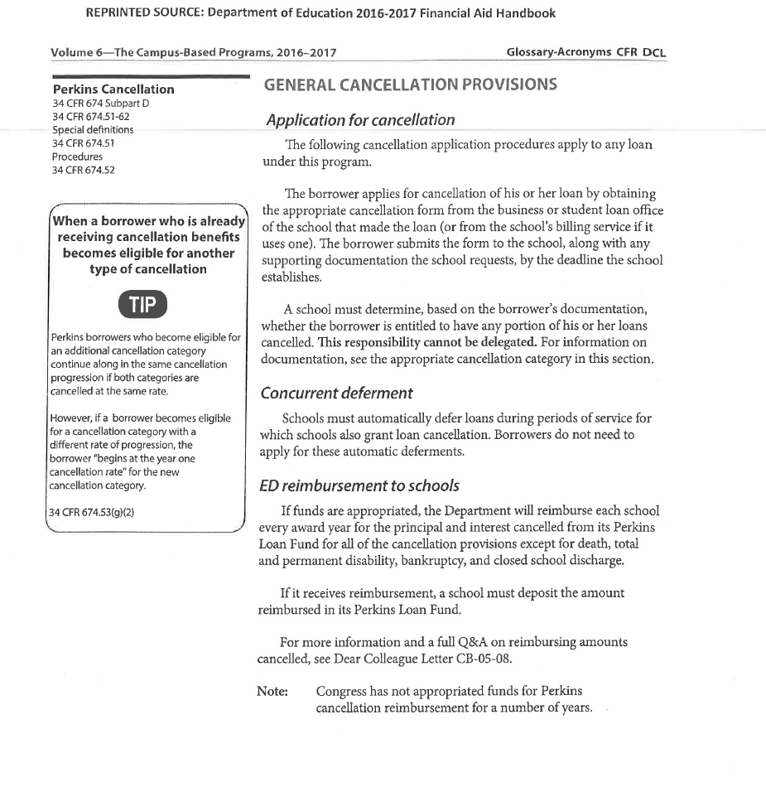
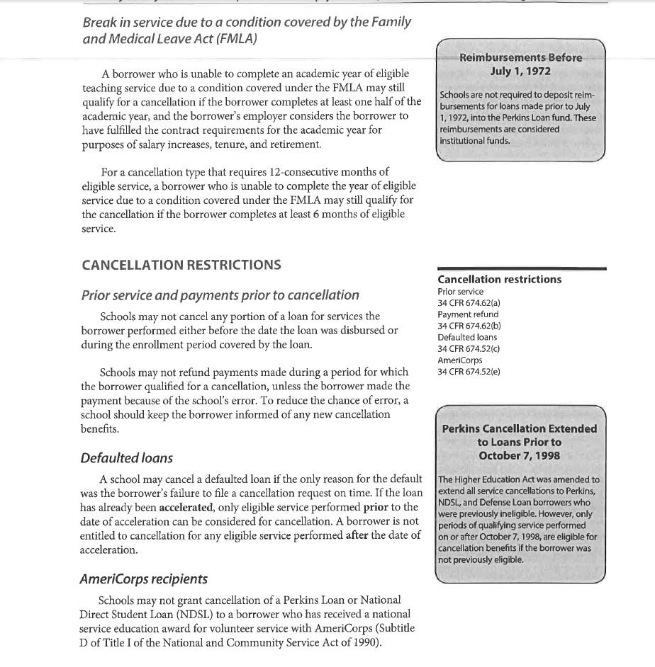
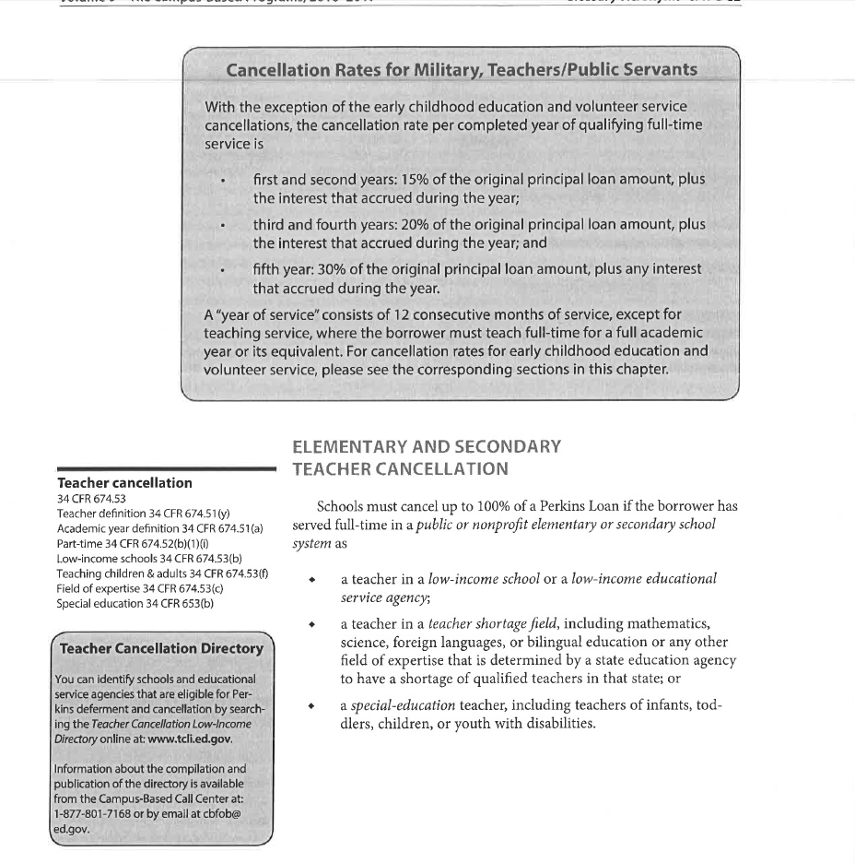
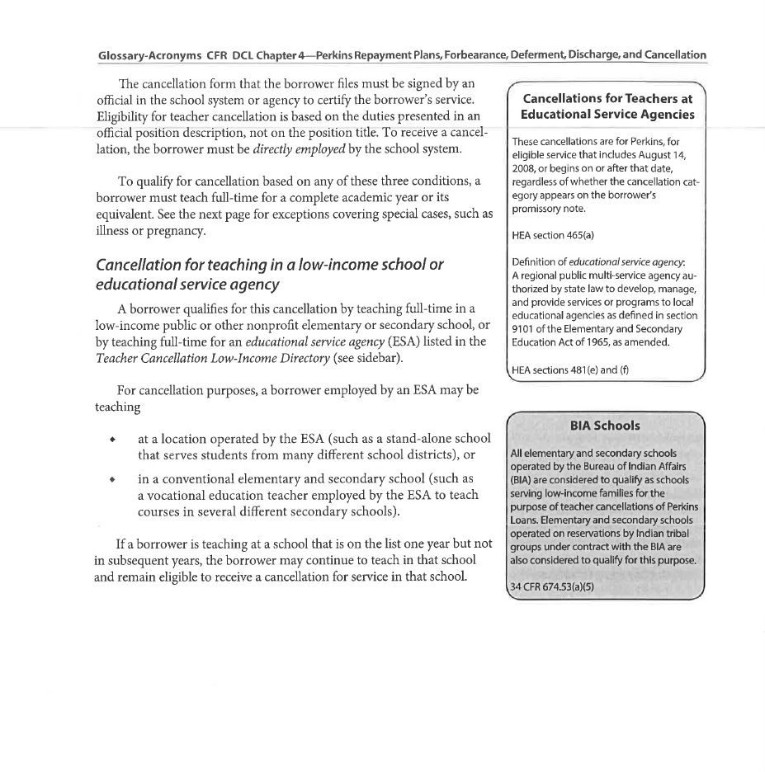
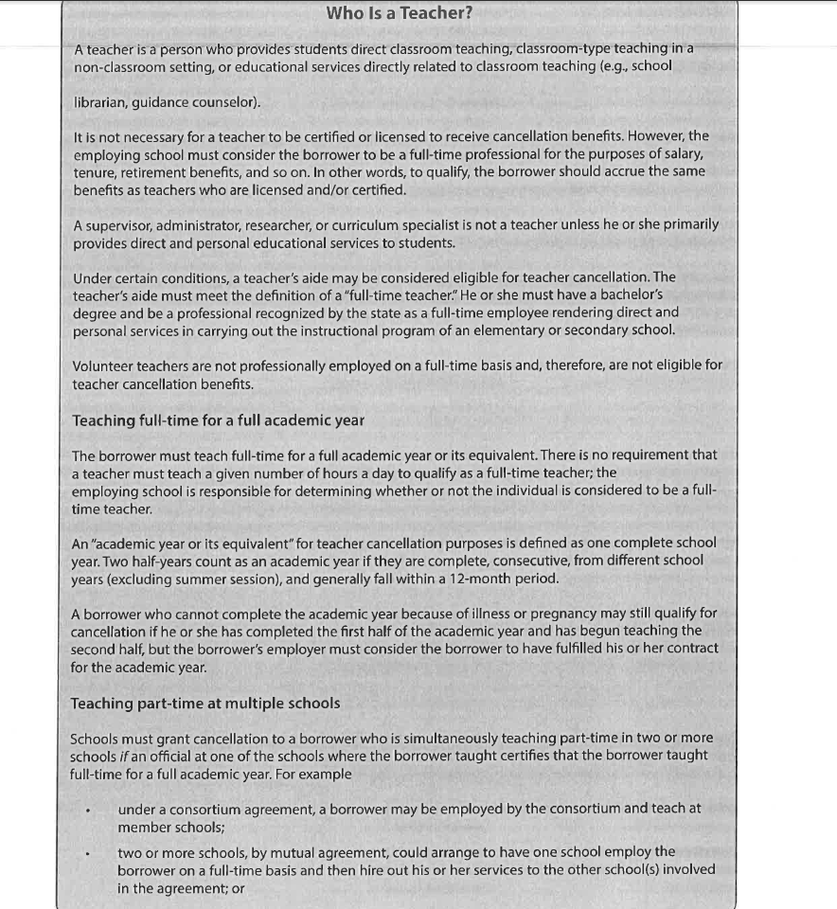
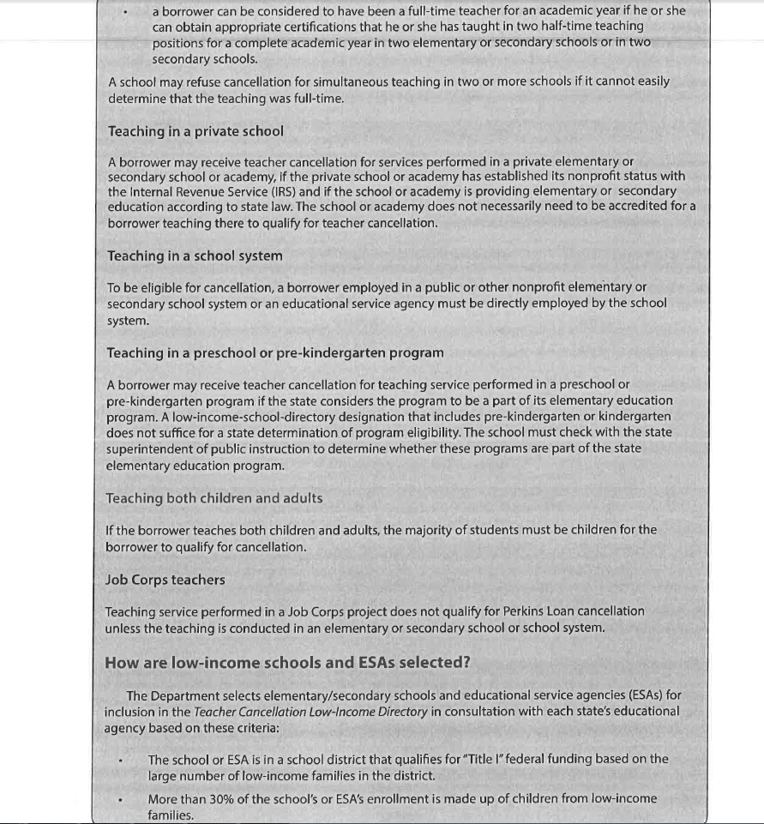
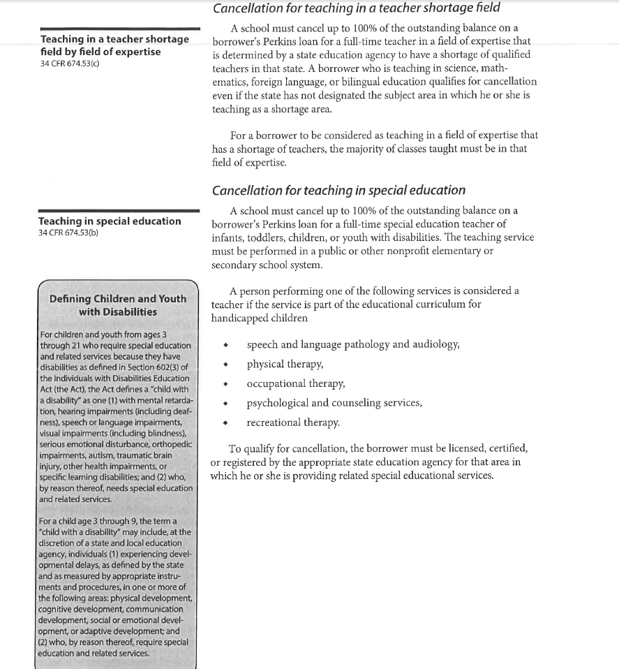
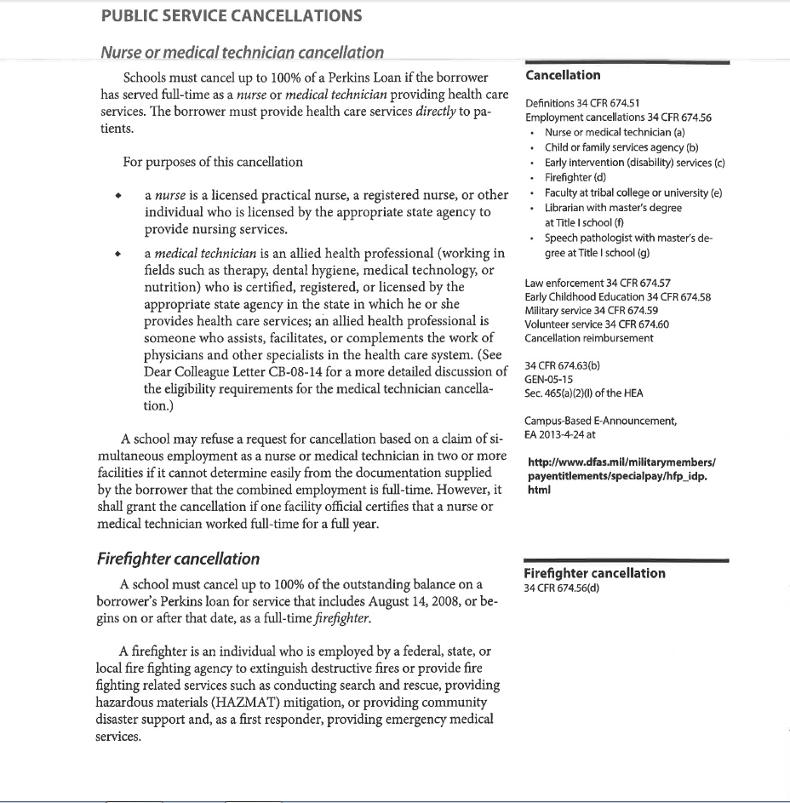
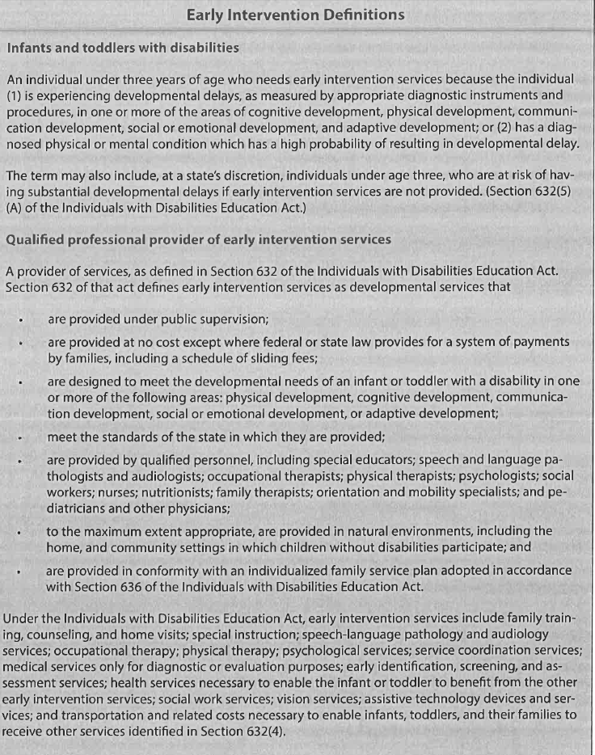
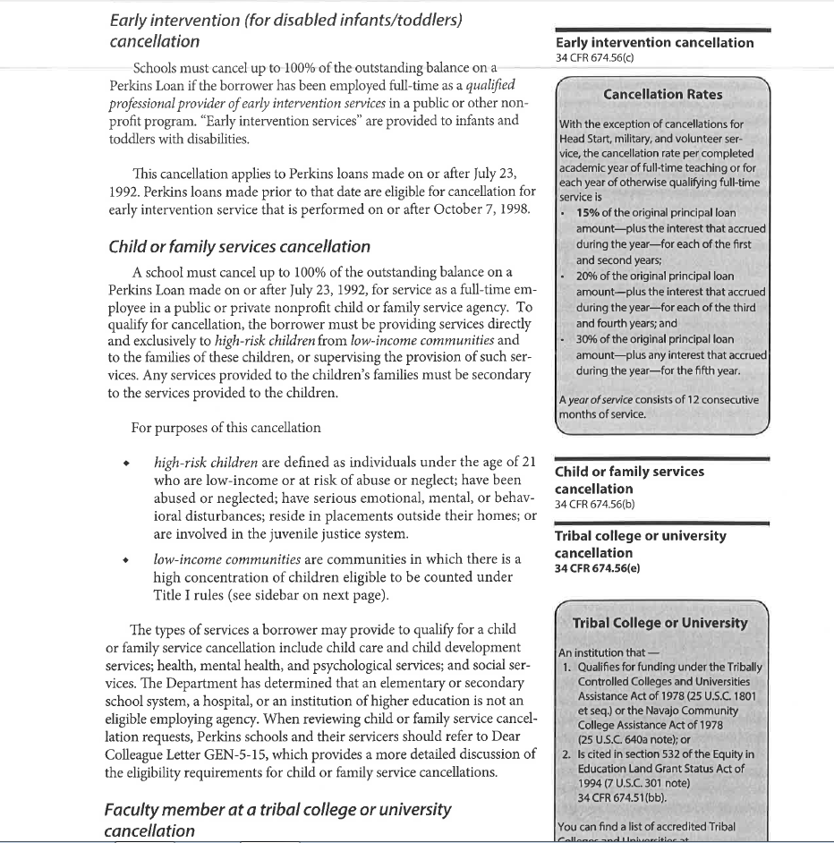
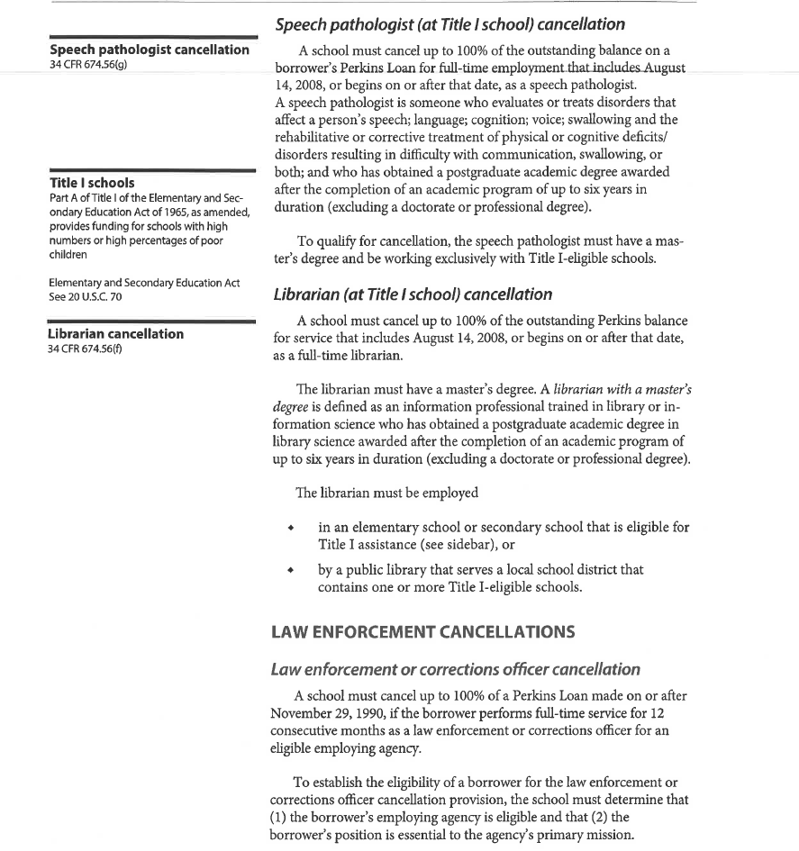
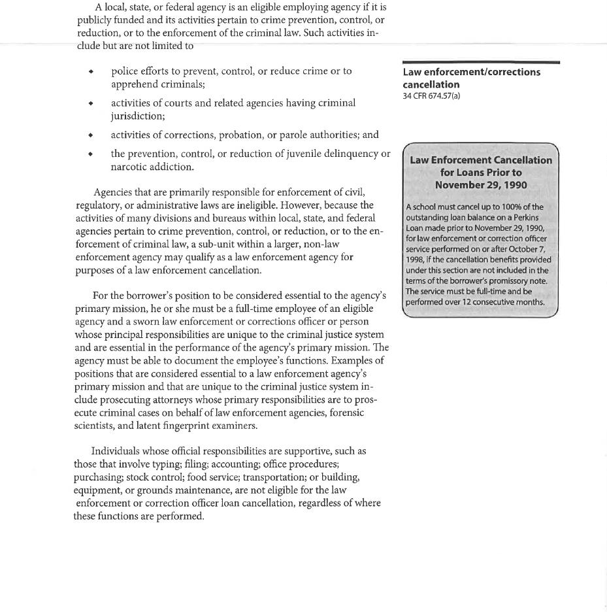
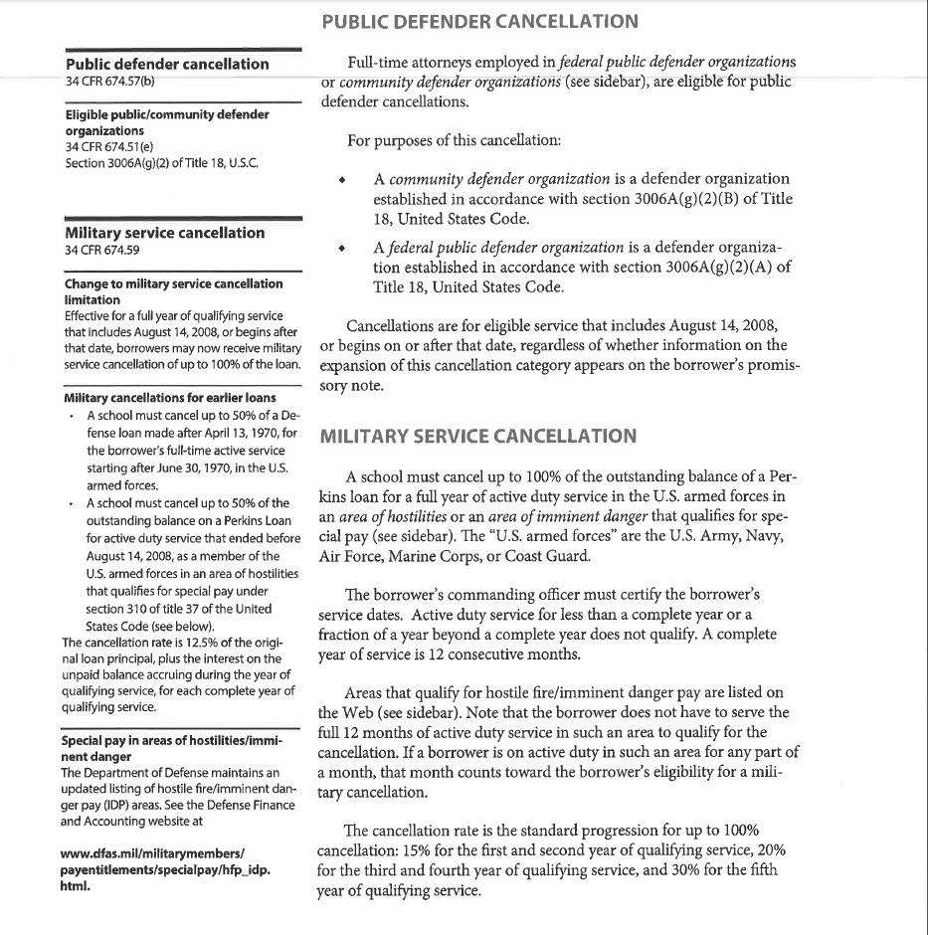
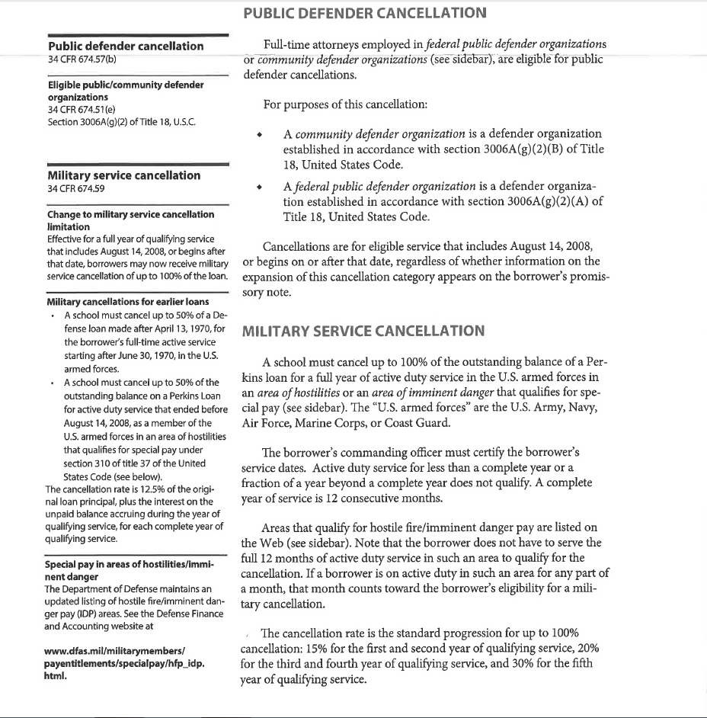
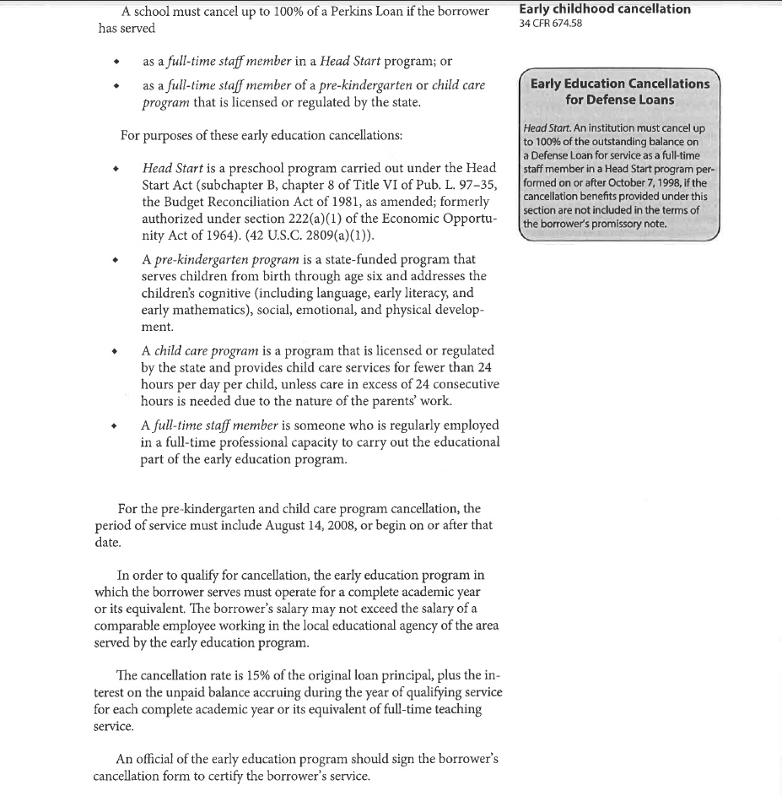

1

