[Name and Address of Medical Resident]

Re: Medical Resident FICA Refund Claims

Dear Sir or Madam,

I am pleased to inform you that as a result of Thomas Jefferson University Hospitals, Inc. and Thomas Jefferson University’s continued diligence in pursuing and filing refund claims with the IRS, we are expecting refunds of the social security and medicare taxes that were withheld from your pay during your residency for periods prior to April 1, 2005. These taxes are Federal Insurance Contributions Act (FICA) taxes and the claims are referred to as Medical Resident FICA Refund Claims (or MR claims).

On March 2, 2010, the IRS announced it would honor the MR claims. After we perfect our MR claim(s), the IRS will have to approve and verify the amount of the MR claim(s) and begin issuing refunds plus statutory interest. We cannot receive a refund of the FICA taxes that were withheld and paid on your behalf unless we have your written consent. If you do not consent to have Thomas Jefferson University Hospitals, Inc. and/or Thomas Jefferson University obtain your refund, you may be precluded from receiving any refund of the FICA taxes withheld and paid on your behalf because the time period for filing an individual claim for refund with the IRS may have expired.

If the IRS approves the MR claim(s) and you consent, Thomas Jefferson University Hospitals, Inc. and/or Thomas Jefferson University will pay you your FICA tax refund, plus statutory interest, after we receive the refund from the IRS. The FICA tax refund is not taxable; however, the interest on the refund is taxable to you whether or not you receive a Form 1099-INT, Interest Income. Thomas Jefferson University Hospitals, Inc. and/or Thomas Jefferson University is required to file Form 1099-INT with the IRS and furnish a copy to you if we pay you interest of $600 or more in a calendar year.

In addition, if the IRS approves the MR claim(s), Thomas Jefferson University Hospitals, Inc. and/or Thomas Jefferson University will file Form W-2c, Corrected Wage and Tax Statement, with Social Security Administration (SSA), and furnish a copy to you for each tax year for which you receive a refund of FICA taxes. In most cases, Form W-2c will show a reduction in your earnings for social security coverage purposes in an amount equal to all the wages you were paid for services performed as a medical resident. Social security benefits are based on your earnings over your working lifetime. Accordingly, based on your personal circumstances, a refund could have a detrimental effect upon disability, survivors, or retirement benefits that you, or your family, are receiving or may seek to receive in the future. If you want information about the effect on your social security benefits, you should contact SSA directly at 1-800-772-1213 (toll free). If you call or visit a Social Security office, please have this letter with you. It will help SSA answer your questions. You might want to review your social security record before and after your refund has been processed. You can use your current Social Security Statement or you can request a copy of your Social Security Statement at the following link: http://www.ssa.gov/mystatement .

To consent to receive your share of the refund from Thomas Jefferson University Hospitals, Inc. and/or Thomas Jefferson University, you must complete the enclosed Employee Consent Form and send it to Thomas Jefferson University Hospitals, Inc. and/or Thomas Jefferson University at the address shown at the bottom of the consent form. Your consent form must be postmarked no later than Friday, September 24, 2010.

If you have already claimed and received a refund or credit for FICA taxes that were withheld from medical resident wages, or if you filed an individual refund claim for such FICA taxes and that claim is still pending with the IRS, then we will not be able to file your MR claim for the year(s) that you received a refund or credit or have a pending refund claim. This restriction does not apply if you filed a refund claim and it was rejected by the IRS. If we can file your MR claims for some years, but not others, check “Yes” for the years you are eligible or “No” for the years you are not eligible.

If you consent to be part of Thomas Jefferson University Hospitals, Inc. and/or Thomas Jefferson University's MR claim and the IRS determines that you are ineligible for a refund because you already received a refund based on an individual claim you filed, the IRS will not refund your share to us and this information may be disclosed to us.

If you have any questions about this letter, please contact Robert A. Raucci, Director of Operations, at 215-503-2899 or email tjuh_mrfica@us.pwc.com. You may also visit our website, http://www.jefferson.edu/controller/departments/FICArefundformedicalresidents.cfm, for additional information and for updates.

Very Truly Yours,
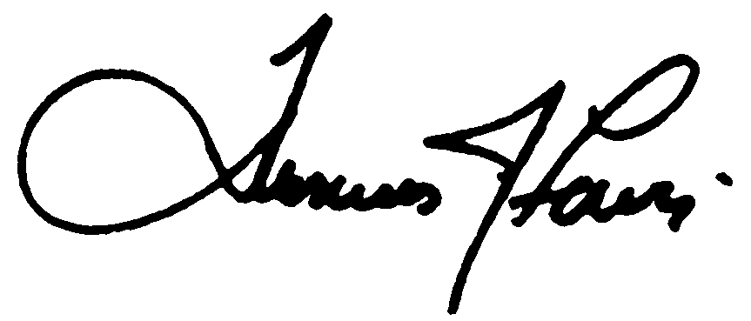
Thomas J. Lewis
President and Chief Executive Officer
Thomas Jefferson University Hospitals, Inc

