Concur Training Site

<https://www.concursolutions.com/expense/client/view_training.asp>

Concur Support Email

[Concur@Jefferson.edu](mailto:Concur@Jefferson.edu)

Concur Support Hotline

(215) 503-2020

M-F: 10am-5pm

# Welcome to Concur

Concur provides tools to book travel as well as create and submit expense reports. Managers use the service to review and approve expense reports and back-office employees use the service to produce audit reports, ensure compliance, and deliver business intelligence.

# Section 1: Log on to Concur

|  |  |  |
| --- | --- | --- |
|  |  | Additional Information |
| 1. Log on to Concur. |  | Using your campus key and password, access Concur through the intranet link, pulse or via [concur.jefferson.edu](https://concur.jefferson.edu/simplesaml-concur/module.php/core/loginuserpass.php?AuthState=_7a9e73a49f811f7f6c3c93d022daa7dd141a0bc3cd%3Ahttp%3A%2F%2Fconcur.jefferson.edu%2Fsimplesaml-concur%2Fsaml2%2Fidp%2FSSOService.php%3Fspentityid%3DConcur%26cookieTime%3D1461181305). If you search for Concur and access the concursolutions.com page, you will not be able to login.  You cannot change your password for Concur. |

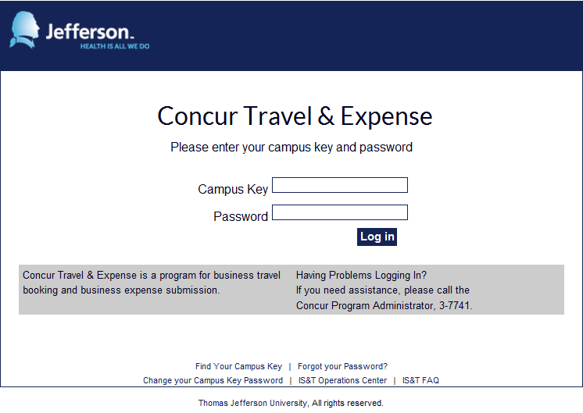

# Section 2: Explore the Concur Homepage

The Concur homepage includes several sections that make it easy for you to find the information you need.

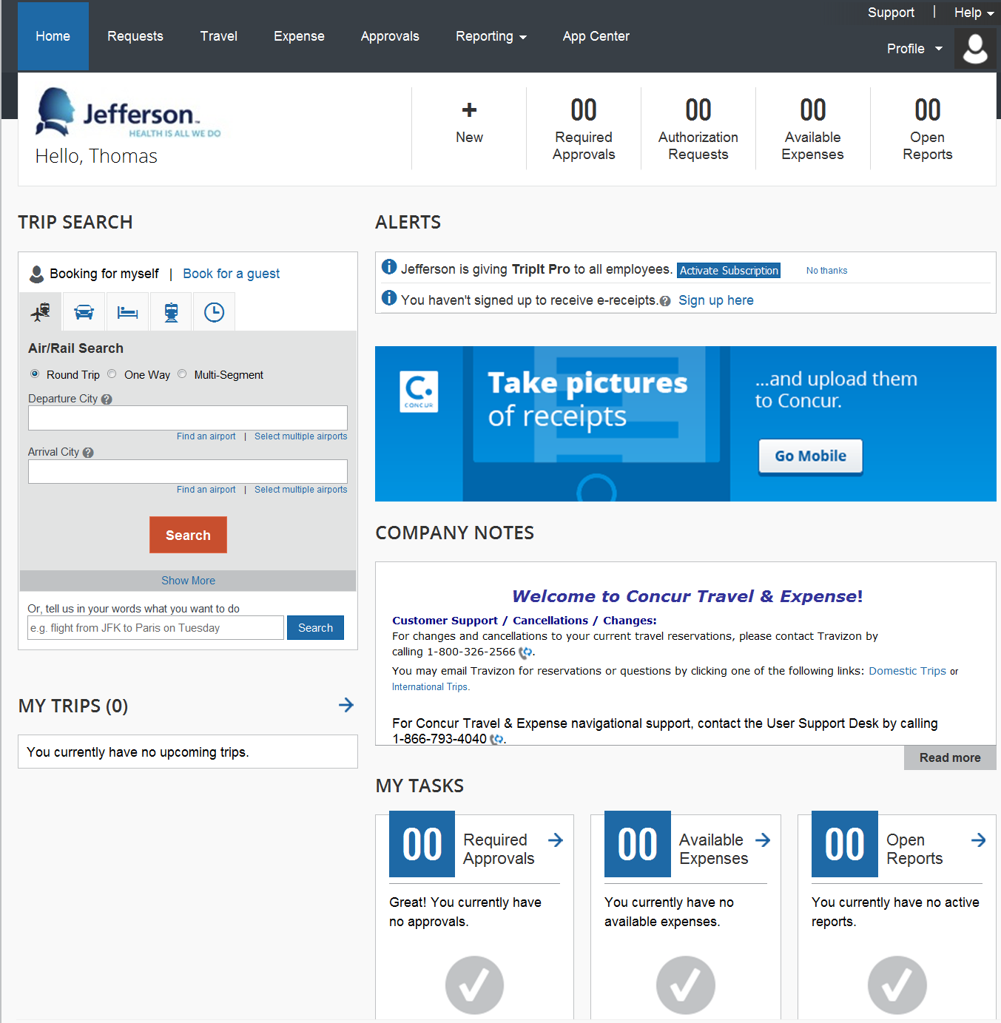

|  |  |  |
| --- | --- | --- |
|  |  | Additional Information |
| The **Trip Search** section. |  | This section provides a portal through which you may obtain pricing and book a trip with any or all of these: flight, rail, car and hotel. You may also search for travel and book outside of the system, provided you secure more competitive pricing.   * If you book outside of system, you must catalog comparative rates. |
| The **Company Notes** section. |  | This section displays important system announcements and links updated by Jefferson. |
| The **My Tasks** section. |  | This section provides links to view your existing reports and requests in addition to expenses that have not yet been reconciled. If you are an approver, this section will also include items pending approval. |
|  | | |
| The **Approvals** sectionappears on My Concur only if you are an Expense approver and if you have received at least one item for approval. |  | This section lists the expense reports awaiting your review and approval as well as any travel authorization or cash advance requests. |
|  | | |
|  |  |  |
| The **My Trips** section. |  | This section lists any outstanding trips and appears only after booking. |
|  | | |
| The **Trips Awaiting Approval** section appears on My Concur only if you are a travel approver. |  | This section lists the trips awaiting your approval. |

|  |  |  |
| --- | --- | --- |
|  |  |  |
| Explore the **Available Expenses** section. |  | This section lists all imported credit card transactions and expenses created in the Concur mobile application. |

### 

### Section 3: Update Your Travel Profile

You must update your profile prior to using Concur Travel.

# Step 1: Change System Settings and Email Preferences

|  |  |  |
| --- | --- | --- |
|  |  | Additional Information |
| 1. From any page, click **Profile** at the top of the page. |  |  |
| 1. On the **Profile** submenu, click **Profile Settings**. |  |  |
|  |  |  |

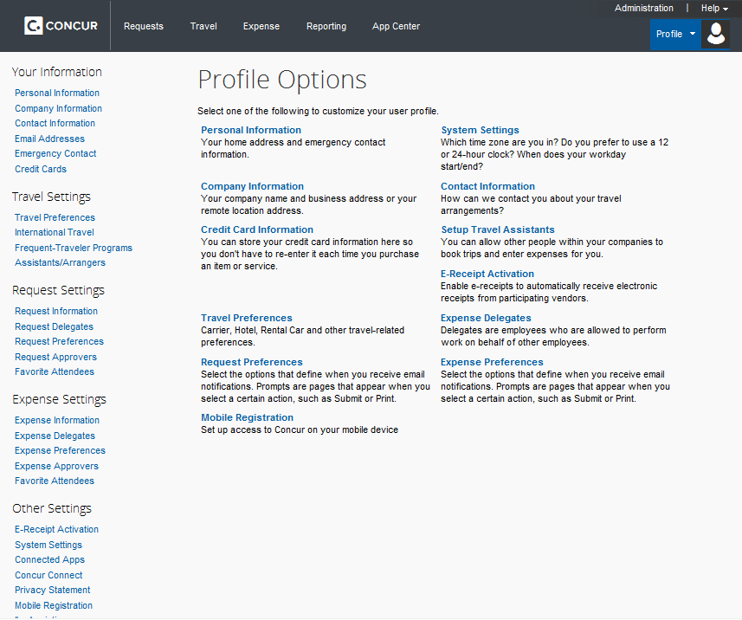

|  |  |  |
| --- | --- | --- |
| 1. On the **System Settings** page, configure your email preferences, and then click **Save**. |  | Rather than monitoring Concur for changes in approval status, you may configure automated emails to provide status updates. |

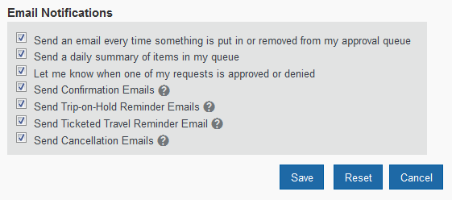

# Step 2: Update Your Personal Information

|  |  | Additional Information |
| --- | --- | --- |
|  |  |  |
| 1. On the **Profile** Options page, click **Personal Information**. |  |  |
| 1. On the **My Profile – Personal Information** page, update the appropriate information, and then click **Save**. |  | Some sections of your travel profile will be prepopulated. If any of the prepopulated data is incorrect, please update that information in HR Self Service; information will be transmitted to Concur the following evening. You must complete all fields marked **Required** to save your profile.  **Be certain to verify that the first and last name fields match the government-issued ID you will use to travel.**  You may also add discount club memberships, frequent flier programs and emergency contacts. |

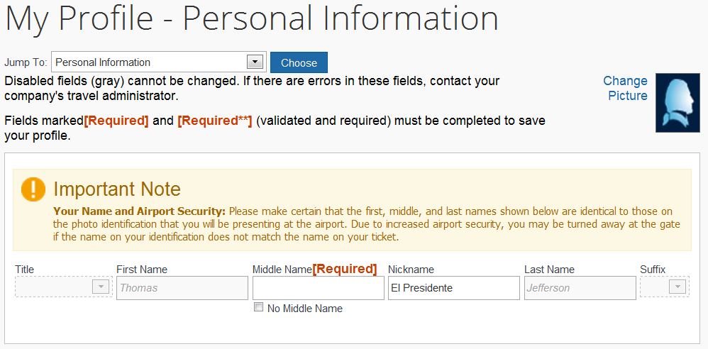

### Step 3: Set Up a Travel Arranger or Assistant (Optional)

|  |  | | Additional Information |
| --- | --- | --- | --- |
| 1. On the **My Profile** page, click **Assistants/Arrangers** on the menu at the left of the page. |  | | Use **Assistants/Arrangers** to give other users the ability to view and modify your travel profile or book travel for you. |
|  | | | |
| 1. Click **Add an Assistant** to search for your assistant’s last name. |  |  | |
| 1. Click on your assistant’s name |  |  | |
|  | | | |
| 1. Select **Can Book Travel for Me**. |  |  | |
| If applicable, select **Is My Primary Assistant for Travel**   1. Click **Save**. 2. The program administrator can give certain employees the ability to add themselves as any traveler’s assistant. If you do not wish for these employees to add themselves to your list of assistants, check the “Refuse Self Assigning Assistants” box. |  |  | |

# Section 4: Obtain Travel Approval

### Step 1: Submit a Travel Request

|  |  | Additional Information |
| --- | --- | --- |
| 1. Click **Requests** at the top of the page |  |  |
| 1. Click **New Request** |  |  |

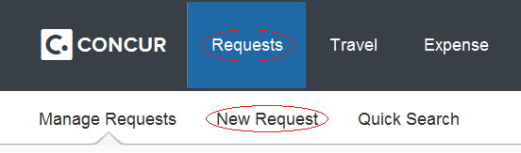

|  |  |  |
| --- | --- | --- |
| 1. On the **Request Header** tab, complete all required fields. |  | Required fields are indicated with a red highlighted left border.  If the request will be charged to a sponsored project, select “yes” from the **Grant** dropdown menu. |
| 1. If requesting a cash advance, indicate the amount in the appropriate field and provide justification as to why a cash advance is necessary, in the **Purpose** field. |  | The Cash Advance **Purpose** is required only if a cash advance is being requested. |

# 

|  |  |  |
| --- | --- | --- |
| 1. Click on the **Segments** tab and provide your anticipated expenses. |  | Click the appropriate icon (air, rail, rental car, hotel), complete all fields and click save each time, repeating as necessary. |

# 

|  |  |  |
| --- | --- | --- |
| 1. If additional expense types are anticipated, click the **Expenses** tab, select the expense type and assign an associated amount. |  |  |
| 1. When finished, click **Submit Request**   After you click **Submit Request**, a popup window will appear. If you would like to view the travel policy, please be certain to hold down the CTRL button on your keyboard while clicking. Failure to do so will navigate you away from the page. | w |  |
| 1. Click **Accept & Submit** |  | Your travel request will be automatically routed to your default approver. You can monitor the status of your request in Concur and you may book your trip upon receipt of approval. |

# 

# Section 5: Make a Travel Reservation

### Step 1: Make a Flight Reservation

|  |  | Additional Information |
| --- | --- | --- |
| 1. In the **Trip Search** section of the homepage, click the **Air/Rail** tab. |  | If you have a car, hotel or rail to book without air/rail, use the corresponding tabs. |
| 1. Select one of the following types of flight options:  * Round Trip * One Way * Multi-Segment |  | If you wish to book airfare for a spouse, partner, guest or child, you must first contact the program administrator to request “guest booking permissions.” You may then select the **Book for a guest** option, before following the procedure below and paying via personal means.   * Users **cannot** book travel arrangements for themselves and for guests at the same time. * Users **must** complete their reservations before booking for a guest and may only book for one guest at a time. |

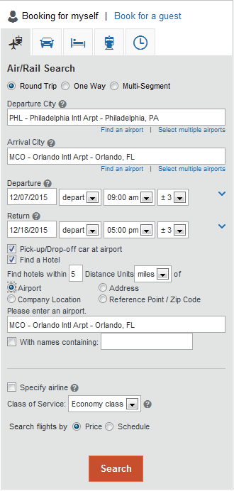

|  |  |  |
| --- | --- | --- |
| 1. In the **Departure City** and **Arrival City** fields, enter the cities for your travel. |  | When you type in a city, airport name, or code, Travel will automatically search for a match. |
| 1. Click in the **Departure** and **Return** date fields, and then select the appropriate dates from the calendar. |  | You can also modify the **Departure** and **Return** times and range. |
| 1. If you need a rental car, select the **Pick-up/Drop-off car at Airport** checkbox. |  |  |
| 1. If you need a hotel, select the **Find a Hotel** checkbox. |  | You can choose to search for the hotel by:   * Airport * Address * Company Location * Reference Point / Zip Code |
| 1. Select **Search flights by Price** or **Schedule.** |  | The forward tab that you see on the search results screen will depend on which you select. |
| 1. Click **Search**. |  | To filter the results, select a column, row, or cell in the airline grid at the top of the results screen or use the sliding scales on the right. You can easily switch between **Shop by Fares** and **Shop by Schedule** by clicking on the tab corresponding tab.  You can also click the **more like this** link, and then select either **Outbound flight** or **Return flight** to view more options for the selected flight. |
| 1. Review the search results on the **Shop By Fares** tab, and then click **Show Details**. |  | Click **show details** to expand flight information, to view fare rules and, if needed, to add or choose a different frequent flier program. Concur automatically selects the corresponding frequent flier program from the profile, if available.  To choose your seat assignment, click the **Select Seats** button next to the flight. A key appears at the bottom of the page, showing which seats are available, occupied, or considered preferential. |
| 1. Select any available seat and click the seat to see the seat number. |  | Select preferential seats if you have preferred status on the selected airline. Your frequent flyer number must be in your Travel profile. If you select a preferential seat and this information is not in Travel, your seat request might not be honored. |

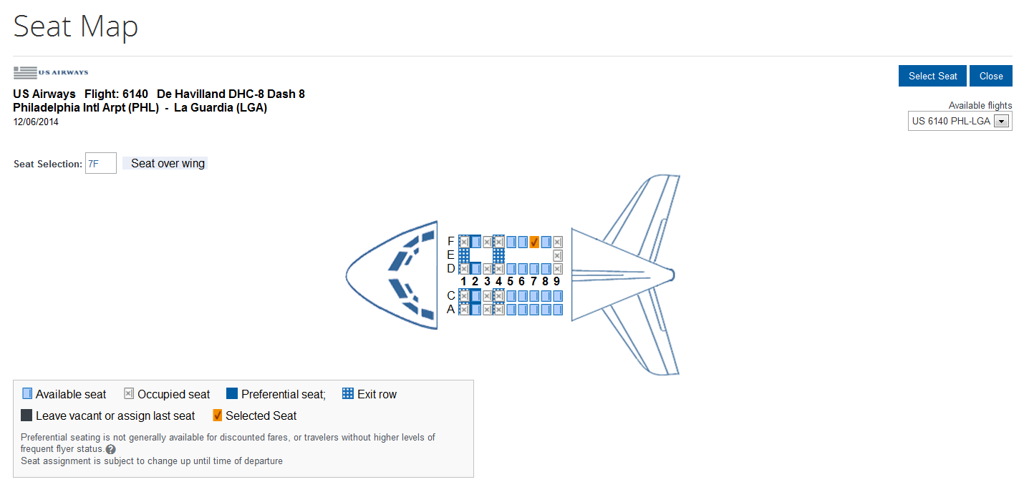

|  |  |  |
| --- | --- | --- |
| 1. Click the appropriate seat to select it, and then click **Select Seat**. |  | To change your seat, click the seat you prefer. |
| 1. Once you have made your seat selection, click **Close**. Repeat for all flights. |  |  |
| 1. From the **Shop By Fares** tab, click **Select** to select your airfare. |  | * A *green* **Select** button indicates that the fare is the least expensive result matching the search criteria you provided. This does not mean that the result is policy-compliant though and you may be required to expand your search criteria to obtain more economical rates. * A *yellow* **Select** button indicates the fare is outside of policy. If you select this fare, you must enter additional information and provide a justification as to why the selection is necessary. |

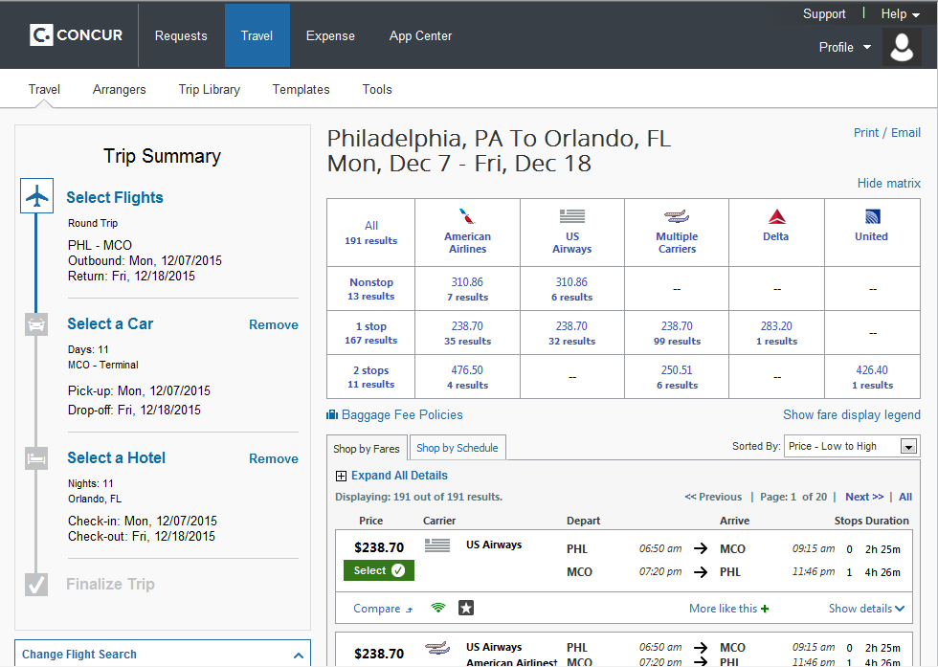

# Section 5: Make a Travel Reservation (Continued)

### Step 2: Select a Car

|  |  | Additional Information |
| --- | --- | --- |
| 1. If you selected **Pick Up/Drop off Car at airport** on the **Flight** tab, you will see the results for the car search. |  |  |
| 1. Select the most economical rental car, and then click **Reserve**. |  | You can sort the car results to help find your selection. |

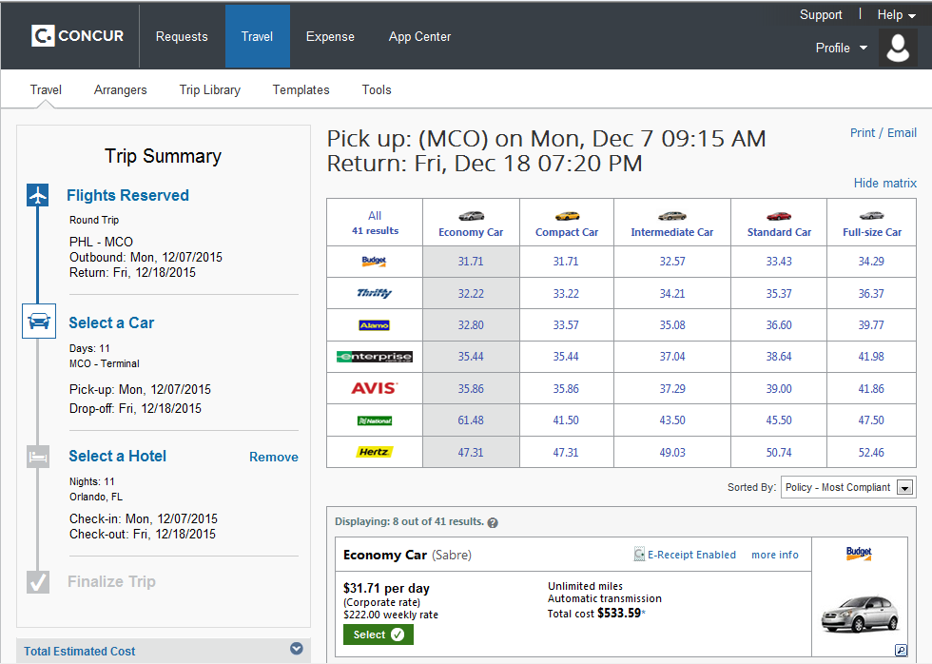

# Section 5: Make a Travel Reservation (Continued)

### Step 3: Select a Hotel

|  |  |  |
| --- | --- | --- |
|  |  | Additional Information |
| 1. If you selected the **Find a Hotel** option on the **Flight** tab, the hotel results appear after you choose your rental car. |  | You can sort the list of hotels by **Preference**, **Price**, **Rating**, **Distance** and **Policy**. |
| 1. To filter by hotel chain, enter the chain name in the **With names containing** box next to the **Sorted by** box |  | To filter by multiple chains, in the **Hotel chain** box on right, click **hide all** and then select only the chains you want displayed. |
| 1. Use the filter options to narrow your search by **Amenity** or **Chain**. |  |  |
| 1. To filter by neighborhood, select the desired neighborhoods in the **Neighborhood** box on the right. |  | A map of hotels appears at the top of the page. |
| 1. Click the **more info** link for a specific hotel to find more detailed information for the hotel. 2. Click **choose room** to view room rates. |  |  |
| 1. When you are ready to reserve your hotel room, click the radio button next to the desired room type, and then click **Reserve**. |  | The **Reserve** buttons are color coded as follows:   * A *green* **Select** button indicates that the fare is the least expensive result matching the search criteria you provided. This does not mean that the result is policy-compliant though and you may be required to expand your search criteria to obtain more economical rates. * A *yellow* **Select** button indicates the fare is outside of policy. If you select this fare, you must enter additional information and provide a justification as to why the selection is necessary.   You will see a notification if a hotel is outside of policy. You can view the type of rate and room, as well as other information that is available from the agency system.  After clicking the **Reserve** button, the hotel confirmation page appears. |
| 1. Review the information on the **Rate details/Cancellation policy** pop-up window, click to agree**,** and then click **Continue.** |  |  |

### Step 3: Select a Hotel (Continued)

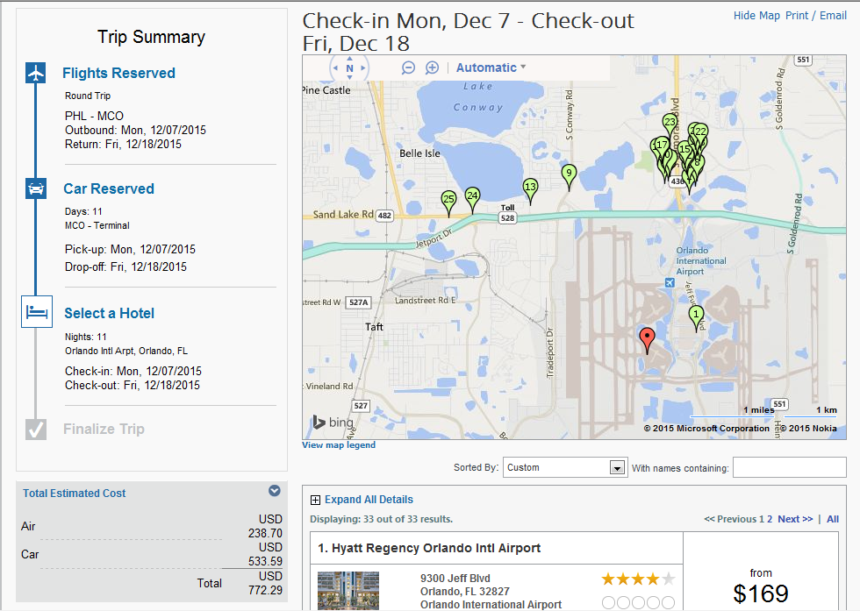

### Step 4: Complete the Reservation

|  |  |  |
| --- | --- | --- |
|  |  | Additional Information |
| 1. Review the details of the reservation, and then click **Next**. |  | From here, you can add or make changes to the car, hotel as well as change the dates of the flight. You may also add Parking at this time. |
|  | | |

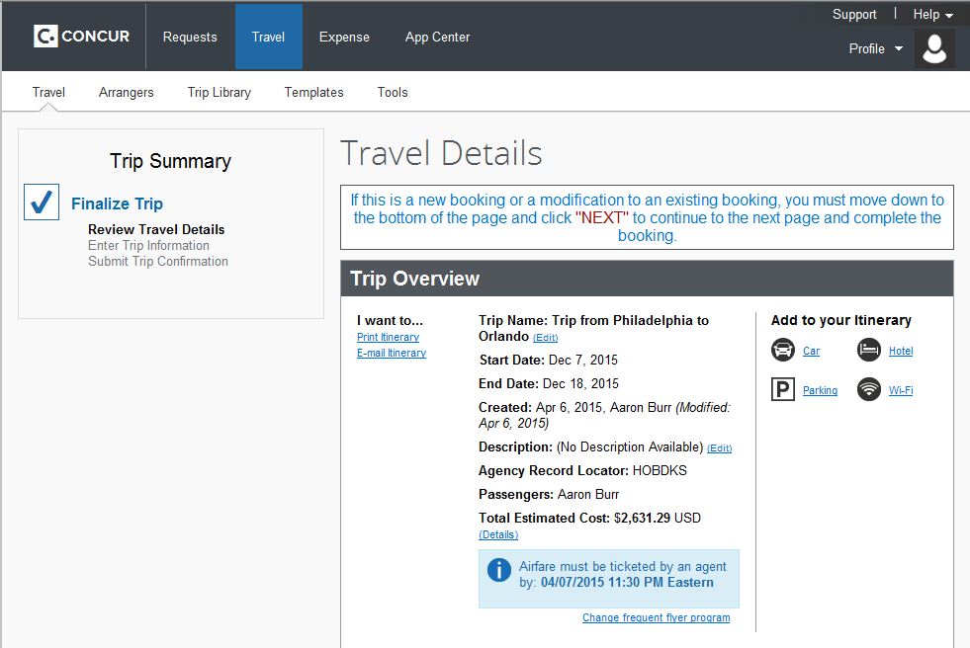 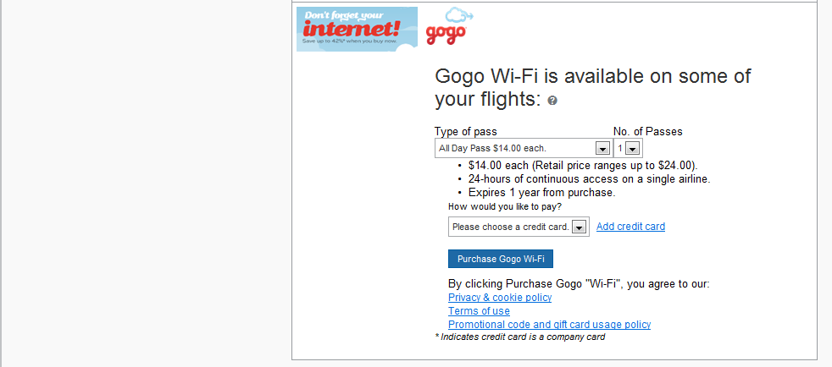 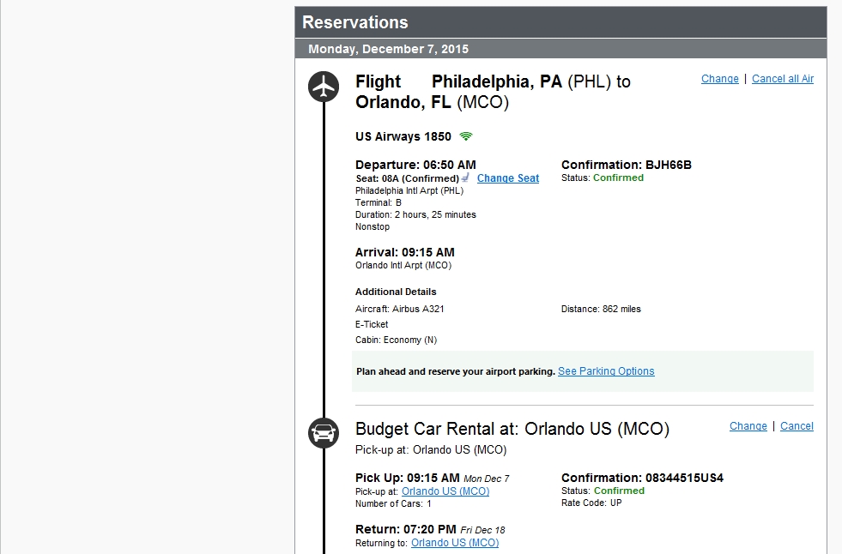 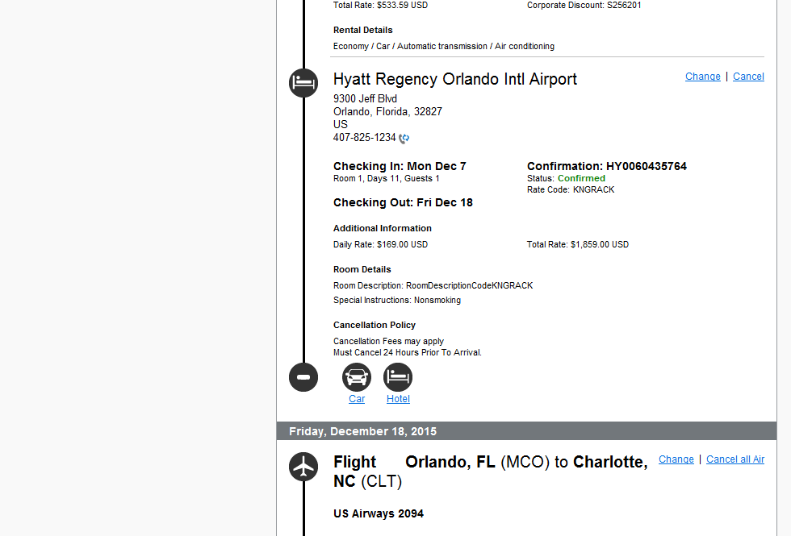 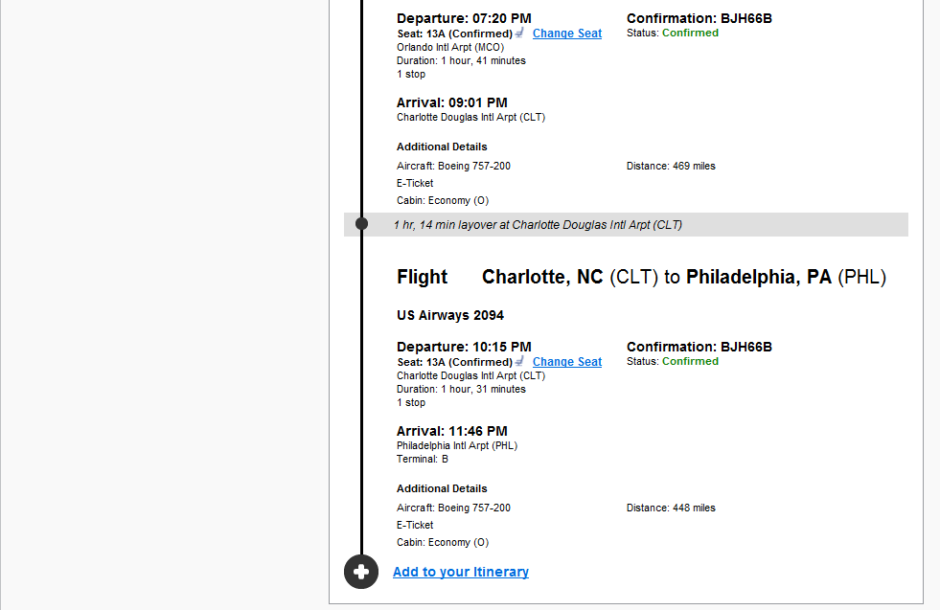 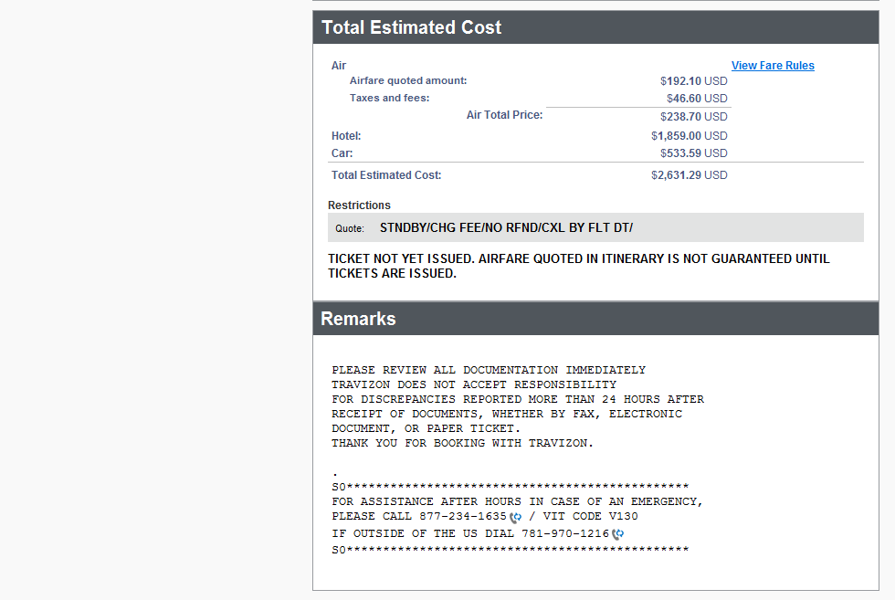 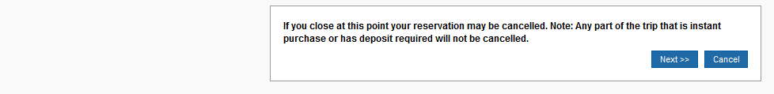

|  |  |  |
| --- | --- | --- |
| 1. On the **Enter Trip Information** page, enter your trip information in the **Trip Name** and **Trip Description** fields. |  | The trip name and description data are for your record keeping. **You must enter your approved travel request number on this page.** |
|  | | |
|  |  |  |
| 1. Click **Next.** |  | You will see the name and itinerary, along with the quoted airfare amount. |
| 1. Click **Purchase Ticket** to finalize your trip. |  |  |

# Section 6: Cancel or Change an Airline, Car Rental, or Hotel Reservation

|  |  |  |
| --- | --- | --- |
|  |  | Additional Information |
| 1. At the top of the **My Concur** page, click **Travel**. |  |  |
| 1. On the **Upcoming Trips** tab, click the name of the trip you want to change. |  | Flight changes are available for e-tickets that include a single carrier.  If the trip is already ticketed but has not occurred, you can change the time and/or date of the flight. Your change options will be with the same airline and routing.  Trips booked outside of Concur travel cannot be modified in Concur. |

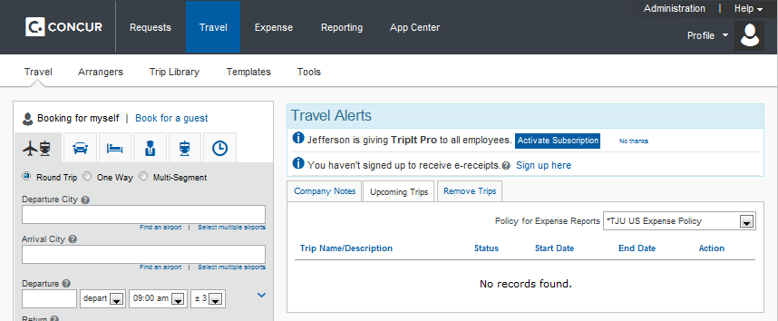

|  |  |  |
| --- | --- | --- |
| 1. From the **Upcoming Trips** menu, click **Change Trip**. |  |  |
| 1. On the **Itinerary** page, select the portion of the trip you want to change. |  | From the **Itinerary** page, you can:   * Email your itinerary * Change seat * Change the flight day or time for travel (you cannot change the airline) * Add, change, or cancel car rental * Add, change, or cancel hotel |
| 1. To cancel your entire trip, click the **Upcoming Trips** tab. |  | When you cancel a trip, if your ticket is refundable, your ticket will be voided or refunded, as applicable. If your ticket is non-refundable, and you cancel it in accordance with the airline rules, an e-ticket will be retained that you can apply to future trips. |
| 1. From the **Trip Actions** menu, click **Cancel Trip**, and then click **OK**. |  |  |

# Section 7: Update Your Expense Profile

### Step 1: Review Your Expense Settings

|  |  |  |
| --- | --- | --- |
|  |  | Additional Information |
| 1. In the left-hand navigation of the **Profile** page, in the **Expense** **Settings** section, click **Expense Information**. |  | The **Expense Information** page is read-only. If the information needs to be changed, contact your site administrator. |

### Step 2: Add a Delegate (Optional)

|  |  |  |
| --- | --- | --- |
|  |  | Additional Information |
| 1. In the **Expense Settings** section, click **Expense Delegates**. |  | The **Expense Delegates** page appears.  From this page, you may give other users the ability to prepare, submit, approve, view receipts and review or approve reports, on your behalf. |
| 1. Click **Add Delegate**. |  |  |
| 1. In the **Search by employee name, email address or logon id** field, type the last name of the delegate you wish to add. |  | As you begin to type the name, Expense provides a list of users to select from. |
| 1. Click the name of the delegate from the list. |  |  |
| 1. Click **Add**. |  |  |
| 1. Select the appropriate task checkboxes. |  | The delegate can only perform the tasks you select. A delegate must be an approver to approve reports on your behalf. |
| 1. To add additional delegates, repeat steps 2-6. |  |  |
| 1. Click **Save**. |  | You can see if others have added you as their delegate by clicking the **Delegate For** tab. |

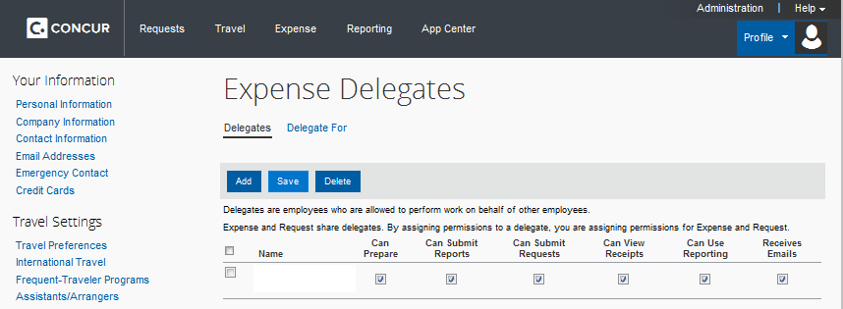

# Section 7: Update Your Expense Profile (Continued)

### Step 3: Select Expense Preferences

|  |  |  |
| --- | --- | --- |
|  |  | Additional Information |
| 1. In the **Expense Settings** section, click **Expense Preferences**. |  | From this page, you can specify when you will receive email notifications and prompts. |
| 1. In the **Send email when** section, select the applicable checkboxes. |  | In this section, you determine when you will receive email notifications. |
| 1. In the **Prompt** section, select the applicable checkboxes. |  | In this section, you determine when Expense will prompt you for further action. |
| 1. In the **Display** section, select the applicable checkboxes. |  |  |
| 1. Click **Save**. |  |  |

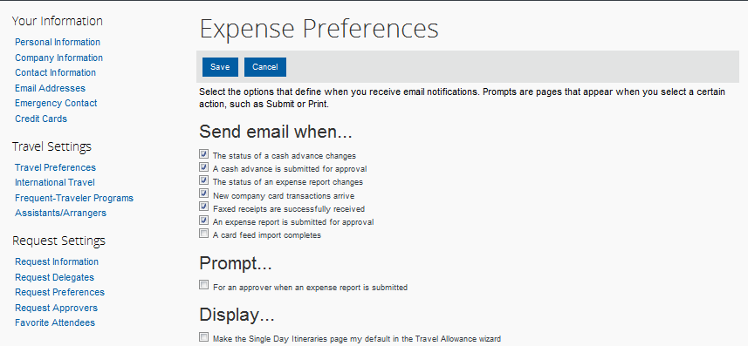

### Step 4: Review Expense Approvers

|  |  |  |
| --- | --- | --- |
|  |  | Additional Information |
| 1. In the **Expense Settings** section, click **Expense Approvers**. |  |  |
| 1. Review your **Expense Approvers**. |  | Verify that the listed approver is correct and notify your system administrator for any needed corrections. |

# Section 7: Update Your Expense Profile (Continued)

### Step 5: Add Favorite Attendees

|  |  |  |
| --- | --- | --- |
|  |  | Additional Information |
| 1. In the **Expense Settings** section, click **Favorite Attendees**. |  | The **Favorite Attendees** page appears, which allows you to add, edit, or delete frequently-used Jefferson and non-Jefferson attendees. |
| 1. Click **New Attendee**. |  |  |
| 1. Select the **Attendee Type** from the list. |  |  |
| 1. Enter the **Last Name** of the attendee. |  |  |
| 1. Enter the **First Name** of the attendee. |  |  |
| 1. Enter the **Attendee Title**. |  |  |
| 1. Enter the attendee’s **Company**. |  |  |
| 1. Click **Save**. |  | If you need to add more than one attendee, click **Save & Add Another**.  Your favorite attendees list is also updated based on attendees you add to your expense reports. |

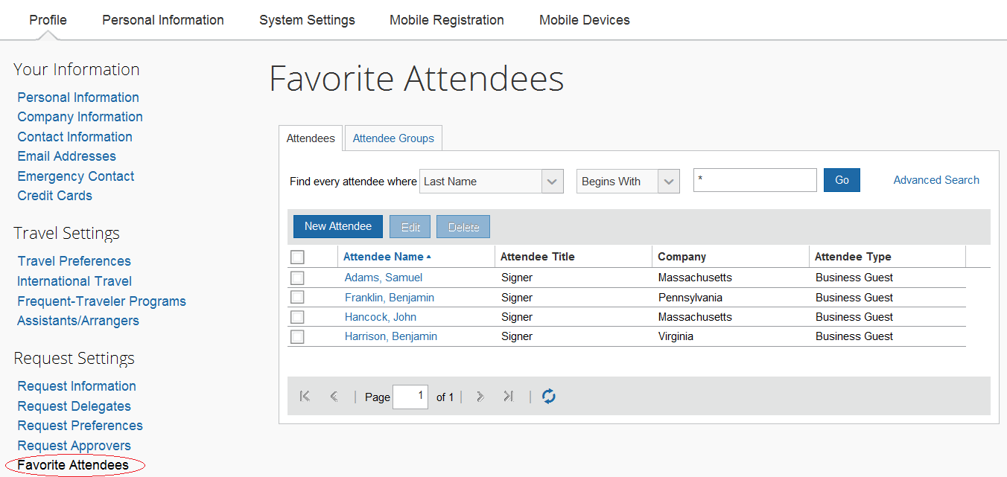

# Section 8: Create a New Expense Report

### Step 1: Create a New Report

|  |  |  |
| --- | --- | --- |
|  |  | Additional Information |
| 1. In the **Active Reports** section of the **Expense** page, click **Create New Report**. |  | The **Create a New Expense Report** page appears. |
|  |  |  |

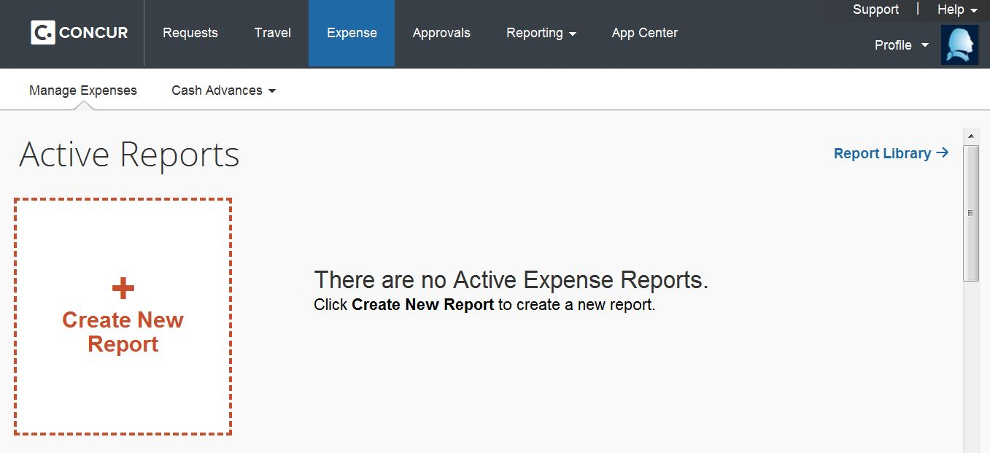

|  |  |  |
| --- | --- | --- |
| 1. Complete all required fields, as indicated by the red bar at the left of the text field. |  | The “Charge Code” field is used as an identifier and does not affect the allocation of the expense report. The “Company,” “Business Unit” and “GL Segment” fields are used to assign a charge code to the entire report. (Individual allocations and itemizations may be applied within the expense report). |

# 

1. **Click** **Next**.**Step 2: Assign a Cash Advance to the New Expense Report (if Applicable)**

|  |  |  |
| --- | --- | --- |
|  |  | Additional Information |
| 1. Reconcile a cash advance within an expense report submission. 2. If you have any outstanding cash advances, a cash advance popup will appear |  | Click the box next to the cash advance(s) you are reconciling and click “Assign Cash Advance to Report” |

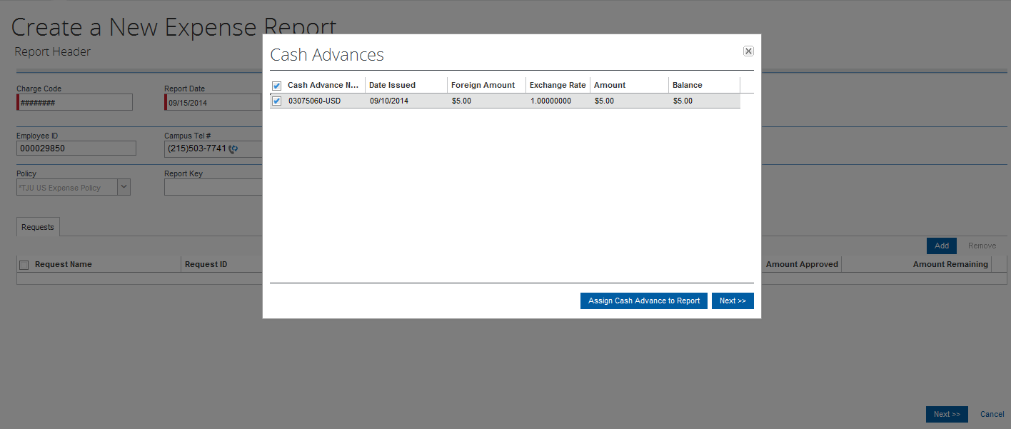

|  |  |  |
| --- | --- | --- |
| 1. **Click** **Next**. |  |  |
|  |  |  |

### Step 3: Add Per Diem Meal Allowances to the New Expense Report (if Applicable)

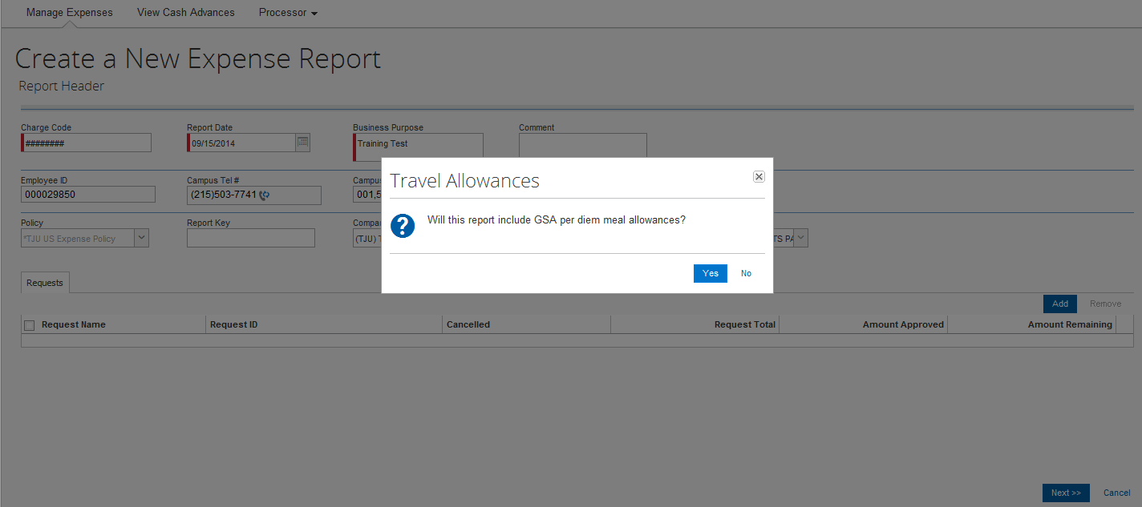

|  |  |  |
| --- | --- | --- |
|  |  | Additional Information |
| 1. Add per diem meal allowances to an expense report. |  | Click yes on the **Travel Allowances** popup. |

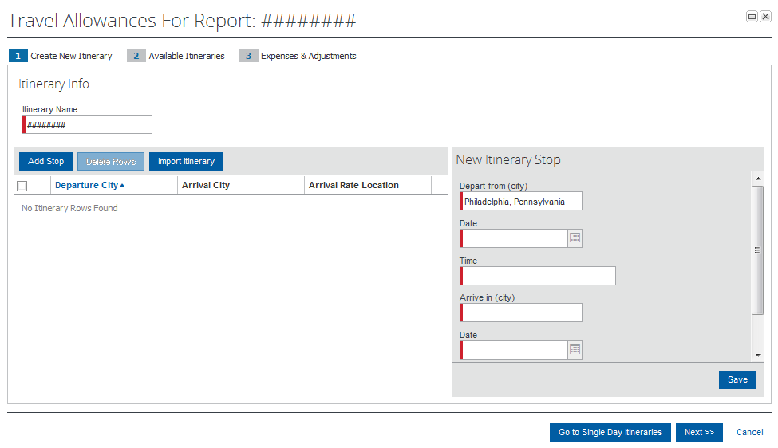

|  |  |  |
| --- | --- | --- |
| 1. Insert departure date data in the **New Itinerary Stop** section. |  | The itinerary you create will automatically calculate applicable per diem meal allowances. |
| 1. Click **Save.** 2. Insert return date data in the **New Itinerary Stop** section. 3. If submitting an expense report containing more than one trip, repeat steps 2-4. |  | The itinerary you create will automatically calculate applicable per diem meal allowances. |
| 1. Confirm that the **Assigned Itineraries** are correct and click **Next.** |  |  |

# Section 8: Create a New Expense Report (Continued)

|  |  |  |
| --- | --- | --- |
|  |  |  |

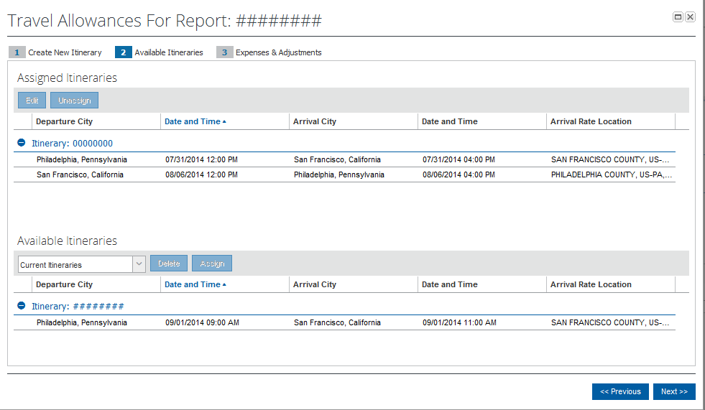

|  |  |  |
| --- | --- | --- |
| 1. Check the boxes where meals were provided by a conference or any other method, not requiring payment by employee. |  | The applicable per diem rates for your destination will be automatically calculated. |

# 

|  |  |  |
| --- | --- | --- |
| 1. Click **Create Expenses** |  | Applicable per diem rates will automatically populate your expense report. |

# Section 8: Create a New Expense Report (Continued)

### Step 3: Add a Company Card Transaction to the New Expense Report

Company card transactions are automatically imported into Expense on a daily basis.

|  |  |  |
| --- | --- | --- |
|  |  | Additional Information |
| 1. Within the Expense Report page, click **Import**, adjacent the **Quick Expenses** button. |  | The **Available Expenses** pane appears. |

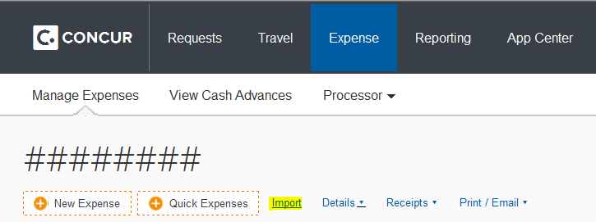

|  |  |  |
| --- | --- | --- |
| 1. In the **Corporate Card Charges** section, select only the transactions billed on your most recent statement, to assign them to the current expense report. |  | You can also add **Corporate Card Charges** to an expense report by dragging and dropping into the **Expenses** area of the page. |
| 1. In the **Available Expenses** section, select **To Current Report**. |  | The expense appears on the left side of the page, with all applicable icons, such as company card or exceptions. |

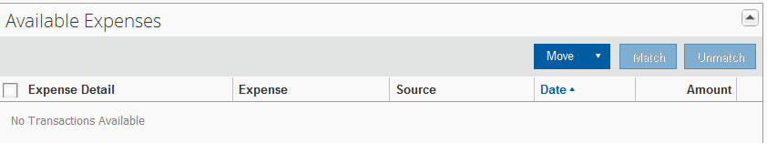

# Section 8: Create a New Expense Report (Continued)

### Step 4: Add an Out-of-Pocket Expense to the New Expense Report

|  |  |  |
| --- | --- | --- |
|  |  | Additional Information |
| 1. Click **New Expense**. |  | The **New Expense** tab appears. |

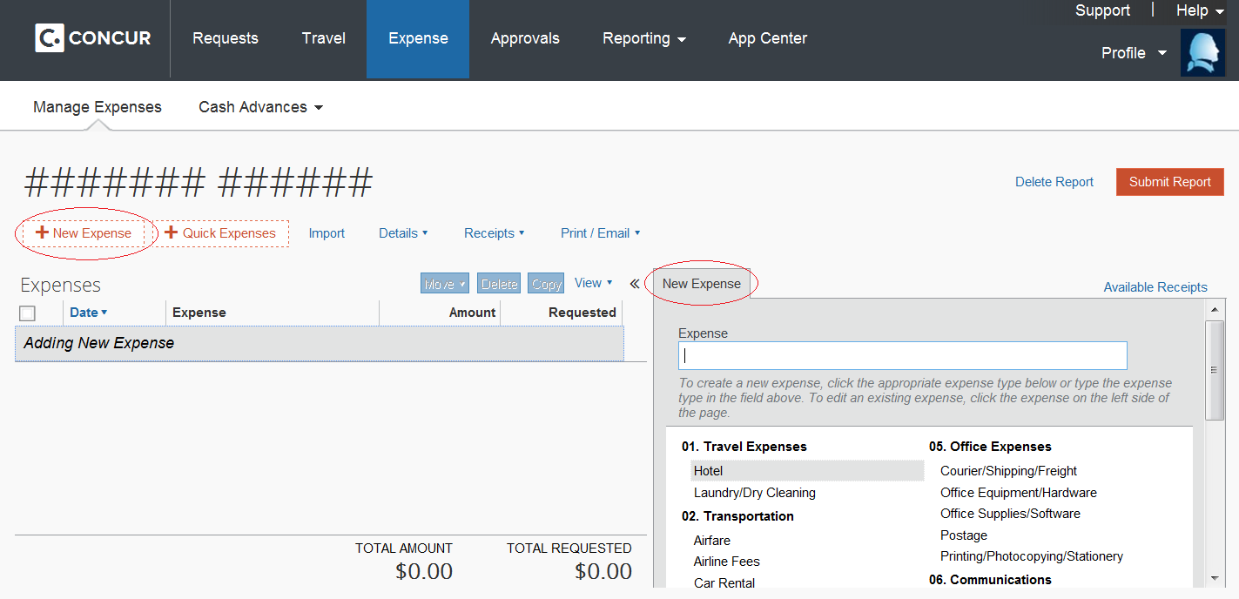

|  |  |  |
| --- | --- | --- |
| 1. On the **New Expense** tab, select the appropriate expense type. |  | The page refreshes, displaying the required and optional fields for the selected expense type. |

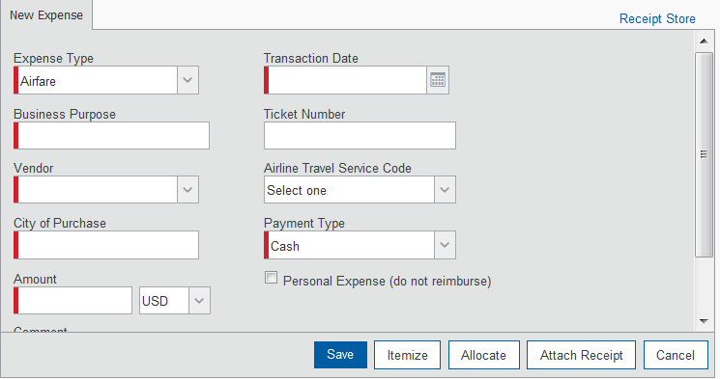

# Section 8: Create a New Expense Report (Continued)

|  |  |  |
| --- | --- | --- |
|  |  | Additional Information |
| 1. Complete all fields. |  | For different types of expenses, such as hotel or car mileage, or for expenses incurred in a currency other than your reimbursement currency, refer to Section 9: *Using Special Features*. |
| 1. Click **Save**. |  | The expense appears on the left side of the page. |

# 

# Section 9: Review and Edit an Expense Report

You should review for accuracy and edit (if necessary) your reports and all expenses, including company card transactions, before submitting your expense report.

### Step 1: Review the Report Information

|  |  |  |
| --- | --- | --- |
|  |  | Additional Information |
| 1. On the **Expense Report** page, in the **Expenses** area, click any transaction to view the details. |  | The expense details appear on the right side of the page. |
| 1. From the **Details** dropdown menu, select **Report** **Header**. |  | The **Report Header** page appears and you can view and update report header information. |
| 1. Make the appropriate changes, and then click **Save**. |  |  |

### Step 2: Review Exceptions

|  |  |  |
| --- | --- | --- |
|  |  | Additional Information |
| 1. On the **Expense Report** page, review anyExceptions. |  |  |

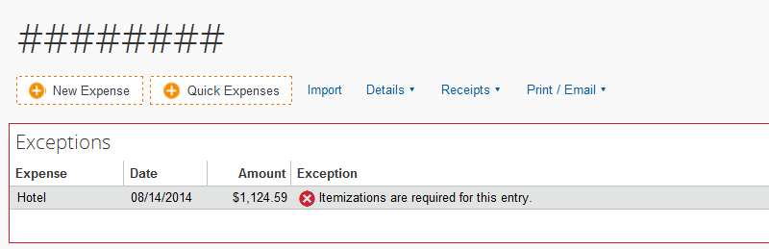

|  |  |  |
| --- | --- | --- |
| 1. Make the appropriate changes, and then click **Save**. |  |  |

# **Section 9: Review and Edit an Expense Report (Continued)**

### Step 3: Edit Multiple Expenses

|  |  |  |
| --- | --- | --- |
|  |  | Additional Information |
| 1. On the **Expense Report** page, in the **Expenses** area, select the checkbox for the expenses that you want to update. |  | The multiple expense options box appears. When you select more than one expense, you will have the ability to delete, allocate, or edit the expenses at the same time. |
| 1. Select the action you would like to perform for the expenses. |  | If you choose to **Edit** the selected expenses, you will be prompted for all of the field(s) that you can update. |

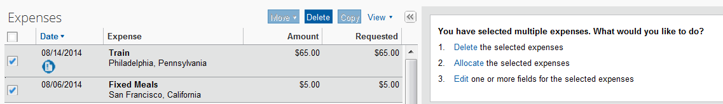

# 

# Section 10: Use Special Features

## Itemize Nightly Lodging Expenses

A hotel bill typically contains a variety of expenses including room fees, taxes, parking, meals, valet, telephone charges, and personal items. These expenses must be itemized so that they can be accounted for correctly. Concur gives you the tools to quickly itemize your lodging-related expenses.

## Step 1: Verify Auto-Itemized Hotel Expenses

The hotel auto-itemization feature automatically itemizes any card transactions that have hotel folio data or an e-receipt from a hotel vendor. If imported unsuccessfully, you can manually itemize your hotel expenses as described in Step 2 below.

The result of hotel auto-itemization is similar to what you see if you manually itemize the hotel expense. Expense itemizes the hotel expense based on predetermined mapping. Examples of the itemizations you will see on your expense report are: parking, meals, and internet access. You can update the auto-itemized expenses and itemize any remaining balance as described in Step 3 below.

## Itemize Nightly Lodging Expenses (Continued)

## Step 2: Create and Itemize a Lodging Expense

|  |  |  |
| --- | --- | --- |
|  |  | Additional Information |
| 1. Click **New Expense**. |  | The **New Expense** tab appears. |
| 1. On the **New Expense** tab, select the **Hotel** expense type. |  |  |
| 1. Complete the required fields on the page as usual. |  |  |

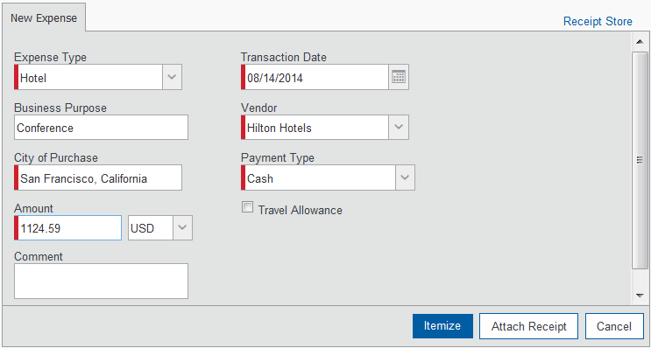

|  |  |  |
| --- | --- | --- |
| 1. Click **Itemize**. |  | The expense appears on the left side of the page and the **Nightly Lodging Expenses** tab appears. |

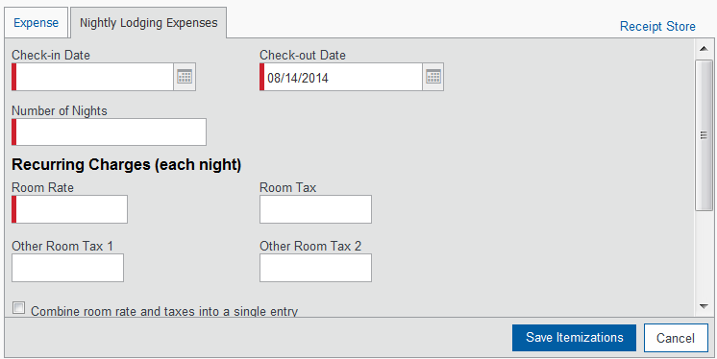

|  |  |  |
| --- | --- | --- |
| 1. On the **Nightly Lodging Expenses** tab, in the **Check-in Date** field, type the date or use the calendar. |  | The number of nights appears automatically. |
| 1. In the **Room Rate** field, enter the amount that you were charged per night for the room. |  |  |
| 1. In the **Room Tax** fields, enter the amount of each room tax that you were charged. |  |  |
| 1. In the **Additional Charges (each night)** section, from the first **Expense Type** dropdown menu, select the appropriate expense type. |  |  |
| 1. In the **Amount** field, enter the amount of the expense. |  |  |
| 1. Repeat steps 8-9 using the second **Expense Type** field if you have more than one recurring additional charge. |  |  |
| 1. Click **Save Itemizations**. |  | If there is a remaining amount to be itemized, the remaining amount is displayed and the **New Itemization** tab appears. |

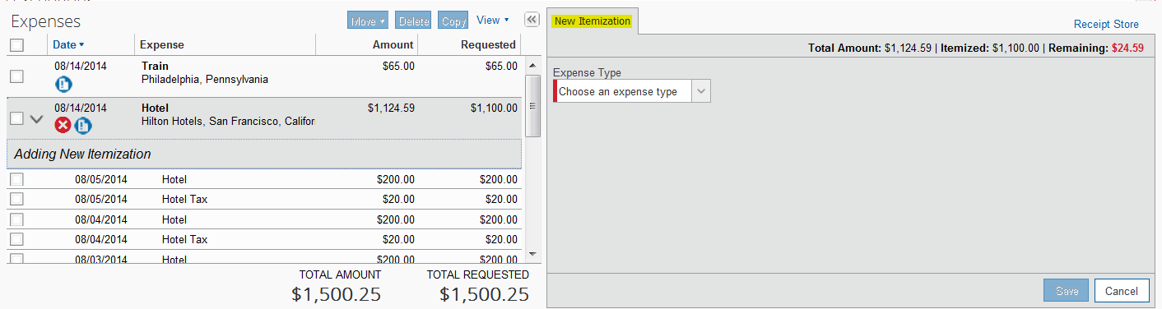

### Step 3: Itemize the Remaining Balance

|  |  |  |
| --- | --- | --- |
|  |  | Additional Information |
| 1. If the amount remaining is more than zero, on the **New Itemization** tab, click the **Expense Type** dropdown arrow, and then select the appropriate expense from the dropdown list. |  | The page refreshes, displaying the required and optional fields for the selected expense type. |
| 1. Complete all fields. |  |  |
| 1. Click **Save**. |  | The expense appears on the left side of the page and the remaining amount equals zero. |
| 1. Repeat steps 1-3 until the **Remaining Amount** equals $0.00. |  |  |

# Section 10: Use Special Features (Continued)

## Add Attendees

For some expense types, such as business meals, you are required to list the Jefferson and non-Jefferson attendees who were present at these events.

|  |  |  |
| --- | --- | --- |
|  |  | Additional Information |
| 1. Click **New Expense**. |  | The **New Expense** tab appears. |
| 1. On the **New Expense** tab, select the **Business** **Meals (Attendees)** expense type. |  | The page refreshes, displaying the required and optional fields for the selected expense type. |
| 1. Complete all required fields *except* the attendee information. |  | In the attendee area, your name automatically appears as an attendee with the full amount of the expense. As you add attendees to the expense, the expense amount is distributed over all attendees. |

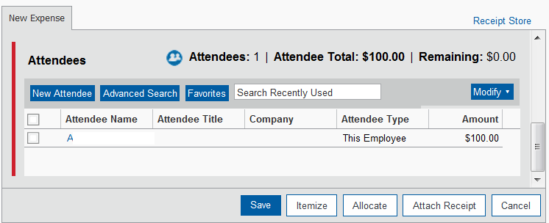

|  |  |  |
| --- | --- | --- |
| 1. Click **Favorites**. |  | The **Search Attendees** window opens.  You can also locate an attendee that is already in your **Favorites** list by typing the first letter of the attendee name in the **Favorites** field, and then selecting the attendee name from the dropdown list. |
| 1. On the **Favorites** tab in the **Search Attendees** window, select the attendees for this expense, and then click **Add to Expense**. |  |  |
| 1. To add a new attendee to the expense, click **New Attendee**, complete the required information, and then click **Save**. |  | The new attendee is added to the list. The expense amount is distributed among the attendees. |
| 1. To search for an attendee, click **Search**, enter your search criteria in the **Search Attendees** window, and then click **Add to Expense**. |  | The “found” attendee is added to the list. The expense amount is distributed among the attendees. |
| 1. Click **Save**. |  | The expense appears on the left side of the page. |

# Section 10: Use Special Features (Continued)

## Itemize Expenses

You may itemize expenses to account for expenses that include both business and personal items or to make sure that each of your expenses is billed to the correct department in your organization.

|  |  |  |
| --- | --- | --- |
|  |  | Additional Information |
| 1. On the **Expense Report** page, click the expense you want to itemize. |  | The page refreshes, displaying the required and optional fields for the selected expense type. |
| 1. Click **Itemize**. |  | The expense appears on the left side of the page. The **New Itemization** tab appears which displays the total amount, itemized amount, and remaining amount. |

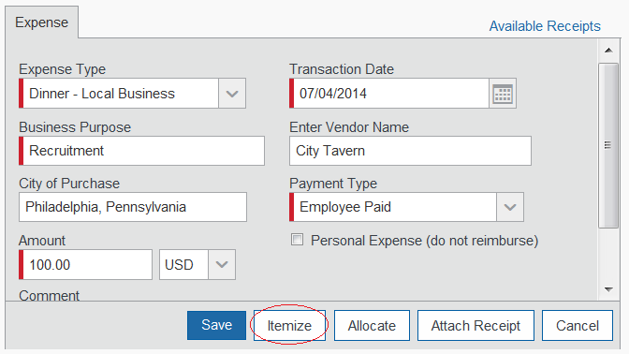

|  |  |  |
| --- | --- | --- |
| 1. On the New Itemization tab, click the Expense Type dropdown arrow, and then select the appropriate expense. |  |  |
|  |  |  |
| 1. Complete all fields. 2. If an item is of a personal nature, click “**Personal Expense (do not reimburse)”** |  |  |
|  | | |
| 1. Click **Save Itemization**. |  | The itemized item appears in the expense list and the totals are adjusted accordingly. |
|  |  |  |

# Section 10: Use Special Features (Continued)

## Convert Foreign Currency Transactions

When adding an out-of-pocket expense that was incurred in a currency other than United States Dollars (USD), Expense will assist you in converting the expense to USD.

|  |  |  |
| --- | --- | --- |
|  |  | Additional Information |
| 1. Click **New Expense**. |  | The **New Expense** tab appears. |
| 1. On the **New Expense** tab, select the appropriate expense type. |  | The page refreshes, displaying the required and optional fields for the selected expense type. |
| 1. Complete all required fields as usual *except* **Amount**. |  | Because the currency conversion rate is based on the Transaction Date that you select, be sure to select the exact Transaction Date. |
| 1. In the **Amount** field, enter the foreign currency amount. |  |  |
| 1. Select the “spend” currency from the dropdown list to the right of the **Amount** field. |  | If you select a **City** that has a different currency than USD, Expense automatically selects the spend currency for you.  Concur supplies the **Rate** and calculates the reimbursement **Amount**. |
| 1. Click the multiplication sign to switch, if needed, and then click **Save** (or click **Itemize** to itemize the expense). |  | Currency can be converted by multiplying by a particular rate or dividing by a different rate. You may need to switch from multiplication to division of the rate, depending on the type of rate you received, by clicking the symbol above the rate field. |

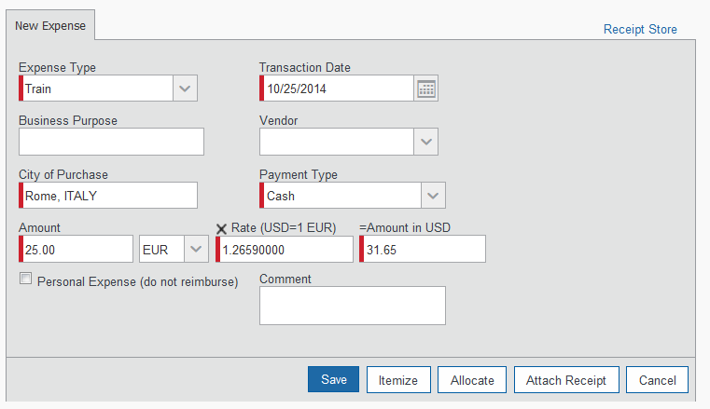

# Section 10: Use Special Features (Continued)

## Add Personal Car Mileage to an Expense Report

|  |  |  |
| --- | --- | --- |
|  |  | Additional Information |
| 1. Click **New Expense**. |  | The **New Expense** tab appears. |
| 1. On the **New Expense** tab, select the **Personal Car Mileage** expense type. |  |  |
| 1. In the **Transaction Date** field, type the date or use the calendar. |  |  |
| 1. In the **From Location** field, enter the starting location of your trip. |  |  |
| 1. In the **To Location** field, enter the ending location of your trip. |  |  |
| 1. Click the **Mileage Calculator**. |  | The **Mileage Calculator** helps you to determine mileage between locations. Notice that the To and From locations that you entered for the expense automatically appear. Using the **Mileage Calculator**, you can change the locations, add additional locations or select roundtrip mileage. The distance between locations will appear for you to add to your expense report. |
|  | | |
| 1. Click **Add Mileage to Expense**. |  |  |
| 1. Enter any necessary comments, and then click **Save**. |  | The expense appears on the left side of the page. |

# Section 10: Use Special Features (Continued)

## Copy an Expense

# Use the copy feature to copy an expense within an expense report. You can then edit the copied expense, as needed.

|  |  |  |
| --- | --- | --- |
|  |  | Additional Information |
| 1. On the **Expense Report** page, from the **Expenses** area, select the checkbox next to the expense you wish to copy. |  | The expense is highlighted. |
| 1. Click **Copy**. |  | The new expense appears below the original. |
| 1. Click on the new expense. |  | The expense details appear. |
| 1. Make all necessary changes to the new expense. |  |  |
| 1. Click **Save**. |  |  |

# 

# Section 10: Use Special Features (Continued)

## Allocate Expenses

The Allocation feature allows you to allocate expenses to projects or departments. The departments you choose will be charged for those expenses.

|  |  |  |
| --- | --- | --- |
|  |  | Additional Information |
| 1. Complete all expenses as usual. |  |  |
| 1. Select the expense you wish to allocate from the expense list. |  | The expense detailsappear. |
| 1. Click **Allocate** near the lower right-hand corner of the expense details section. |  | The **Allocate Report** window appears. |

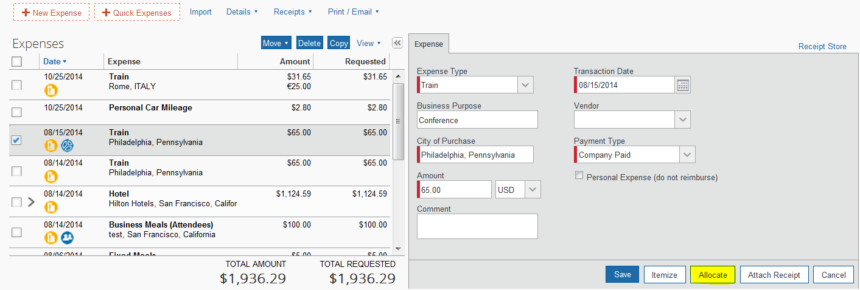

|  |  |  |
| --- | --- | --- |
| 1. From the **Allocate By** dropdown menu, select either **Percentage** or **Amount**. |  |  |
| 1. In the **Allocate By** field, enter the ***Percentage*** or ***Amount***. |  |  |
| 1. Click in the field under the **Business Unit** and **GL Segment** column headings. |  |  |
| 1. Select the department that will receive the allocation. |  |  |

## 

## Allocate Expenses (Continued)

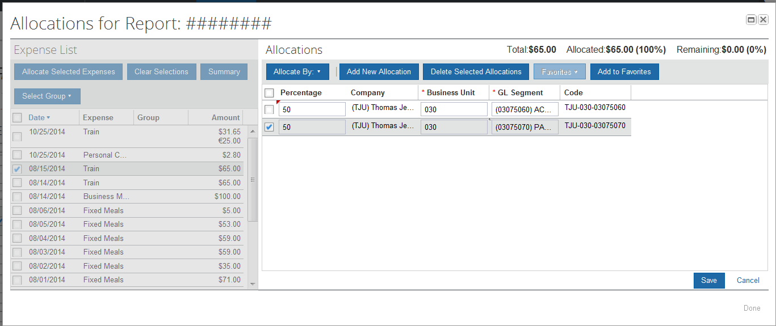

|  |  |  |
| --- | --- | --- |
| 1. Click **Add New Allocation**. |  | A new allocations field appears. |
| 1. Repeat steps 5-7 for each new allocation. |  | Add as many allocations as necessary. You can adjust the amounts and percentages. You are not required to allocate 100% of the total. The amount that you do not allocate is charged to your default cost center. |
| 1. Click **Save**. |  |  |
| 1. In the confirmation message box, click **OK**. |  |  |
| 1. In the **Allocate Report** window, click **Done**. |  | The allocation pie chart icon appears on the left side of the expense. |

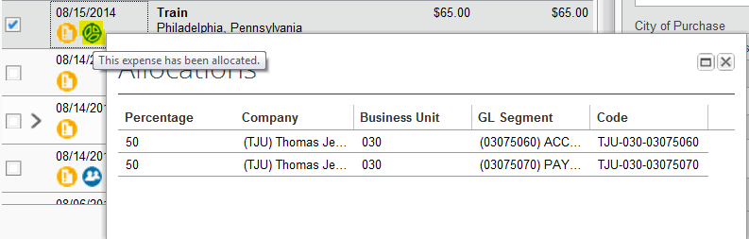

# Section 10: Use Special Features (Continued)

## Allocate Multiple Expenses

If you have multiple expenses in a report to allocate, you can select and allocate all applicable expenses at the same time.

|  |  |  |
| --- | --- | --- |
|  |  | Additional Information |
| 1. Complete all expenses as usual. |  |  |
| 1. Select all the expenses you wish to allocate from the expense list. |  | A message appears in the right pane, which states that you have selected multiple expenses and provides three options. |

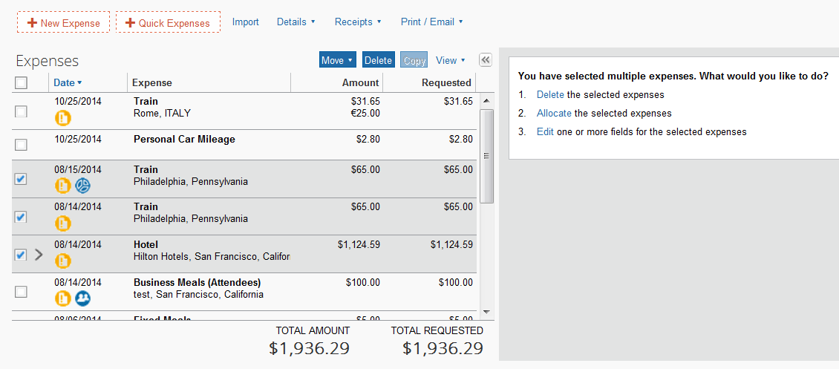

|  |  |  |
| --- | --- | --- |
| 1. Click **Allocate**. |  | The **Allocate Report** window appears. |
| 1. From the **Allocate By** dropdown menu, select either **Percentage** or **Amount**. |  |  |
| 1. In the **Allocate By** field, enter the ***Percentage*** or ***Amount***. |  |  |
| 1. Click in the field under the **Business Unit** and **GL Segment** column headings. |  | A dropdown list of departments appears. |
| 1. Select the department that will receive the allocation. |  |  |
| 1. Click **Add New Allocation**. |  | A new allocation field appears. |

## Allocate Multiple Expenses (Continued)

|  |  |  |
| --- | --- | --- |
|  |  | Additional Information |
| 1. Repeat steps 5-7 for each new allocation. |  | Add as many allocations as necessary. You can adjust the amounts and percentages. You do not have to allocate 100% of the total. The amount that you do not allocate is charged as usual, to your default cost center. |
| 1. Click **Save**. |  |  |
| 1. In the confirmation message box, click **OK**. |  |  |
| 1. In the **Allocate Report** window, click **Done**. |  |  |

# Section 11: Print and Submit/Resubmit Expense Reports

## Preview and Print Your Expense Report

|  |  |  |
| --- | --- | --- |
|  |  | Additional Information |
| 1. From the **Print/Email** menu, select **Report - Detailed**. |  | The report appears in a separate window. |
|  | | |
| 1. Select your desired file format. |  |  |

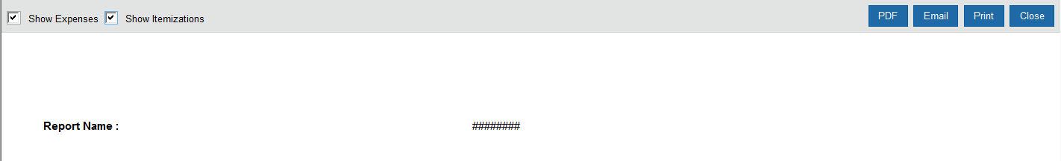

## Attach Scanned Receipt Images

### Attach Scanned Images

|  |  |  |
| --- | --- | --- |
|  |  | Additional Information |
| 1. On the **Expense Report** page, from the **Receipts** dropdown menu, select **Attach Receipt** **Images**. |  | The **Attach Files** window appears. |

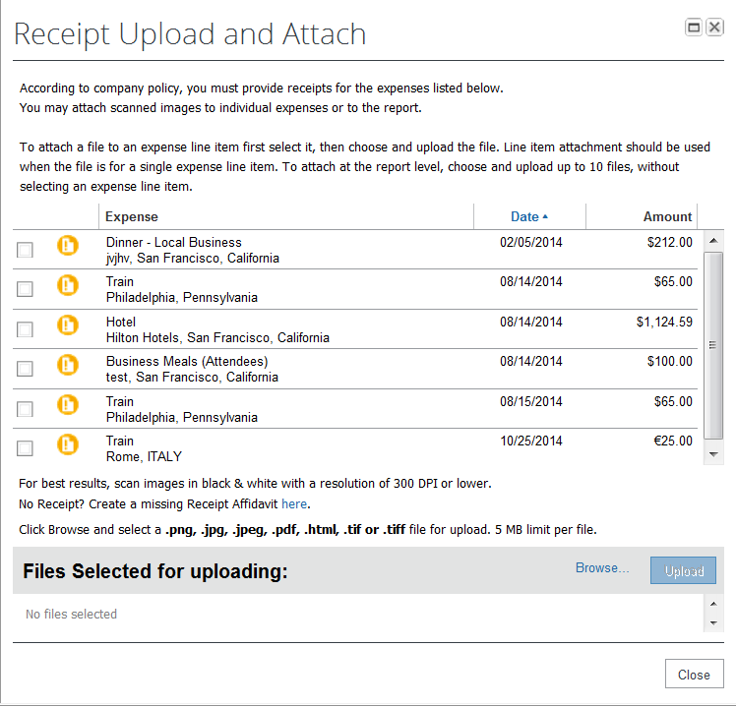

|  |  |  |
| --- | --- | --- |
| 1. Click **Browse**, and then locate the file you want to attach. |  |  |
| 1. Click the file, and then click **Open**. |  | The selected file appears in the **Files Selected for uploading** section of the window. |
| 1. To attach another image, click **Browse**, and then repeat the process. |  | Attach a receipt to **each** individual expense as required. **Note:** When additional receipts, such as conference brochures and additional information, are required, attached at the header level. |
| 1. Click **Upload,** and thenclick **Done**. |  |  |
| 1. To view the attached receipts, from the **Receipts** dropdown menu, select **Check Receipts**. |  | After you have checked receipts for the first time, you will see two different options on the Receipts menu: **View Receipts in New Window** and **View Receipts in Current Window**. |

## 

# Section 11: Print and Submit/Resubmit Expense Reports (Continued)

## Use E-Receipts

E-receipts are an electronic version of receipt data that can be sent directly to Concur to replace imaged paper receipts. To use this feature, you must opt in from your Profile before e-receipts will show in Expense. You may opt-in for e-receipts in the **Travel Alerts** section on the **My Concur** page.

### Enable E-Receipts

|  |  |  |
| --- | --- | --- |
|  |  | Additional Information |
| 1. On the **My Concur** page, in the **Travel Alerts** section, click **Sign up here**. |  | The E-Receipt Activation page appears. |
|  | | |
| 1. Click **E-Receipt Activation**. |  | The **E-Receipt Activation and Use Agreement** appears. |

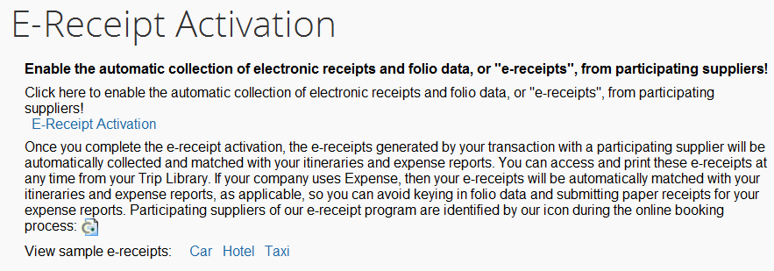

|  |  |  |
| --- | --- | --- |
| 1. Click **I Accept**. |  | The e-receipts confirmation appears.  Once you have confirmed the e-receipt activation, your corporate American Express card is included.  As you create your expense reports, you will see the e-receipt icon next to any transactions that have an e-receipt. You can click the icon to view the e-receipt. |

## 

# Section 11: Print and Submit/Resubmit Expense Reports (Continued)

## Submit Your Completed Expense Report

Given our sequential, ascending approval flow, your expense report might be sent to multiple approvers. If one of the approvers makes changes to your expense report, you will be notified and the report might need to go through the approval process again.

|  |  |  |
| --- | --- | --- |
|  |  | Additional Information |
| 1. On the **Expense Report** page, click **Submit Report**. |  | The **Final Review** window appears, which lists all expenses that require receipts. |
| 1. Click **Submit Report**. |  | The **Report Submit Status** window confirms that the report was successfully submitted. |
| 1. Click **Close**. |  | The **Expense Report List** page appears. |

## Correct and Resubmit a Report Sent Back by Your Approver

If your approver requires changes or additional information, he/she will return your expense report.

The returned report appears in the **Active Work** section of the **Concur** homepage, along with a comment from your approver.

|  |  |  |
| --- | --- | --- |
|  |  | Additional Information |
| 1. Click the report to open the report. |  | The **Expense Report** page appears. |
|  | | |
| 1. Make the requested changes. |  |  |
| 1. Click **Submit Report**. |  |  |

# Section 12: Review and Approve Expense Reports

As an approver, you can approve an expense report “as is”; send an expense report back to the employee to modify and resubmit; or adjust the authorized amount of one or more expenses to comply with company policy and then approve the expense report for the lowered amount.

If one of the approvers makes changes to your expense report, the report might need to go through the approval process again.

## Review and Approve an Expense Report

All reports awaiting your review and approval appear in the **Approvals** section of the **Concur** homepage.

|  |  |  |
| --- | --- | --- |
|  |  | Additional Information |
| 1. Click the report name (link) to open the report. |  | The **Expense Report** page appears. |
| 1. To review the report information, from the **Details**dropdown menu, select **Report Header** (under **Report**). |  | The **Report Header** page appears. Click **Cancel** on the **Report Header** page. |
| 1. To review expense entry information, click an expense entry. |  | The expense entry details appear on the right side of the page. |
| 1. When ready to approve, click **Approve**. |  | The report moves to the next step in the workflow. |

## Send an Expense Report Back to the Employee

All reports awaiting your review and approval appear in the **Approval Queue** section of the **My Concur** page.

|  |  |  |
| --- | --- | --- |
|  |  | Additional Information |
| 1. Click the report name (link) to open the report. |  | The **Expense Report** page appears. |
| 1. Click **Send Back to Employee**. | T | The **Send Back Report** box appears. |
| 1. Enter a comment for the employee, and then click **OK**. |  | The report is returned to the employee. |

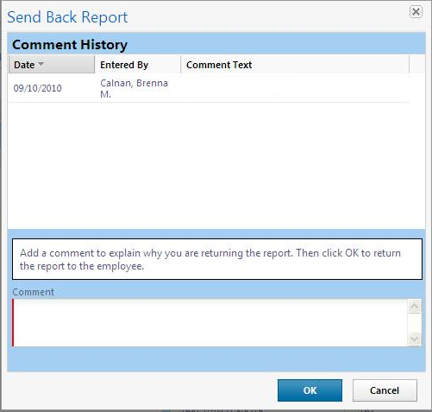

# Section 12: Review and Approve Expense Reports (Continued)

## Send Single Expenses Back to an Employee

Expense allows you to send back an individual expense item to an employee for correction instead of sending back the entire expense report.

|  |  |  |
| --- | --- | --- |
|  |  | Additional Information |
| 1. In the **Approval Queue** section of **My Concur**, click the name of the report that you want to view. |  | The expense report opens. |
| 1. Review the expense report. |  |  |
| 1. Click the expense you wish to send back for correction. |  | The expense details appear. |
| 1. In the expense details sections, select the **Send Back Expense?** checkbox. |  |  |
| 1. Click **Approve**. |  | You can send back multiple expenses on an expense report without sending back the entire report. You will repeat the steps for each expense that needs to be sent back. |

# Section 12: Review and Approve Expense Reports (Continued)

## Add an Additional Review Step for an Expense Report

You can add additional approval steps for an expense report, as needed. For example, if the expense report has an allocation to a cost center that is not within your approval authorization, you can manually select the appropriate approver for the report.

|  |  |  |
| --- | --- | --- |
|  |  | Additional Information |
| 1. On the **My Concur** page in the **Approval Queue** section, click the report name (link) to open the report. |  | The **Expense Report** page appears. |
| 1. Click **Approve & Forward**. |  | The **Approval Flow** window appears. |
| 1. In the **Approval Flow** window, click the **Search Approvers By** dropdown arrow. |  | A list of search options appears. |
| 1. Select the desired search option from the dropdown list. |  |  |
| 1. In the **User-Added Approver** field, type the search criteria. |  | The system displays all matches for the search criteria that you entered. |
| 1. From the list of options displayed by the search, select the appropriate approver. |  |  |
| 1. Click **Approve**. |  | The expense report is forwarded to the selected approver. |

# Section 12: Review and Approve Expense Reports (Continued)

## Adjust Authorized Amounts on an Expense Report

All reports awaiting your review and approval appear in the **Approvals** section of the **Concur** homepage. Depending on your company’s configuration, you might not have the ability to adjust authorized amounts on expense reports.

|  |  |  |
| --- | --- | --- |
|  |  | Additional Information |
| 1. Click the report name (link) to open the report. |  | The expense report page appears.  If you have the authority to adjust amounts, then the **Amount** field is editable. |
| 1. Make the appropriate adjustments, and then click **Save**. |  |  |
| 1. Click **Approve**. |  | The report moves to the next step in the workflow. |

